  - Answer Key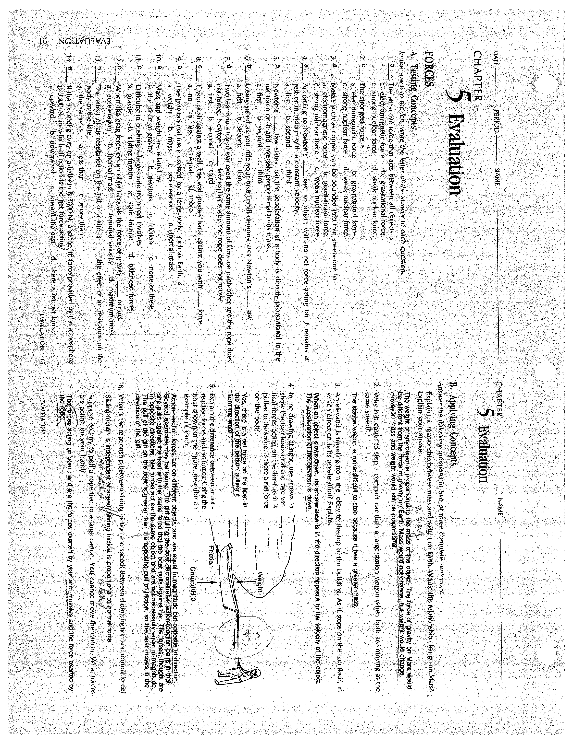
Gravity is not a force ... force due to gravity
Gravity is not a force ... force due to gravity

6. sliding friction does not change significantly unless the velocity is high (more friction, more heat)

  - 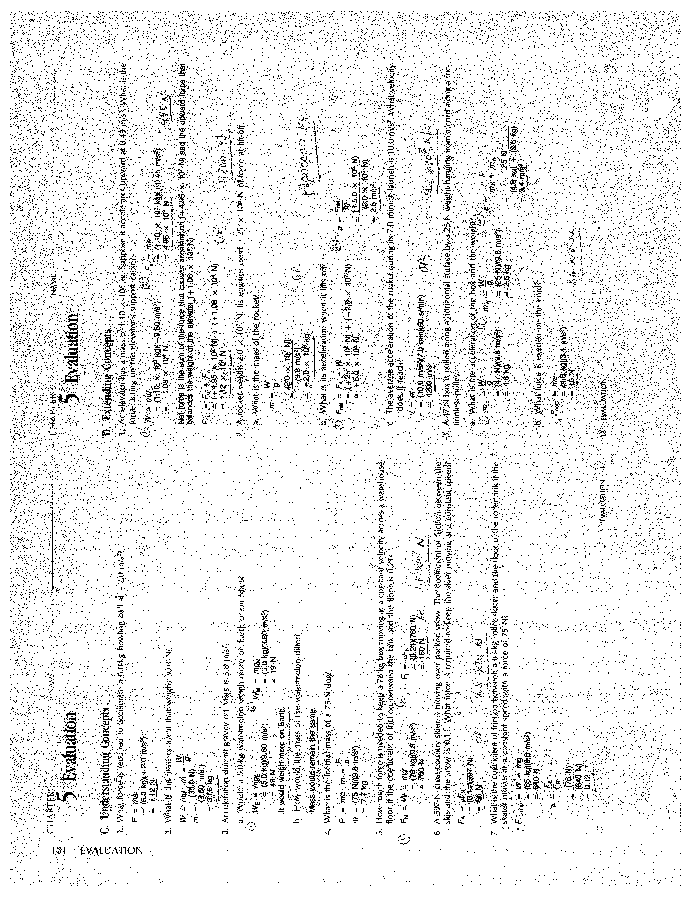

The tension involves the weight of the box (47 N) resisting the 25 N weights fall. One needs to know the coefficient of friction on the horizontal surface to answer this. The tension on a frictionless surface would be the net force (22 N) as in “a”. As friction is applied, the net force would increase.
F_{net} = 47 N – 25 N = 22 N
a = f_{net} / total mass = 22 N / 7.4 kg
a = 3.0 m/s

