Name _____ Day, Time ____

Date _____

1. What causes wind?

2. Winds blow from _____ pressure to _____ pressure. In low pressure centers, winds blow _____ and _____ around the low pressure center. Winds blow out of and _____ from high pressure centers.

3. List and define the three factors that affect wind:

a. _____:

b. _____:

c. _____:

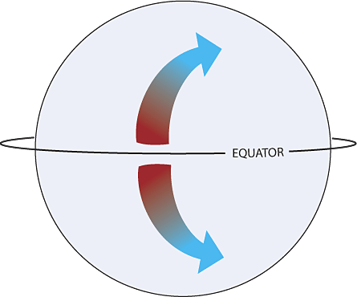

4. What force is pictured to the right? _____

5. Explain what an isobar is

6. What happens to pressure gradient & wind strength as isobars get closer together?

7. Low pressure systems are known as _____ and generally bring _____ weather. Winds move in a(n) _____ direction around low-pressure centers.

8. High pressure systems are known as _____and generally bring _____ weather. Wind moves out and in a _____ direction around high-pressure centers.

9. Label where the high & low pressure centers are located on the image (use an H or an L):

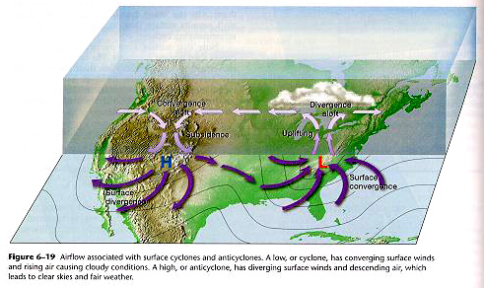

10. Why do winds higher in the atmosphere travel at higher speeds?

11. What Upper-level winds dictate the movement of storms?

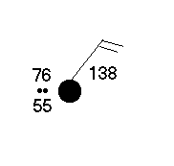12. Use the weather station model to the right to answer the following questions:

a. What is the temperature at this location? _____

b. What is the air pressure? _____

c. What is the cloud cover? _____

d. What is the dew point temperature? _____

e. What is the wind direction? _____

13. _____ are sections of air with similar humidity, temperature, and air pressure.

14. Air masses tend to take on characteristics of ____

15. Explain the characteristics of an air mass sitting over a desert (temperature and humidity):

16. Explain the characteristics of an air mass sitting over the Caribbean Sea (temperature and humidity):

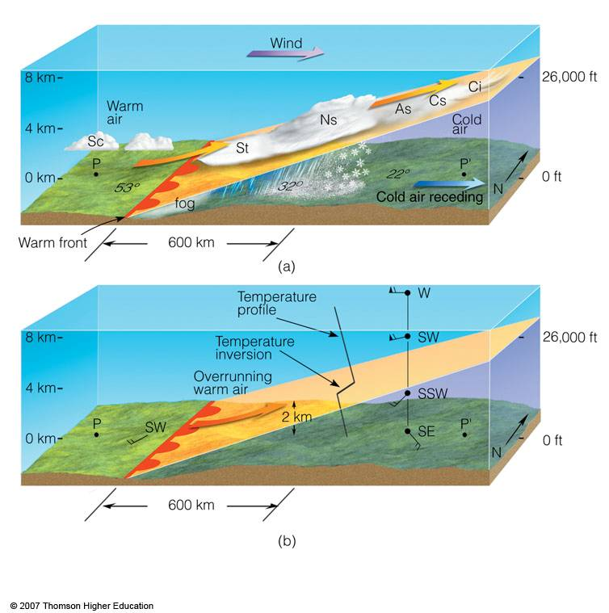17. Use the image to answer the following questions:

a. Is this a cold or warm front _____

b. What type of weather conditions will the front bring? _____

c. What type of clouds will this front form?

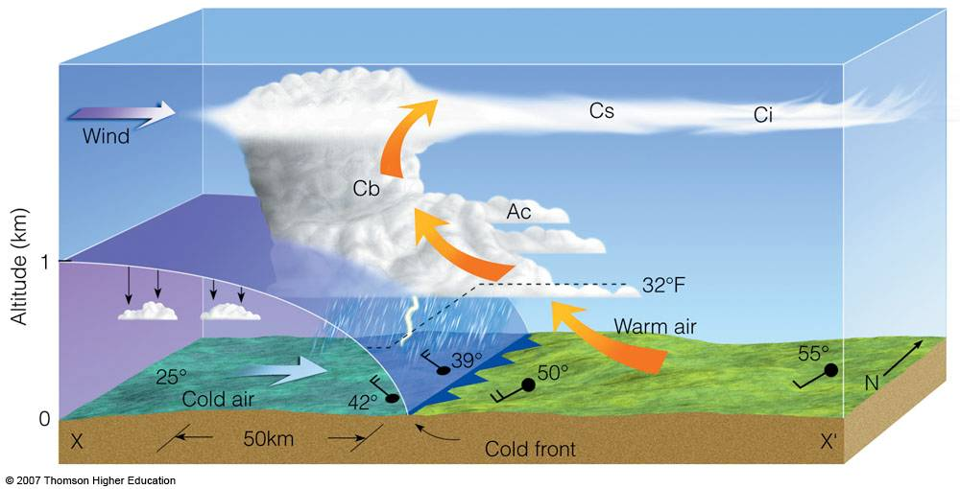

Use the image to the right to answer the following questions:

18. Is this a cold or warm front _____

19. What type of weather conditions will the front bring?

20. Label the symbols for fronts below:

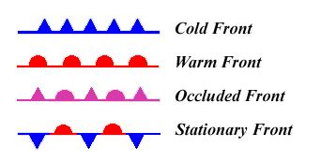

ANSWERS

1. What causes wind? *Differences in air pressure and air temperature (density)*

2. Winds blow from *high* pressure to *low* pressure. In low pressure centers, winds blow *IN* and *counter-clockwise* around the low pressure center. Winds blow out of and *clockwise* from high pressure centers.

3. List and define the three factors that affect wind:

a. *Pressure Gradient Force: causes horizontal pressure differences and winds*

b. *Gravity: causes vertical pressure differences and winds*

c. *Coriolis Force Effect: causes all moving objects (air) to deflect or veer to the right in the Northern Hemisphere and left in the Southern Hemisphere.*

4. What force is pictured to the right? *Coriolis Effect*

5. Explain what an isobar is *a line of equal pressure on a weather map*

6. What happens to pressure gradient & wind strength as isobars get closer together?

*Pressure gradient increases (steeper) and winds get stronger*

7. Low pressure systems are known as *cyclones* and generally bring *inclement (bad)* weather. Winds move in a *counter-clockwise* direction around low pressure centers.

8. High pressure systems are known as *anticyclones* and generally bring *fair* weather. Wind moves out and in a *clockwise* direction around high pressure centers.

9. Label where the high & low pressure centers are located on the image (use an H or an L):



10. Why do winds higher in the atmosphere travel at higher speeds?

*Winds higher in the atmosphere have less friction and travel at a higher speed*

11. What upper level winds dictate the movement of storms?

*The Jet Stream drives low pressure centers*

12. Use the weather station model to the right to answer the following questions:

a. What is the temperature at this location? *76°*

b. What is the air pressure? *138*

c. What is the cloud cover? *100%*

d. What is the dew point temperature? *55°*

e. What is the wind direction? *northeast*

13. *Air Masses* are sections of air with similar humidity, temperature, and air pressure.

14. Air masses tend to take on characteristics of *the surface that they sit over*

15. Explain the characteristics of an air mass sitting over a desert (temperature and humidity):

*High temperature; dry (low humidity)*

16. Explain the characteristics of an air mass sitting over the Caribbean Sea (temperature and humidity):

*Moderate temperature; moist (high humidity)*

17. Use the image to answer the following questions:

a. Is this a cold or warm front? *warm*

b. What type of weather conditions will the front bring?

*Gentle rain or snow*

c. What type of clouds will this front form?

*High wispy cirrus clouds*



Use the image to the right to answer the following questions:

18. Is this a cold or warm front? *cold*

19. What type of weather conditions will the front bring?

*severe*

20. Label the symbols for fronts below

