Heading
Energy Transfer

Introduction

Purpose To determine how heat energy is transferred from one object to the next. Given the materials listed below, how can heat energy transfer be measured?

Discussion
List and define three ways heat energy is transferred. What factor affects how heat is absorbed in this lab?
- ___
- ___
- ___
- ___

Hypothesis

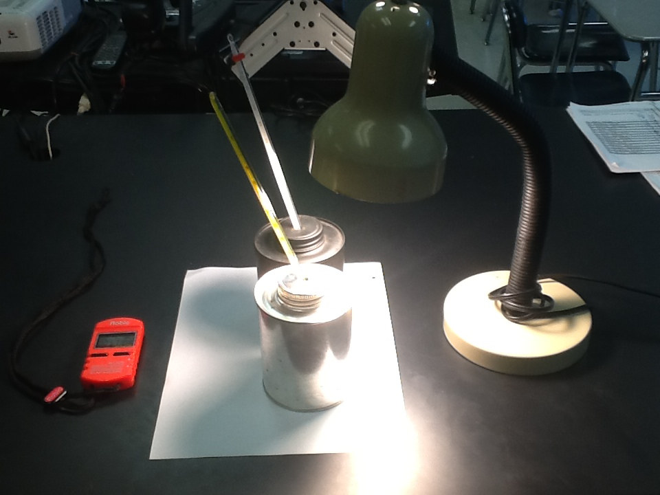

Materials

Black Radiation Can 2 Thermometers (°C) Timer
Silver Radiation Can 200-Watt Light / Lamp

Procedures
Create a set of specific procedural steps that tests your hypothesis by setting up an experiment (as shown in the picture) that would allow you to measure the temperature change of the air inside two differently colored cans when equally exposed to radiant energy. [The experiment is not focusing on which cans will absorb the most radiant energy from the lamp, but on how the heat energy is transferred, and how this energy transfer is measured].

Heat Energy Transfer Pre-Lab Questions

1. Identify and define three ways that heat energy is transferred. Give an example of each.

2. Define the term “albedo” and state the relationship between albedo and amount of temperature increase in a material.

3. Give examples of two substances that would have a high albedo, and two substances that would have a low albedo. Explain the difference related to temperature.

4. How do alcohol thermometers work? How do they measure the temperature of an object?

During Lab Questions:

1. Identify how each type of energy transfer is occurring in this lab.

Post Lab Questions (Answer in complete sentences with supporting data):

1. How were you able to measure the temperature change of the two cans? Which of the two cans changed temperature the most?

2. What was the rate of temperature increase for each can (in °C/min.)?
Hint: Rate = change in temperature (∆ T in °C) over time (minutes).

3. What is the difference in the movement of the air molecules in the black can versus the movement of the air molecules in the silver can? How do you know this?

4. Draw a diagram, starting with the lamp, use arrows to show how energy flowed from the lamp to the can, to the air inside the can, to being measured in the thermometer. Label each part of the diagram, and the types of energy transfer in the diagram.

Lamp Color of Cans Movement in the Cans

- Which can has the greatest albedo? How can you determine this from the experiment?

Images
(Include images of the experiment, showing both cans being radiated by the heat source. Give the relevance of the image(s) based on the experiment.)

DATA TABLE
Be sure to give units for each temperature measurement

Time (Minutes) | Temperature  Black (°C) | Temperature  Silver (°C)
0
3
6
9
12
15
18
21
24

Make a scatterplot graph of the time (in minutes) versus the temperature for each can. Use time as the independent variable.

BONUS
Write a summary paragraph showing the energy transfer in this lab.

Graphing Guidelines
1. Title your graph – (should be descriptive of data plotted).
2. Label axes with proper variable placement; leave space to label each axis; include units.
3. Always plot the independent variable (control) on the horizontal (x) axis.
4. Choose an appropriate scale – make sure that each box on each axis is given the same interval value, and that the data will fit on the graph according to your scale.
5. Draw a scatterplot (connect the points) for each can and label the slope line.

