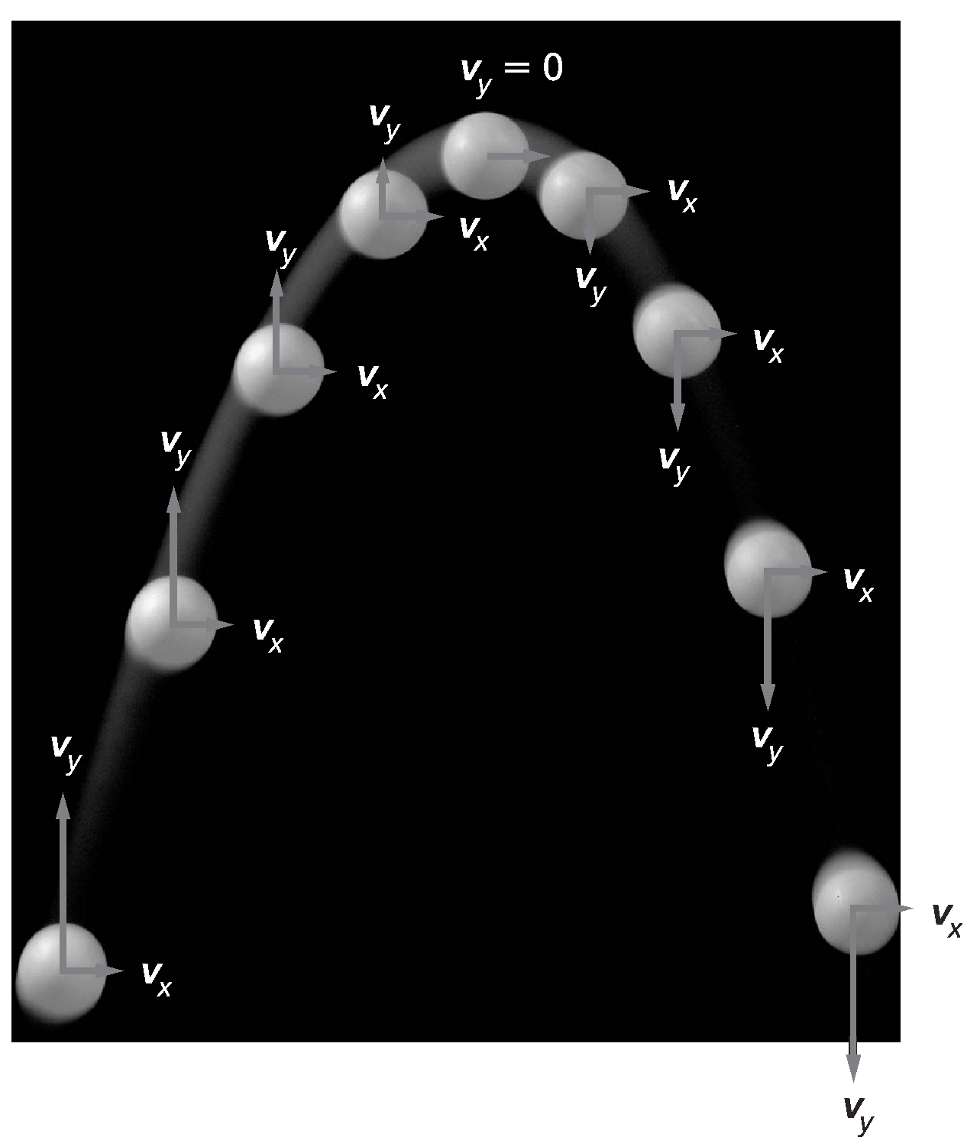

1. What is the name of the path followed by a water drop?

2. What term is used to describe the water drop?

3. What do V_{x} and V_{y} stand for?

4. Does the magnitude of V_{x} change along the path? If so, how?

5. Does the magnitude of V_{y} change along the path? If so, how?

6. What is the relationship between V_{x} and V_{y}?

7. What force is acting on each drop in the y-direction?

8. What force is acting on the drop in the x-direction? The motion in the x-direction illustrates which of newton’s laws?

9. Explain why you do not see the same changes in V_{x} and V_{y} along the path.

ANSWERS

1. What is the name of the path followed by a water drop?

Parabolic trajectory

2. What term is used to describe the water drop?

Projectile

3. What do V_{x} and V_{y} stand for?

Horizontal (Vx) and vertical (Vy) components of the velocity vector

4. Does the magnitude of V_{x} change along the path? If so, how?

The horizontal component does not change (assuming no friction)

5. Does the magnitude of V_{y} change along the path? If so, how?

Vy decreases as it moves to the peak of the trajectory (due to gravity as an opposing force), becoming zero, then increases as it falls (due to acceleration due to gravity).

6. What is the relationship between V_{x} and V_{y}?

The horizontal component does not change (assuming no friction) and therefore, does not affect the vertical component which is influenced by gravity.

7. What force is acting on each drop in the y-direction?

The force of attraction, producing acceleration due to gravity. Gravity is an opposing force for objects going upward, but increases velocity in the downward direction (no longer an opposing force).

8. What force is acting on the drop in the x-direction? The motion in the x-direction illustrates which of Newton’s laws?

The initial force that set the object in motion (balanced in this case because Vx is constant). This Newton’s first law, inertia.

9. Explain why you do not see the same changes in V_{x} and V_{y} along the path.

The horizontal component (Vx) is constant (indicating a balanced force acting on it) while the vertical component (Vy) changes due to the acceleration of gravity (produced by an unbalanced force).

