Energy Summary Reference Material

Up to this point, we have reviewed aspects regarding general information of energy, hydropower, solar energy, nuclear energy and wind energy. This reference material will summarize some other general areas concerning energy and its relevance to our lives.

ENERGY is the ability to do work. WORK is power multiplied by time. POWER is the rate at which work is done or the rate at which energy is expended. Did you realize it takes so much energy to discuss power? Man, this is a lot of work.

|  |  |  |  |
| --- | --- | --- | --- |
| FORMS OF ENERGY |  | **SOURCES OF ENERGY** | Description |
|  | | | |
| Radiant (light) |  | SUN | Solar energy, Wind energy, flowing water (hydropower), tides |
|  | | | |
| Thermal (heat) |  | WATER | Ocean thermal energy |
|  | | | |
| Chemical |  | EARTH | Geothermal energy, Fuels |
|  | BIOMASS FUELS | Food, Wood, Waste -  Biomass fuels come from living things recently harvested |
|  |  |
|  | | | |
| Mechanical |  | Sun, Water | Windmills |
|  | | | |
| Electrical |  | Electricity comes from ALL the energy Sources | |
|  | FOSSIL FUELS | Fossil fuels (Coal, oil & natural gas) are derived from decayed materials produced over a long time under great pressure |
|  | | | |
| Nuclear |  | RADIOACTIVE ELEMENTS | Uranium and Plutonium |

## Energy Units

**Barrel:** a liquid volume equal to 42 gallons or 159 liters. One barrel of crude oil has about the same heat energy as 350 pounds of bituminous coal, 5.8 x 109 joules or 5.5 x 106 Btu or 1.39 x 106 kcal.

**Btu:** British Thermal Unit, a unit for measuring heat; a Btu is the quantity of heat necessary to raise the temperature of one pound of water one degree Fahrenheit, about ¼ of a kilocalorie (252 calories)

**Calorie:** (also: gram calorie): a metric unit of heat energy; the amount of heat needed to raise the temperature of one gram of water one degree Celsius. It equals 0.0039 Btu.

**Kilocalorie:** one thousand calories; sometimes called a Calorie or food Calorie.

**Watt:** a unit of measure for electrical power equal to the transfer of one joule of energy per second. The watt is the unit of power most often associated with electricity and is determined by multiplying required volts by required amperes. The English measurement of One horsepower = 746 watts.

**Kilowatts:** a measure of power, usually electrical power of heat flow; equal to 1,000 watts or 3,413 Btu per hour.

**Kilowatt-hour**: the amount of energy equivalent to one kilowatt of power being used for one hour; equals 3,413 Btu, or about 860 kcal.

**Quad:** a unit for describing very large amounts of energy, like the energy used by an entire country in a year; equals 1015 Btu.

Why deal with this issue of Energy? Just to give you busy work? To keep you off the streets and away from drugs? Just to fool your parents into thinking we are actually doing something constructive in school? Absolutely!

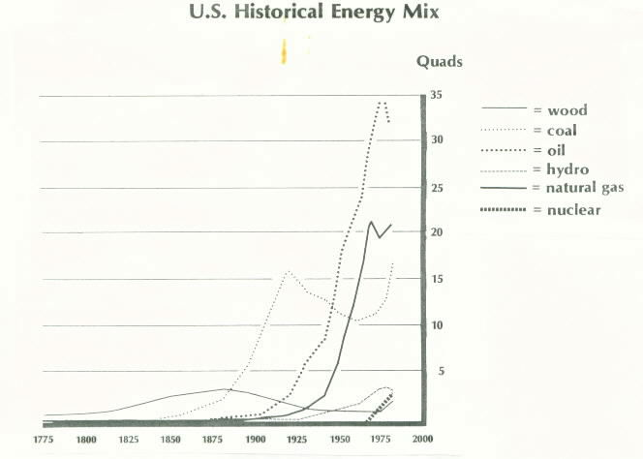

The chart below gives one reason to look into Energy. Note the great fluctuation in the price of energy related items compared to the non-energy related items. The point is that the availability and cost of energy is highly unstable and can change quickly. This certainly affects our pocketbooks and wallets.

|  |  |  |  |  |
| --- | --- | --- | --- | --- |
| Price Comparison For Energy and Other Commodities 1973 versus 1983 | | | | |
|  | **1973** | **1983** | **Increase** | **1989** |
| Barrel of oil | $3.39 | $29.42 | 8.7 X | $13-17 |
| Gallon of heating oil | $0.23 | $1.10 | 4.3 X | $1 |
| Gallon of gasoline (regular) | $0.42 | $1.23 | 2.9 X | $1 |
| Therm of natural gas | $1.74 | $7.63 | 4.4 X | $11 |
| KWH of electricity | $03.5 | $0.10 | 2.9 X | $0.13 |
| Bottle of soda pop | $0.25 | $0.55 | 2.2 X | $0.65 |
| Postage stamp | $0.08 | $0.20 | 2.5 X | $0.25 |
| Gallon of milk | $0.99 | $1.99 | 2.0 X | $2.50 |
| Subway token | $0.35 | $0.75 | 2.1 X | $1.35 |
| Pound of hamburger | $0.99 | $1.68 | 1.7 X | $1.90 – 2.20 |

Notice the amount of energy that the United States consumes. We represent only 6% of the total world population!

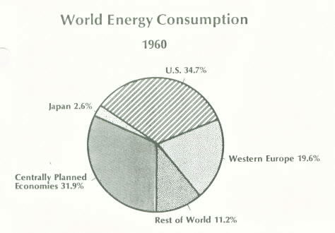

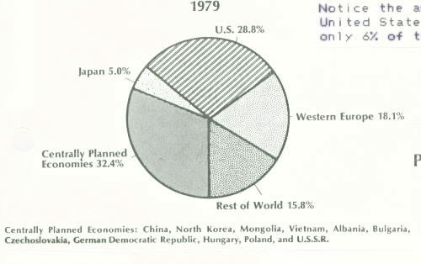

The United States produces the most energy of all world nations. This is due mainly to our resources, technology, ingenuity and freedom.

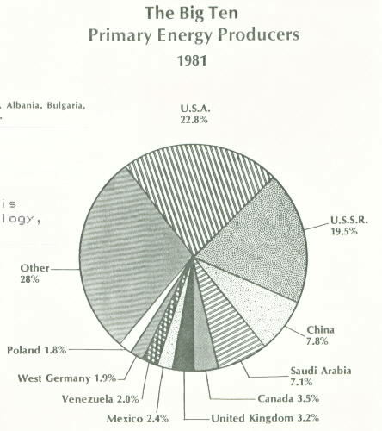

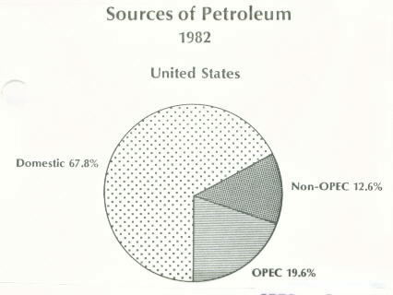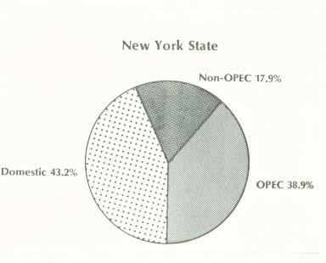

###### OPEC: Organization of Petroleum Exporting Countries

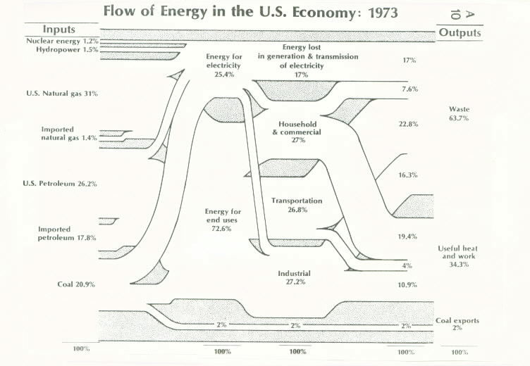

INFERENCES: *conclusions drawn from the chart above*

1. Coal’s major use was for electrical generation.
2. 2/3 of all energy used to generate electricity was lost in generation or transmission.
3. Transportation was the least efficient sector of our economy.
4. 2/3 of all energy used in society ends as WASTE.
5. We need to develop more efficient energy to get less waste:

a) resource energy: recycling, reuse, composting, source

separation, source reduction

b) alternative energy: solar (photovoltaics) energy,

hydropower, wind energy

# Electrical Generation

## A. Using Steam

1. fossil fuels: coal, oil, natural gas

1. solar boilers using solar cells
2. nuclear reactors
3. geothermal energy

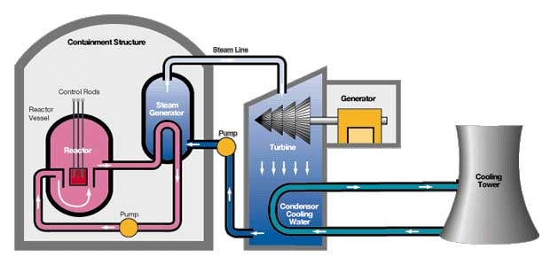

Electrical generation typically uses steam from a heated boiler to drive a turbine

and turn a generator. Some kind of fuel is used to produce the steam from water.

The highly pressurized steam from the boiler spins the blades of the turbine, which is like a large, may-bladed windmill. The turbine shaft spins the rotor within the generator. The generator consists of bundles of coiled wires on a rotor between two opposing magnetic poles. When the rotor spins, electricity is generated in the wires as they move in the magnetic field.

The hot steam then passes through a condenser where it is cooled by water from a nearby river, lake, ocean or cooling tower. When the steam condenses back into water, it returns to the boiler and the whole process begins again.

1. Using Hydropower … *we have covered this in detail earlier in this unit.*
2. OTEC 🡪 Ocean Thermal Energy Conversion
3. Photovoltaics 🡪 Solar energy converted directly to electricity

Hydropower, OTEC, and Photovoltaics are systems available that produce electricity without the use of fossil fuels. These are highly efficient, free from significant pollution, and are all renewable resources.

Lastly, the topic of energy is as vast as the ocean (*How profound, eh?*). Today’s researchers are developing ways to produce oil and natural gas from coal (“Gasification”) because coal is cheap. Also, many industries use the concept of “cogeneration,” the dual production of electricity AND useful heat energy from a common source. For instance, the exhaust steam used in electrical generation is used to heat nearby homes and buildings.

I could go on and on, but I don’t want add anymore “fuel to the fire.” I’m already convinced that all this talk of electricity was shocking to many of you. But as they say in the Yukon … “Nothin’ succeeds like a seed sucker.”

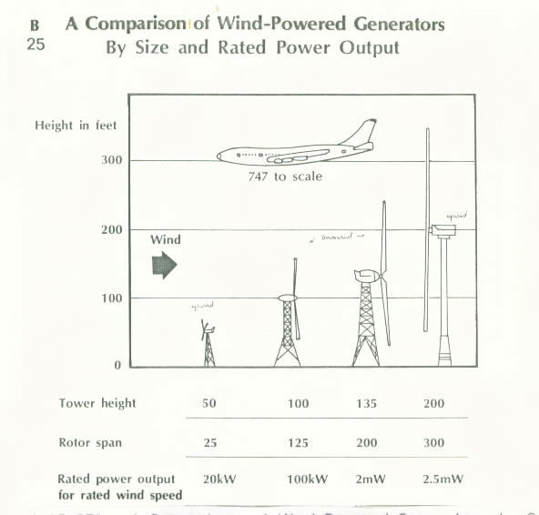

Answer the following questions, using the picture above:

1. What two factors most effect the amount of energy that a wind powered generator can produce?
2. What assumption can you make concerning wind speed and the height a tower is above the ground? In other words, as the tower height increases above the ground, what happens to the wind speed?
3. Is the relationship between wind speed to height above the ground the same as the relationship between wind speed and elevation? Support you answer.