Cell Division: Mitosis

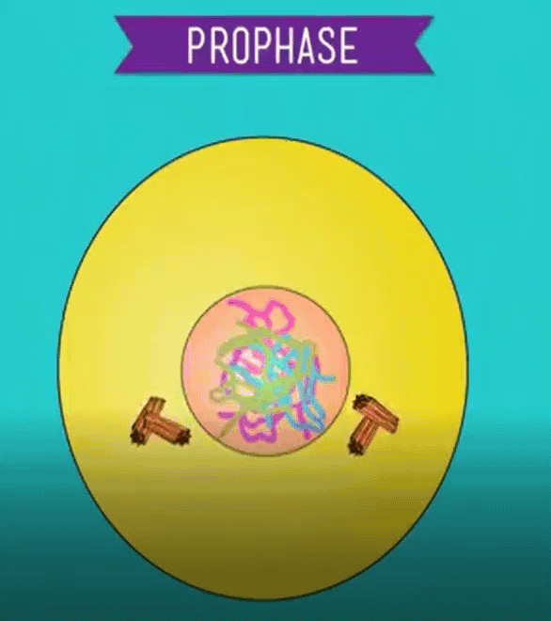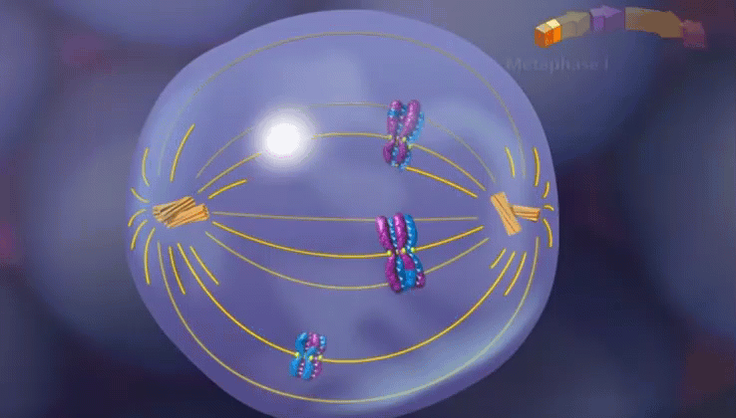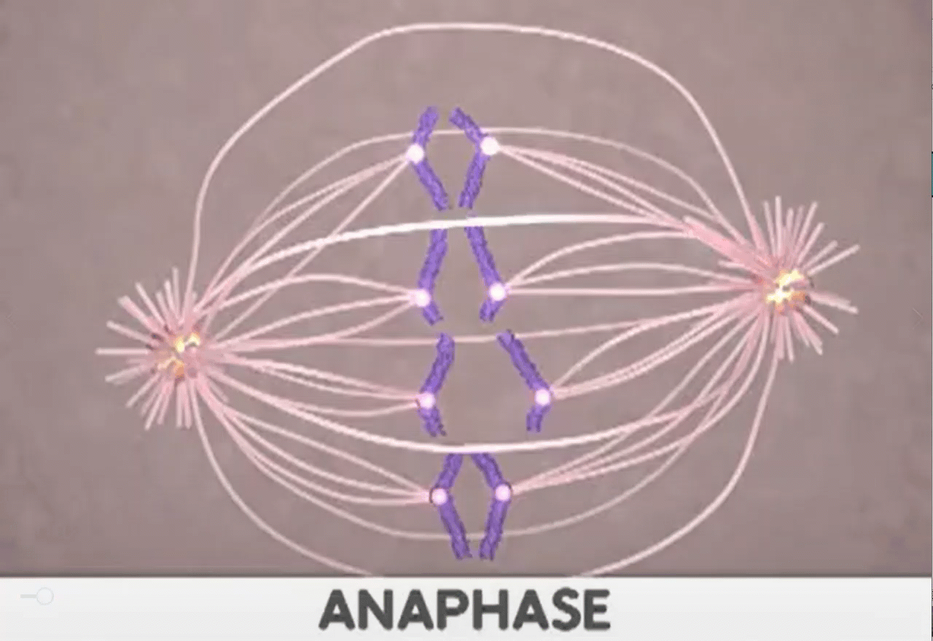

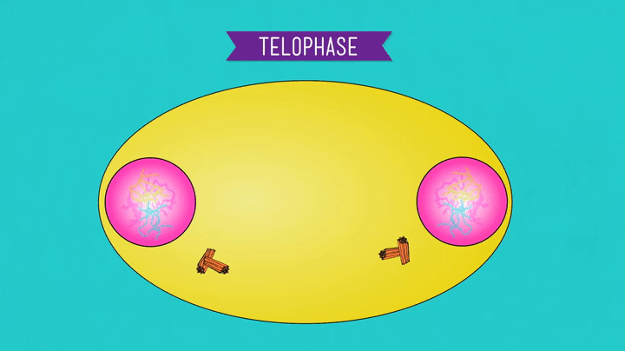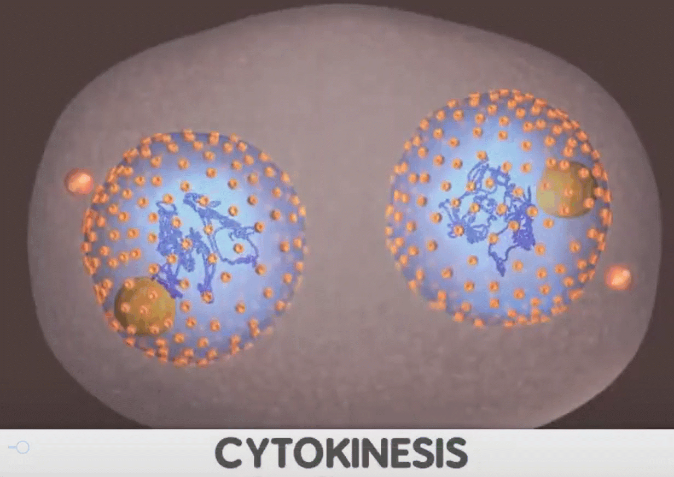

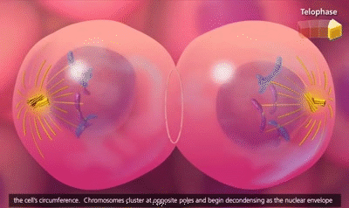

See https://www.learningctronline.com/courses for Materials and Resources.

Topics:
- Mitosis

Objectives:
- Discuss the biological process of asexual cell division, called mitosis.
- Review the theory of spontaneous generation and how it was disproved.
- Review the Theory of Biogenesis.
- Investigate the process of DNA replication.
- Learn how DNA is packaged in the cell at various stages.
- Discuss, identify, and describe the events of the cell cycle related to cell division.

TAKE NOTE

- Test Corrections (due before next week’s class)

- Notes/Study Guide Mitosis (1 week)

- Homework from Text

- Lab Mitosis (Onion Root Tip)

- Honors Include pictures in the lab.

- Week 11 Devotional (https://www.learningctronline.com/devotional)

Text: Chapter 10: Mitosis pp. 174 – 195

Read the assigned pages in the text.

Class Notes: PowerPoint or PDF

Notes/Study Guide: Fill in the Chapter 10 Study Guide worksheet to understand the class notes.

Homework: (1 week)
- Study Questions (end of the chapter in the text) #1-2, 4-6; 10-18 (explain true/false),

- Use a Word document format as follows:

  - Heading: Your name, Chapter in Text, Study Questions
  - Number the appropriate questions you are to answer
  - Write the answer in a complete sentence use the question as the template (do not copy the question, but reword it into a statement that answers the question).

- Use the same document each week by starting a new “Study Question” for a different chapter on the next page.

- Assignments will be “spot checked” during class or submitted via email.
Lab: Mitosis (Onion Root Tip)
- Complete the "Mitosis" lab using the lab worksheet provided. The following video shows the lab:
  - http://somup.com/c3fXDcObaA (3:41) Mitosis Lab (Onion Root Tip)

- After completing the Lab worksheet, email it to learningctronline@gmail.com for grading.

- Save document into your LAB folder in the Biology folder on your desktop.

TEST: No Quiz this week

Supplemental Resources (Optional)
http://somup.com/c3fXDcObaA (3:41) Mitosis Lab (Onion Root Tip)

http://somup.com/c3fXD1Obz6 (1:46) Mitosis Overview

https://youtu.be/f-ldPgEfAHI (8:26) The Amoeba Sisters Channel – Mitosis

http://somup.com/c3fl0nOqmy (1:19) Binary Fission

http://somup.com/c3fl0hOqmJ (2:08) DNA Replication Animation

http://somup.com/c3fl0wOqHP (5:46) DNA Replication (Mitosis)

