**Introduction**

**Purpose** To investigate the concepts of density, area, volume, percent error and precision.

**Discussion**

Measurement is the basis of valid scientific discovery, principles and laws. Two crucial components of measurement are accuracy and precision. There is always a degree of uncertainty in measurement because measurement depends on the skill and carefulness of the person and the limitations of the instruments.

Generally, accuracy refers to the measurer while precision to the instrument used to measure. Young scientists must learn accuracy in their measuring techniques, indicating how close their measurement is to the accepted value. For instance, when reading the volume of water in a graduated cylinder, the student does not read the “meniscus,” but rather the top of the water line. This shows inaccuracy of measurement. When one measures a calibrated length and their measurement does not match the calibration, this is inaccuracy.

Scientists must also utilize precision based on the reliability or reproducibility of a measurement. Usually, the more decimal places that an instrument can measure, the more precision the instrument exhibits. For example, one can measure a floor tile to the nearest meter, decimeter, centimeter or even millimeter using a meter stick. The millimeter calibration yields the most precise measurement.

Percent error is a mathematical way of showing accuracy and precision.

% Error = observed value - accepted value x 100%

accepted value

**Hypothesis**

If various measurements are made, then accuracy and precision can be practically applied.

**Materials** Metric Ruler Meter Stick Plastic Cube

Aluminum Cylinder Bronze Cylinder Calculator

Spring Scale Triple Beam Balance Electronic Scale

### Procedures & Calculations

1. Determine the area and the volume of your room (nearest 0.1 m).
2. Measure the length of the room (longest wall).
3. Measure the width of the room (opposite wall of length).
4. Record area to the nearest tenth of a square meter. (Show Work)
5. Measure the height of the room.
6. Record volume to the nearest tenth of a cubic meter. (Show Work)
7. Determine the total surface area and the volume of the plastic cube to the nearest tenth of a centimeter.

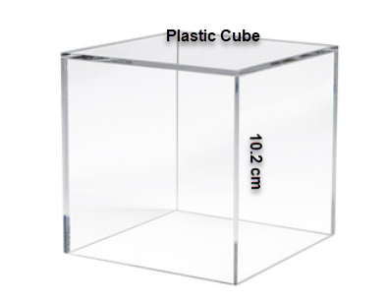

1. Determine which measurement is most precise? Explain. The mass of the bronze cylinder is found to be: 2.9 Kg using a spring scale (*to the nearest gram*), 2950.2 g using a triple beam balance (*to the nearest 0.1 g*), and 2949.30 g using an electronic balance (*to the nearest 0.01g*).
2. Determine the volume of the bronze cylinder without using water displacement techniques (nearest 0.1 cm3).

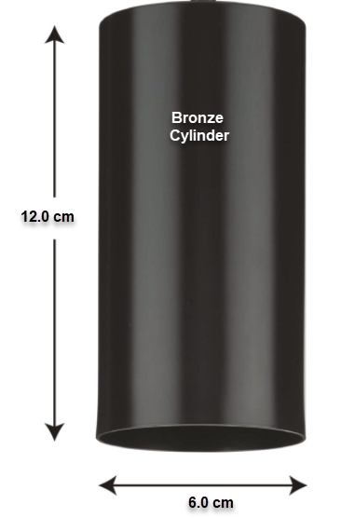

### 

1. Determine the density of the bronze cylinder from your measurements (use precision of the measurements in the answer).

### 

### Conclusions and Questions

1. Do you feel that your area and volume measurements were accurate? Explain and support your answer.

2. Distinguish between precision and accuracy.

3. Which instrument used to measure mass in this lab indicated the greatest precision? Explain your answer.

4. What mathematical venue indicates accuracy and precision?

5. In an experiment to determine the normal boiling point of water at 1 atmosphere of pressure, students’ results consistently averaged 91 ºC. What was their percent error? Does this indicate inaccuracy or lack of precision? Explain your answer.

6. A student was asked to find the area of the floor of a room. A contractor had built the room with 100 m2. The student determined the room at 120 m2. Does this indicate inaccuracy or lack of precision? Explain your answer.

r

Volume of a cylinder 🡪 πr2h

h

### Procedures & Calculations

1. Determine the area and the volume of your room (nearest 0.1 m).
2. Measure the length of the room (longest wall). **4.2 m**
3. Measure the width of the room (opposite wall of length). **3.4 m**
4. Record area to the nearest tenth of a square meter. (L x W) **4.2 m x 3.4 m = 14.3 m2**
5. Measure the height of the room. **3.7 m**
6. Record volume to the nearest tenth of a cubic meter. (L x W x H)

**4.2 m x 3.4 m x 3.7 m = 52.8 m3 = 53 m3 = 5.3 x 101 m3**

1. Determine the total surface area and the volume of the plastic cube to the nearest tenth of a centimeter.



Surface area (L x W x # sides):

10.2 cm x 10.2 cm x 6 sides = 624.24 cm2 = **624 cm2**

or 6.24 x 102 cm2

Volume (L x W x H):

10.2 cm x 10.2 cm x 10.2 cm = 1061.2 cm3 = **1060 cm3**

or 1.06 x 103 cm3

1. Determine which measurement is most precise? Explain. The mass of the bronze cylinder is found to be: 2.9 Kg using a spring scale (*to the nearest gram*), 2950.2 g using a triple beam balance (*to the nearest 0.1 g*), and 2949.30 g using an electronic balance (*to the nearest 0.01g*).

**The most precise measurement is the electronic balance because it measures to the nearest 0.01 g.**

1. Determine the volume of the bronze cylinder without using water displacement techniques (nearest 0.1 cm3).



πr2h = (3.14)(3.0 cm)2(12.0 cm) = 339.0 cm3 = **340 cm3** or 3.4 x 102 cm3

1. Determine the density of the bronze cylinder from your measurements (use precision of the measurements in the answer).

### D = m/V = 2949.30 / 339.0 cm3 = 8.700 g/cm3

**Calculations and Data**

* 1. Compare your results with other students.
  2. You determined the density of the bronze cylinder to be 8.3 g/cm3. Calculate the percent error of your density determination using the accepted value of bronze.

% Error = observed value - accepted value x 100%

accepted value

**% Error = (8.7 cm3 – 8.3 cm3) / 8.7 cm3 x 100% = 4.6 % error**

### Conclusions and Questions

1. Do you feel that your area and volume measurements were accurate? Explain and support your answer.

***Usually, students are inaccurate in their measurements. For instance, some students measured one floor tile and counted floor tiles rather than measuring the length of the room.***

2. Distinguish between precision and accuracy.

***Precision usually refers to the instrument while accuracy usually refers to the person doing the measuring. When a thermometer measures water’s boiling point at 92 C rather than 100 C at STP, this is an imprecise thermometer. When a student misreads the temperature, that is inaccuracy.***

***Precision refers to the decimal place in a measurement. For instance, 1.00 g is more precise than 1.0 g.***

3. Which instrument used to measure mass in this lab indicated the greatest precision? Explain your answer.

***The electronic balance indicated the greatest precision because it measured to the nearest 0.01 g versus the triple beam balance (nearest 0.1 g) and the spring scale (nearest 1 g) .***

4. What mathematical venue indicates accuracy and precision?

***Percent Error indicates accuracy and precision in measurement.***

5. In an experiment to determine the normal boiling point of water at 1 atmosphere of pressure, students’ results consistently averaged 91 ºC. What was their percent error? Does this indicate inaccuracy or lack of precision? Explain your answer.

***% error = (actual - observed) / actual x 100 %***

***(100 C – 91 C) / 100 C x 100 % = 9 percent error***

***This most likely indicates a lack of precision since the measurements are so far off. It is possible that the student measured inaccurately. The boiling point of water at 1 atmosphere of pressure is 100 C. For a temperature reading of 91 C probably indicates using an “immersion” thermometer rather than a normal thermometer.***

6. A student was asked to find the area of the floor of a room. A contractor had built the room with 100 m2. The student determined the room at 120 m2. Does this indicate inaccuracy or lack of precision? Explain your answer.

***The fact that the student was 20 m2 off in his/her measurement probably indicates inaccuracy. Precision would have been indicated by a different decimal place in the measurement.***