**Work, Power, Simple Machines Chapter 14A**

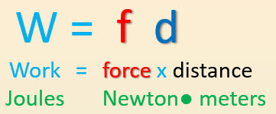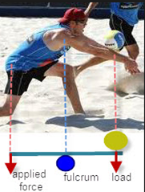

**See** [**https://www.learningctronline.com/courses**](https://www.learningctronline.com/courses) **for Materials and Resources.**

**Topics:**

1. Work, Power, Simple Machines

**Objectives:**

* Define and calculate Work as the force applied to an object over a specific distance (W = f d) in units of joules.
* Understand how work relates to Potential Energy (mgh) and Kinetic Energy (½ mv2).
* Define and calculate Power as the amount of work done per unit of time (P = W/t) in units of Watts.
* Classify the six simple machines

TAKE NOTE

1. Guided Reading Note-Taking Worksheet (Pearson Text) [2 weeks]
2. Pearson Concepts in Action Worksheets
3. Lab Work Activity
4. Lab Classes of Levers
5. Lab Simple Machines (Part 1)
6. Class Song: Let's Get Down to Business Study to show yourself approved unto God.
7. Week 23 Devotional (<https://www.learningctronline.com/devotional>)

**Text**: Chapter 14: Work, Power, Simple Machines pp. 410-420; 427-434

**Guided Reading Note-Taking Worksheet:**

Complete the worksheet for Chapter 14: Work, Power, Simple Machines (14.1 & 14.4).

**Class Notes: PowerPoint or PDF**

**Homework**:

* 14.1 Work & Power Worksheet (Pearson Concepts in Action)
* 14.4 Simple Machines Worksheet (Pearson Concepts in Action)
* Assignments will be “spot checked” during class or submitted via email.

**Lab**: Work Activity

* Complete the activities using the worksheet provided.
* Save the documents into your LAB folder in the Physical Science folder on your desktop.

**Lab**: Classes of Levers Activity

* Complete the activities using the worksheet provided.
* BONUS 🡪 Watch the video: <http://somup.com/cYfT2CiyTE> (6:03). Identify the various kinds of simple machines that are in the cartoon.
* Save the documents into your LAB folder in the Physical Science folder on your desktop.

**Lab**: Simple Machines

* Perform the procedures for part 1 only (inclined plane).
* Complete the worksheet provided for part 1.
* Save the documents into your LAB folder in the Physical Science folder on your desktop.
* *Assignments will be “spot checked” during class or submitted via email.*

**TEST:** The test will be given after next week’s lesson.

Supplemental Resources (Optional)

<http://somup.com/cFX2bhniR8> Work & Power Song (3:30)

<http://somup.com/cFX2bQniR9> Work & Power Hockey (5:03)

<http://somup.com/cFX2qNniWH> Simple Machines Overview (3:02)

<http://somup.com/cYfT2CiyTE> Bugs Bunny Barber of Seville Classes of Levers (Simple Machines) (6:03)

<http://somup.com/cFX2qRniWs> Wheel & Axle & Pulleys (2:16)

<http://somup.com/cYhFFVjyBA> Set Our Hope on God 1 Timothy 6:9,17; I Want to Know You More (5:00)