Student Projects Chapter 11-21

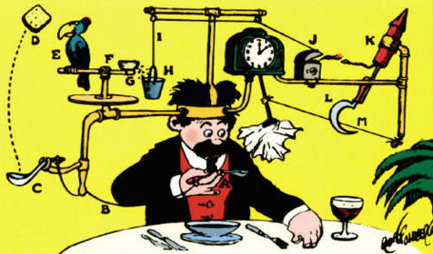

See https://www.learningctronline.com/courses for Materials and Resources.

Topics:
1. Student Projects

Objectives:
- Participate in a project-based, independent study, learning unit as a review of one major concept from 2nd semester.
- Use class notes, labs, homework, textbook, internet, and other resources to research ideas to create a lab experience based on Motion, Newton’s Laws, Simple Machines, Electricity, Sound, or Light.
- Submit a report of the project that includes all elements of a formal lab report.

TAKE NOTE

- Project Ideas Rubric

- Final Project Ideas

- Final Project Report Template

- Class Song: Riesen Knows Best (Students wrote this!)

- Week 31 Devotional (https://www.learningctronline.com/devotional)

Text: Chapters 11 – 21 (excluding Chapter 13)

Guided Reading Note-Taking Worksheet: None
Class Notes: none

Homework:
- Work on Project

Lab: Final Project Report (use template worksheet)

TEST: Project Presentation (bonus) or submit project.

Supplemental Resources (Optional)

- Watch “Student Showcase” videos on Learning CTR Online.
  - How Far We’ll Go – A Tribute to Mr. Riesen
  - Rube Goldberg Machine (2:40 JW)
  - Volleyball

http://somup.com/c3602PvZGR Household Items Machines Project (2:52)

http://somup.com/cFh3oGVHqy Simple Machines Water Wheel CG (1:28)

http://somup.com/cFXD2ynjFm Revenge of the Trebuchet RM Simple Machines (2:24)

http://somup.com/cFXD2anjFH Rube Goldberg Apparatus BF Simple Machines (2:02)

https://screencast-o-matic.com/watch/cFhibFbOgb Electric Circuits LR Electricity (3:09)

http://somup.com/cFhjrZVGCT Newton's Laws in Volleyball JS Newton's Laws (1:49)

http://somup.com/cFXD2BnjFd The Pressure Cooker AS Simple Machines (2:48)

http://somup.com/cFXD2CnjF7 Clock Killer LB Simple Machines (3:15)

http://somup.com/cFh2qrVmrp Simple Machines AH (1:25)

http://somup.com/cFXD2JnjFP The Dog Ate My Homework - Simple Machines HH (1:21)

http://somup.com/cFXD2KnjFR Wonderful, Wonderful Grace BR Song Sound (3:17)

http://somup.com/cqeZVmnO1s Parable of the Sower (3:04)

