1. A high school athlete runs 1.00 x 10² m in 12.20 s. What is the velocity in m/s and km/h?

2. A person walks 13 km in 2.0 h. What is the person’s average velocity in km/h and m/s?

3. Suppose a car travels at a constant 10 m/s. How far would it move in 1 hour? In 1 minute? In 1 second? In 1 millisecond? In 1 microsecond? In 1 nanosecond?

4. A train leaves the station at the 0.0 m marker traveling with a constant velocity of 36.0 m/s.
a. How many seconds later will the train pass the 1620.0 m marker?
b. What is the velocity of the train in km/h?

5. At 1:00 p.m. a car, traveling at a constant velocity of 94 km/h toward the west, is 17 km to the west of your school. Where will it be at 3:30 p.m.?

6. Describe in your own words the motion of the four walkers shown in the four curves in the figure to the right. Assume the positive direction is east and the reference point is the corner of High Street.
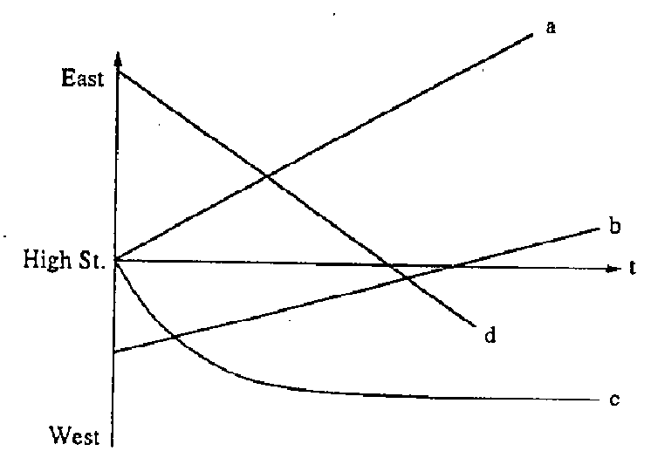

7. Sketch position-time graphs for these four motions:
a. starting at a positive position with a positive velocity
b. starting at a negative position with a smaller positive velocity
c. remaining at a negative position
d. starting at a positive position with a negative velocity.

8. Draw a position-time graph of a moving elevator. Use the first floor as reference point and up as positive. The elevator waits on the first floor for 30 s, rises to the third floor in 20 s, where it stops for 30 s, before going to the basement, which it reaches in 40 s.
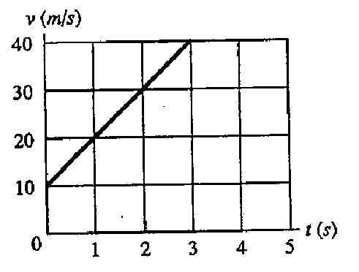
9. The figure on the right is the velocity-time graph of an object. . What is its velocity at:
a. 0 second?
b. 1 second?
c. 2 seconds?

10. Using the previous graph, describe how the instantaneous velocity changes with time.

11. Sketch velocity-time graphs for the position-time graphs in the figure below.
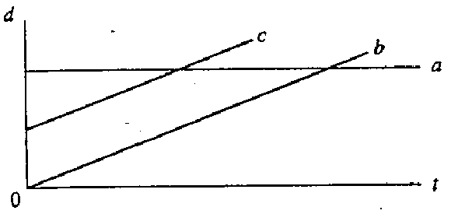
12. A car moves along a straight road at a constant velocity of +75 km/h for 4.0 hours, stops for 2.0 hours, and then drives in the reverse direction at the original speed for 3.0 hours. Plot a velocity-time graph for the car.

13. From the reference frame of a stationary observer, a car, traveling at a constant speed of 92 km/h, is passed by a truck moving at 105 km/h.
a. From the point of view of the car, what is the truck’s speed?
b. From the point of view of the truck, what is the car’s speed?

14. While John is traveling along a straight interstate highway he noticed that the mile marker reads 260. John traveled until he reached the 150 mile marker and then retraced his path to the 175 mile marker. What is the magnitude of John’s resultant displacement from the 260 mile marker?

15. A physics book is moved once around the perimeter of a table of dimension 1.0 m by 2.0 m.
a. If the book ends up at its initial position, what is its displacement?
b. What is the distance traveled?

16. Light from the sun reaches Earth in 8.3 min. The speed of light is 3.00 x 10⁸ m/s. How far is Earth from the sun?

17. You and a friend each drive 50 km. You travel at 90 km/h and your friend at 95 km/h. How long will your friend wait for you at the end of the trip?

18. Ann is driving down a street in a car at 55 km/h. Suddenly a child runs into the street. If it takes Ann 0.75 s to react and apply the brakes, how many meters will she have moved before she begins to slow down?

19. You drive a car 2.0 hours at 40 km/h, then 2.0 hours at 60 km/h.
a. What is your average velocity?
b. Do you get the same answer if you drive 100 km at each of the two speeds above?

1. A high school athlete runs 1.00 x 10² m in 12.20 s. What is the velocity in m/s and km/h?

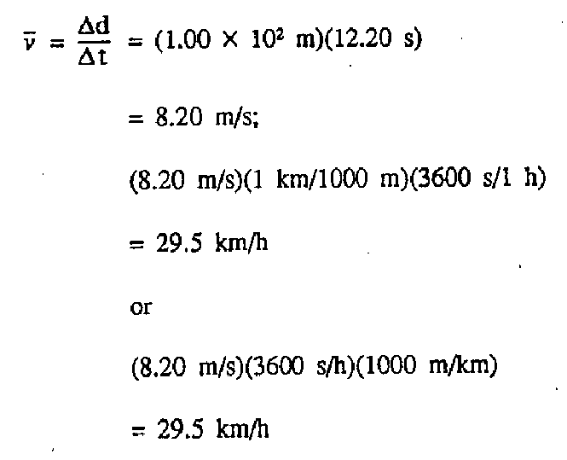
2. A person walks 13 km in 2.0 h. What is the person’s average velocity in km/h and m/s?

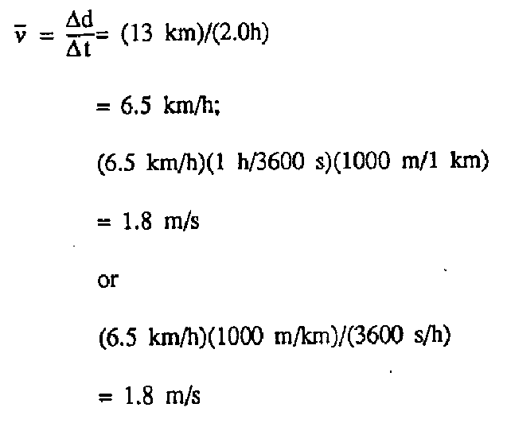

3. Suppose a car travels at a constant 10 m/s. How far would it move in 1 hour? In 1 minute? In 1 second? In 1 millisecond? In 1 microsecond? In 1 nanosecond?

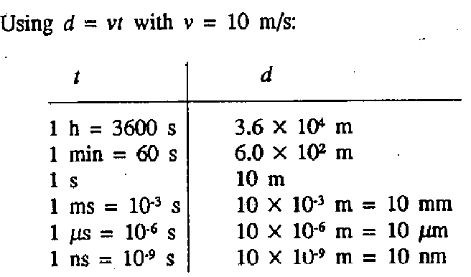

4. A train leaves the station at the 0.0 m marker traveling with a constant velocity of 36.0 m/s.
a. How many seconds later will the train pass the 1620.0 m marker?

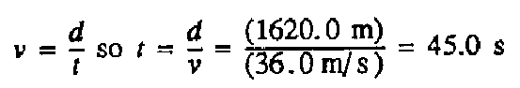

b. What is the velocity of the train in km/h?

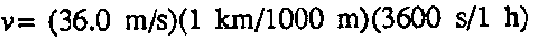
130. km/h

5. At 1:00 p.m. a car, traveling at a constant velocity of 94 km/h toward the west, is 17 km to the west of your school. Where will it be at 3:30 p.m.?

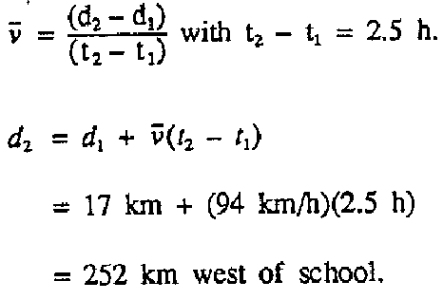

6. Describe in your own words the motion of the four walkers shown in the four curves in the figure below. Assume the positive direction is east and the reference point is the corner of High Street.

ANSWER:
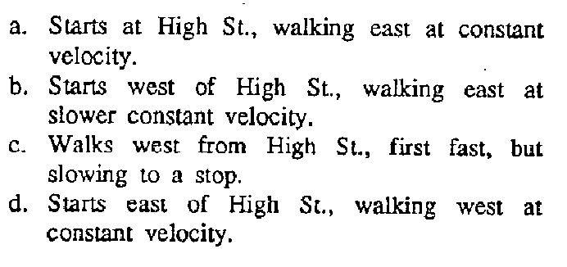

7. Sketch position-time graphs for these four motions:
a. starting at a positive position with a positive velocity
b. starting at a negative position with a smaller positive velocity
c. remaining at a negative position
d. starting at a positive position with a negative velocity.

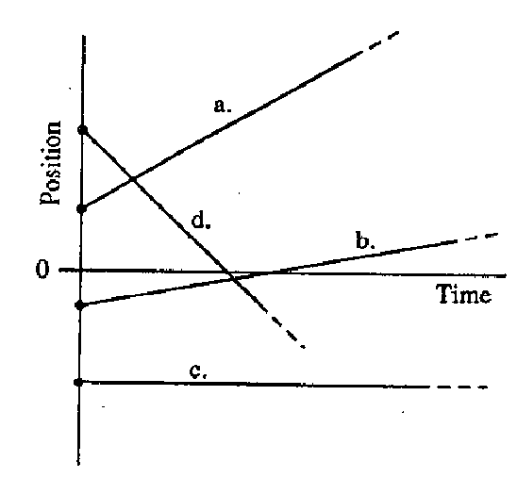

8. Draw a position-time graph of a moving elevator. Use the first floor as reference point and up as positive. The elevator waits on the first floor for 30 s, rises to the third floor in 20 s, where it stops for 30 s, before going to the basement, which it reaches in 40 s.

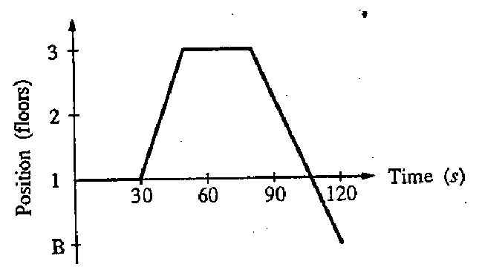

9. The figure on the right is the velocity-time graph of an object. What is its velocity at
a. 0 second? 10 m/s

b. 1 second? 20 m/s

c. 2 seconds? 30 m/s

10. Using the previous graph, describe how the instantaneous velocity changes with time.

Each second it increases 10 m/s.

11. Sketch velocity-time graphs for the position-time graphs in the figure below.
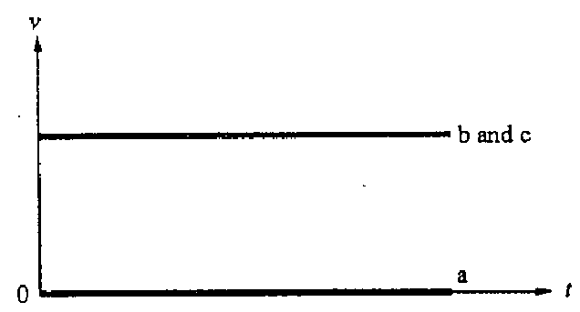
ANSWER:

12. A car moves along a straight road at a constant velocity of +75 km/h for 4.0 hours, stops for 2.0 hours, and then drives in the reverse direction at the original speed for 3.0 hours.

Plot a velocity-time graph for the car.
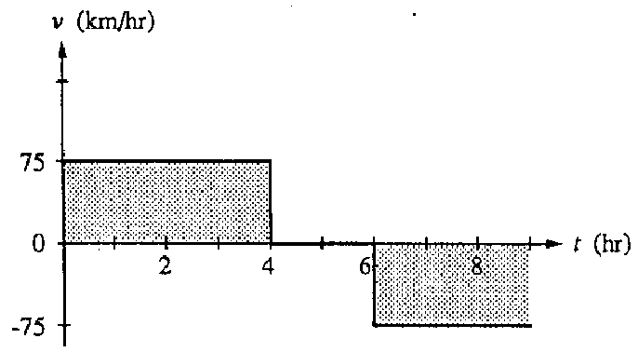

13. From the reference frame of a stationary observer, a car, traveling at a constant speed of 92 km/h, is passed by a truck moving at 105 km/h.

a. From the point of view of the car, what is the truck’s speed?
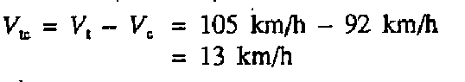

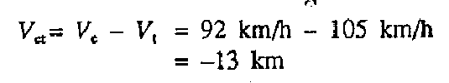
b. From the point of view of the truck, what is the car’s speed?

14. While John is traveling along a straight interstate highway he noticed that the mile marker reads 260. John traveled until he reached the 150 mile marker and then retraced his path to the 175 mile marker. What is the magnitude of John’s resultant displacement from the 260 mile marker?

15. A physics book is moved once around the perimeter of a table of dimension 1.0 m by 2.0 m.
a. If the book ends up at its initial position, what is its displacement?

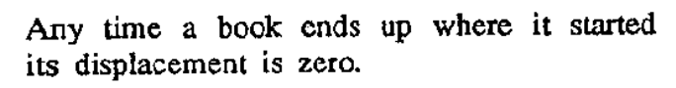

b. What is the distance traveled?

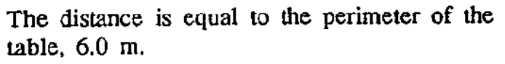

16. Light from the sun reaches Earth in 8.3 min. The speed of light is 3.00 x 10⁸ m/s. How far is Earth from the sun?

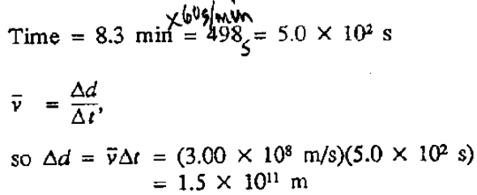

17. You and a friend each drive 50 km. You travel at 90 km/h and your friend at 95 km/h. How long will your friend wait for you at the end of the trip?

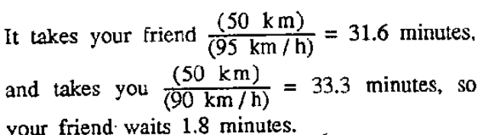

18. Ann is driving down a street in a car at 55 km/h. Suddenly a child runs into the street. If it takes Ann 0.75 s to react and apply the brakes, how many meters will she have moved before she begins to slow down?

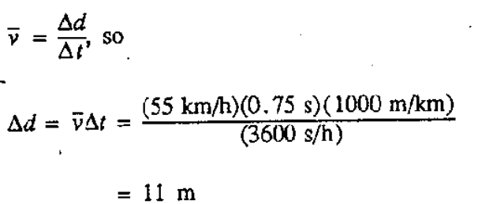

19. You drive a car 2.0 hours at 40 km/h, then 2.0 hours at 60 km/h.
a. What is your average velocity?

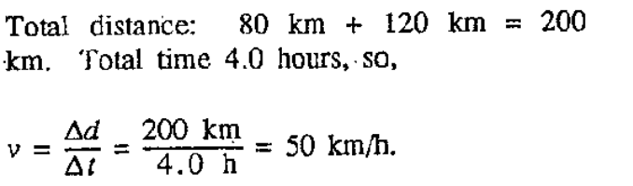

b. Do you get the same answer if you drive 100 km at each of the two speeds above?

