Heading

**Introduction**

**Purpose**

Observe and calculate variables of parabolic trajectory as part of projectile motion when launching an object at a non-horizontal angle from a height.

**Discussion**

Whenever motion is not strictly horizontal or vertical as shown in the diagram below, vector components are needed to resolve angles, distances, and velocity.

For the canon ball trajectory shown below, if we know the initial velocity component, Vi, we can calculate the horizontal and vertical component velocities of the canon.

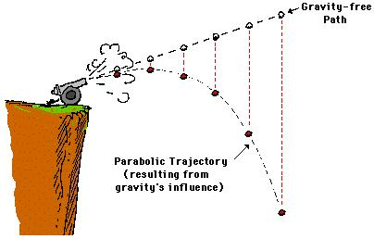



**vi**

**θ**

**vx**

**Vy**

**Vy**

The initial vertical velocity component, **Vy**, can be calculated using: sin θ = Vy / Vi. Therefore, **Vy = Vi sin θ**.

The initial horizontal velocity component, **Vy,** uses cos θ = Vx / Vi. Therefore,rearrange to **Vx = Vi cos θ**.

The total **time of the object’s trajectory** (from launch to hitting the ground) can be calculated using the y component (which is independent of the x component in terms of the object rising and falling vertically). This can be done by using the vertical displacement equation as follows:

dy = y0 + Vyt + ½gt2 🡪 dy = 0 since the cannon is resting on the cliff.y0 = height of the cliff.

Rearrange: 0 = (-4.9)t2 + Vyt + y0 … so now the quadratic equation can be used to solve for t:

**t = [-b +/-√([(b2 – 4ac)] / 2a)**

The total time of the launch (cannonball launched until it hits the ground) can be used to determine the **horizontal distance that a projectile travels** when a trajectory begins at an angle above horizontal (*as shown above*). The equation: dx = **x0 +** Vxt + ½gt2 can be reduced, since, there is no vertical component when dealing strictly with the horizontal component, gravity (g) is not a factor. Therefore, **dx = Vxt**.

HONORS

When an object is projected from a height and at an angle, the **total** **vertical distance** it falls from its highest point can be calculated using two equations. The first: **Vf = Vi + at** is a rearrangement of acceleration, which is change in velocity over time.This equation will give the **TIME** it takes for the cannonball to leave the cannon and reach its highest point in the trajectory. Vf is the velocity at the highest point of the trajectory, which equals 0 because the cannonball will stop momentarily before beginning to free fall. Therefore, the equation becomes 0 = Vi + gt where g is gravity (-9.8 m/s2). Rearranging the equation: **t = Vi/g**.

The second equation: **dy = y0 + Vyt + ½gt2** will calculate the total distance the cannonball falls from its highest point in the trajectory (y component) using the TIME previously determined (t = Vi/g). y0 is the height of the object (on the cliff) before launch.

**Hypothesis**

If a projectile is launched from a non-horizontal position from a height, then the measured trajectory angle, velocities, times, and distances can be confirmed using trigonometry.

**Materials**

PHET Simulation <https://phet.colorado.edu/en/simulation/projectile-motion>

**Procedures**

1. Click on the “Intro” simulation.

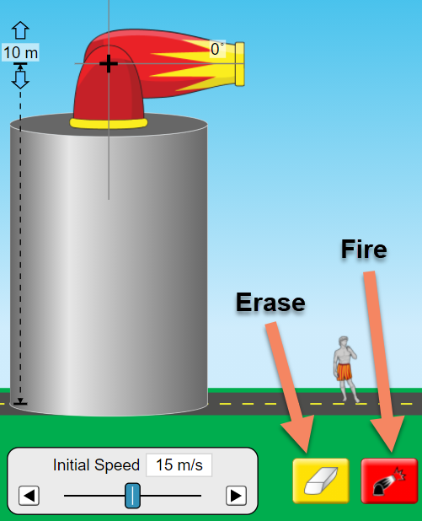

2. Set the initial speed to 12 m/s.

3. Choose the cannonball as the object to launch.

4. Use the target icon to measure the horizontal distances (dx).

5. Use the tape measure to measure the vertical distances (dy) from the highest “dot”.

6. Complete the data table using the simulation.

|  |  |  |
| --- | --- | --- |
| Trajectory | Measured  Horizontal Distance  dx | Measured  Vertical Distance  dy |
| 15° |  |  |
| 30° |  |  |
| 45° |  |  |
| 60° |  |  |
| 75° |  |  |

Since we know the initial launch speed, Vi, we can calculate the horizontal vector components of speed, distance, and time as well as the vertical vector components.

**Calculations and Data**

VERTICAL Vector components

1. Copy the values of the measured vertical distance, dy, from the data table (Procedures) into the “Vertical Components” data table below.

2. Calculate the **vertical launch velocity**, Vy, for EACH ANGLE of trajectory, using the equation: Vy = Vi sin θ. Add these values to the “Vertical Components” data table. Show Work for two velocities. HONORS show work for each angle.

Vy = Vi sin 15° 🡪

Vy = Vi sin ?° 🡪

Vertical Components

|  |  |  |  |
| --- | --- | --- | --- |
| Trajectory | Measured Vertical Distance  dy | **Calculated Vertical Velocity**  **Vy** | **Calculated Total Time of Launch**  **t** |
| 15° |  |  |  |
| 30° |  |  |  |
| 45° |  |  |  |
| 60° |  |  |  |
| 75° |  |  |  |

3. Use the INITIAL vertical velocity to calculate the total **TIME** of launch of the cannonball at EACH ANGLE of trajectory by inserting that time into: dy = y0 + Vyt + ½gt2 where dy = 0 because the canon rests on the cliff. y0 is the cliff height where the cannon rests above the ground where the cannonball falls to.

The displacement equation rearranges to 0 = ½gt2 + Vyt + 10 m. Substitute the actual values into 0 = -4.9t2 + Vyt + 10 m. Use the quadratic equation to solve for time.

**t = [-b +/-√[(b2 – 4ac)]/2a**. Show Work for two times (t) and record in the data table above. HONORS show work for each angle.

15° 🡪 t =

?° 🡪 t =

4. HONORS Calculate the vertical distance the object fell from its highest point, dy, at each angle of trajectory.

This requires calculating the time it takes for the cannonball to leave the cannon and reach its highest point in the air, using **Vf = Vi + at,** where Vf = 0 in the y direction. Rearrange the equation to: **t = Vi/g**.Show Work for at least two times and record in the data table below:

15° 🡪 t =

?° 🡪 t =

Next, insert the time (Vi/g) into the displacement equation: **dy = y0 + Vyt + ½gt2**.

Show Work for two distances and record in the data table below. HONORS show work for each angle.

15° 🡪 dy =

?° 🡪 dy =

Copy the values of the measured vertical distance, dy, and the calculated vertical velocity, Vi, from the data table (Vertical Components) into the data table below.

|  |  |  |  |  |
| --- | --- | --- | --- | --- |
| Trajectory | Measured Vertical Distance  dy | Calculated Vertical Velocity  Vy | **Calculated Time to Highest Point**  **t** | **Calculated Vertical Distance**  **dy** |
| 15° |  |  |  |  |
| 30° |  |  |  |  |
| 45° |  |  |  |  |
| 60° |  |  |  |  |
| 75° |  |  |  |  |

*Calculated values may be slightly off due to rounding.*

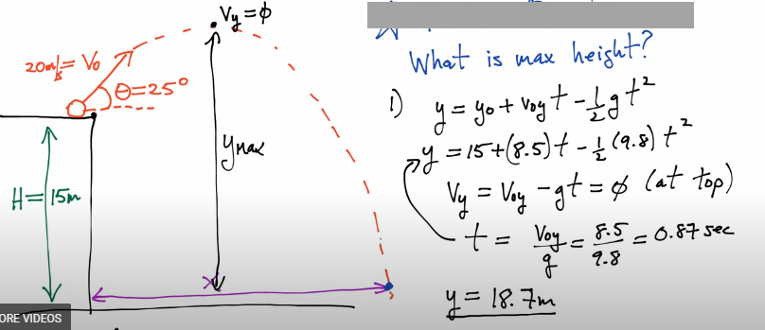

Horizontal Vector components

1. Copy the values of the measured horizontal distance, dx, from the Procedures data table into the table below. Also, copy the values of the calculated total time of launch, t, from the Vertical Components data table into the table below.

|  |  |  |  |  |
| --- | --- | --- | --- | --- |
| Trajectory | Measured Horizontal Distance  dx | **Calculated Vertical Velocity**  **Vx** | Calculated Total Time of Launch  t | **Calculated horizontal displacement dx** |
| 15° |  |  |  |  |
| 30° |  |  |  |  |
| 45° |  |  |  |  |
| 60° |  |  |  |  |
| 75° |  |  |  |  |

*Calculated values may be slightly off due to rounding.*

2. Calculate the horizontal launch velocity, Vx, for each angle of trajectory, using the equation: **Vx = Vi cos θ**. Add these values to the data table above. Show Work for two speeds. HONORS show work for each angle.

15° 🡪Vx =

30° 🡪Vx =

3. Using the measured horizontal distance the object travelled and the calculated time (from vertical distance fallen), calculate the horizontal distance, dx, using: **dx = Vx t**. Show Work for two displacements. HONORS show work for each angle.

15° 🡪dx =

30° 🡪dx =

**Conclusions and Questions**

1. Explain why one can use Vx = dx / t and Vy = ½ gt2 for certain measurements rather than the overall displacement equation for projectiles: d = d0 + Vit + ½ gt2.

2. Draw a diagram showing the projectile path of the object through its entire flight for ONE angle of trajectory in this experiment. Then, draw a vector diagram on it, labeling the launch velocity, Vi, and the horizontal and vertical displacements (dx and dy).

3. HONORS Explain why two times are needed to calculate the total vertical displacement of an object launched at an angle from a height.

Answers

**Procedures Part 1**



1. Click on the “Intro” simulation.

2. Set the initial speed to 12 m/s.

3. Choose the cannonball as the object to launch.

4. Use the target icon to measure the horizontal distances (dx).

5. Use the tape measure to measure the vertical distances (dy).

6. Complete the data table using the simulation.

|  |  |  |
| --- | --- | --- |
| Trajectory | Horizontal Distance  dx | Vertical Distance  dy |
| 15° | 20.5 m | 10.4 m |
| 30° | 22.4 m | 11.9 m |
| 45° | 21.5 m | 13.7 m |
| 60° | 17.0 m | 15.4 m |
| 75° | 9.4 m | 16.7 m |

VERTICAL Vector components

1. Copy the values of the measured vertical distance, dy, from the data table (Procedures) into the “Vertical Components” data table below.

2. Calculate the **vertical launch velocity**, Vy, for EACH ANGLE of trajectory, using using the equation: Vy = Vi sin θ. Add these values to the “Vertical Components” data table.

15° 🡪Vy = Vi sin 15° = (12 m/s)(sin 15°) = 3.1 m/s

30° 🡪Vy = Vi sin 30° = (12 m/s)(sin 30°) = 6.0 m/s

45° 🡪Vy = Vi sin 45° = (12 m/s)(sin 45°) = 8.5 m/s

60° 🡪Vy = Vi sin 60° = (12 m/s)(sin 60°) = 10.4 m/s

75° 🡪Vy = Vi sin 75° = (12 m/s)(sin 75°) = 11.6 m/s

Vertical Components

|  |  |  |  |
| --- | --- | --- | --- |
| Trajectory | Measured Vertical Distance  dy | **Calculated Vertical Velocity**  **Vy** | **Calculated Total Time of Launch**  **t** |
| 15° | 10.4 m | 3.1 m/s | 1.8 s |
| 30° | 11.9 m | 6.0 m/s | 2.2 s |
| 45° | 13.7 m | 8.5 m/s | 2.5 s |
| 60° | 15.4 m | 10.4 m/s | 2.8 s |
| 75° | 16.7 m | 11.6 m/s | 3.0 s |

3. Use the INITIAL vertical velocity to calculate the total **TIME** of launch of the cannonball at EACH ANGLE of trajectory by inserting that time into: dy = y0 + Vyt + ½gt2 where dy = 0 because the canon rests on the cliff. y0 is the cliff height where the cannon rests above the ground where the cannonball falls to.

The displacement equation rearranges to 0 = ½gt2 + Vyt + 10 m. Substitute the actual values into 0 = -4.9t2 + Vyt + 10 m. Use the quadratic equation to solve for time.

**t = [-b +/-√[(b2 – 4ac)]/2a**. Show Work for at least two times (t) and record in the data table above:

15° 🡪 t = [-(3.1) +/-√[(3.1)2 – 4(-4.9)(10)]]/2(-4.9) **=** 1.8 s

30° 🡪 t = [-(6.0) +/-√[[(6.0)2 – 4(-4.9)(10)]]/2(-4.9)] = 2.2 s

45° 🡪 t = [-(8.5) +/-√[(8.5)2 – 4(-4.9)(10)]]/2(-4.9) **=** 2.5 s

60° 🡪 t = [-(10.4) +/-√[[(10.4)2 – 4(-4.9)(10)]]/2(-4.9)] = 2.8 s

75° 🡪 t = [-(11.6) +/-√[(11.6)2 – 4(-4.9)(10)]]/2(-4.9) **=** 3.0 s

4. HONORS Calculate the vertical distance the object fell from its highest point, dy, at each angle of trajectory.

This requires calculating the time it takes for the cannonball to leave the cannon and reach its highest point in the air, using **Vf = Vi + at,** where Vf = 0 in the y direction. Rearrange the equation to: **t = Vi/g**.Show Work for at least two times and record in the data table below:

15° 🡪 t = Vi/g = 3.1 m/s / 9.8 m/s2 = 0.32 s

30° 🡪 t = Vi/g = 6.0 m/s / 9.8 m/s2 = 0.61 s

45° 🡪 t = Vi/g = 8.5 m/s / 9.8 m/s2 = 0.87 s

60° 🡪 t = Vi/g = 10.4 m/s / 9.8 m/s2 = 1.1 s

75° 🡪 t = Vi/g = 11.6 m/s / 9.8 m/s2 = 1.2 s

Next, insert the time (Vi/g) into the displacement equation: **dy = y0 + Vyt + ½gt2**. Show Work for at least two distances and record in the data table below:

15° 🡪 dy = y0 + Vyt + ½gt2 = 10 m + (3.1 m/s)(0.32 s) + (-4.9 m/s2)(0.32 s)2 = 10.3 m

30° 🡪 dy = y0 + Vyt + ½gt2 = 10 m + (6.0 m/s)(0.61 s) + (-4.9 m/s2)(0.61 s)2 = 11.8 m

45° 🡪 dy = y0 + Vyt + ½gt2 = 10 m + (8.5 m/s)(0.87 s) + (-4.9 m/s2)(0.87 s)2 = 13.7 m

60° 🡪 dy = y0 + Vyt + ½gt2 = 10 m + (10.4 m/s)(1.1 s) + (-4.9 m/s2)(1.1 s)2 = 15.5 m

75° 🡪 dy = y0 + Vyt + ½gt2 = 10 m + (11.6 m/s)(1.2 s) + (-4.9 m/s2)(1.2 s)2 = 16.9 m

Copy the values of the measured vertical distance, dy, and the calculated vertical velocity, Vi, from the data table (Vertical Components) into the data table below.

|  |  |  |  |  |
| --- | --- | --- | --- | --- |
| Trajectory | Measured Vertical Distance  dy | Calculated Vertical Velocity  Vy | **Calculated Time to Highest Point**  **t** | **Calculated Vertical Distance**  **dy** |
| 15° | 10.4 m | 3.1 m/s | 0.32 s | 10.3 m |
| 30° | 11.9 m | 6.0 m/s | 0.61 s | 11.8 m |
| 45° | 13.7 m | 8.5 m/s | 0.87 s | 13.7 m |
| 60° | 15.4 m | 10.4 m/s | 1.1 s | 15.5 m |
| 75° | 16.7 m | 11.6 m/s | 1.2 s | 16.9 m |

*Calculated values may be slightly off due to rounding.*

Horizontal Vector components

1. Copy the values of the measured horizontal distance, dx, from the Procedures data table into the table below. Also, copy the values of the calculated total time of launch, t, from the Vertical Components data table into the table below.

|  |  |  |  |  |
| --- | --- | --- | --- | --- |
| Trajectory | Measured Horizontal Distance  dx | **Calculated Vertical Velocity**  **Vx** | Calculated Total Time of Launch  t | **Calculated horizontal displacement dx** |
| 15° | 20.5 m | 11.6 m/s | 1.8 s | 20.9 m |
| 30° | 22.4 m | 10.4 m/s | 2.2 s | 22.9 m |
| 45° | 21.5 m | 8.5 m/s | 2.5 s | 21.6 m |
| 60° | 17.0 m | 6.0 m/s | 2.8 s | 17.0 m |
| 75° | 9.4 m | 3.1 m/s | 3.0 s | 9.4 m |

*Calculated values may be slightly off due to rounding.*

2. Calculate the horizontal launch velocity, Vx, for each angle of trajectory, using the equation: Vx = Vi cos θ. Add these values to the data table. Show Work for at least two speeds:

15° 🡪Vx = Vi cos θ = (12 m/s)(cos 15°) = 11.6 m/s

30° 🡪Vx = Vi cos θ = (12 m/s)(cos 30°) = 10.4 m/s

45° 🡪Vx = Vi cos θ = (12 m/s)(cos 45°) = 8.5 m/s

60° 🡪Vx = Vi cos θ = (12 m/s)(cos 60°) = 6.0 m/s

75° 🡪Vx = Vi cos θ = (12 m/s)(cos 75°) = 3.1 m/s

4. Using the measured horizontal distance the object travelled and the calculated time (from vertical distance fallen), calculate the horizontal distance, dx, using: **dx = Vx t**. Show work for at least two distances:

15° 🡪dx = Vx t **= (**11.6 m/s)(1.8 s) **=** 20.9 m

30° 🡪dx = Vx t= (10.4 m/s)(2.2 s) = 22.9 m

45° 🡪dx = Vx t= (8.5 m/s)(2.5 s) = 21.6 m

60° 🡪dx = Vx t= (6.0 m/s)(2.8 s) = 17.0 m

75° 🡪dx = Vx t= (3.1 m/s)(3.0 s) = 9.4 m

**Conclusions and Questions**

1. Explain why one can use Vx = dx / t and Vy = ½ gt2 for certain measurements rather than the overall displacement equation for projectiles: d = d0 + Vit + ½ gt2.

*The horizontal component does not include gravity so the ½ gt2 becomes 0. d0 relates to height from the ground (like a cliff) and the horizontal component is 0. Therefore,* ***dx = vxt***

*The total vertical component requires a complicated calculation because it includes not only the free fall from the cliff height, but the amount of height above the cliff. The vertical component does not include Vit when shot horizontally because the vertical component is 0. When objects free fall, the final distance is considered 0 since the object cannot fall further. The complete displacement equation must be used when an object is launched at an angle from a height (e.g. off a cliff).*

2. Draw a diagram showing the projectile path of the object through its entire flight for ONE angle of trajectory in this experiment. Then, draw a vector diagram on it, labeling the launch velocity, Vi, and the horizontal and vertical displacements (dx and dy).



**vi**

**θ**

**vx**

**Vy**

**Vy**

**dy**

**dx**

3. HONORS Explain why two times are needed to calculate the total vertical displacement of an object launched at an angle from a height.

Two times are needed to calculate the total vertical displacement of an object launched at an angle from a height because the vertical component has an initial upward movement, then the object momentarily stops, then it begins to fall. The first time relates to the time it takes the object to reach the highest point from launch. The second time relates to the time from its highest point to the ground.