**Projectile Motion**

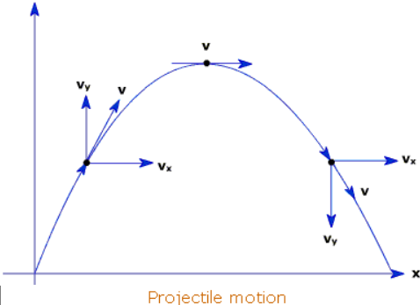

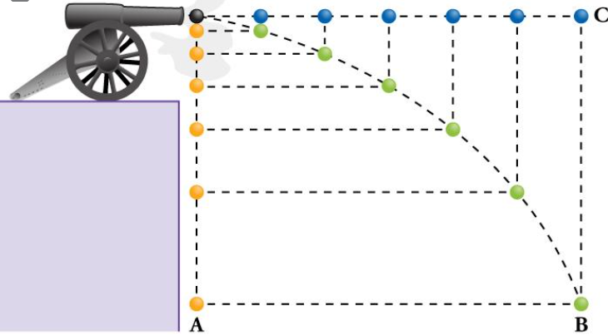

**See** [**https://www.learningctronline.com/courses**](https://www.learningctronline.com/courses) **for Materials and Resources.**

**Topics:**

1. Projectile Motion

**Objectives:**

* Identify five types of projectile motion.
* Resolve horizontal and vertical components of various projectiles (horizontal, upwardly launched).

TAKE NOTE

1. Reading (Hewitt Text)

1. Test Corrections due by next week’s class
2. Worksheet: Projectile Motion Vectors
3. Problem Set Projectiles (2 weeks)
4. Lab: Speed (Lab Report due in 2 days)
5. Lab: Projectiles Ball off table & Hang Time

1. Lab: PHET Simulation Projectiles
2. Lab: Projectile Motion
3. Quiz: Projectile Motion
4. HONORS / Extra Credit: Film Review October Sky (Projectiles)
5. Week 7 Devotional (<https://www.learningctronline.com/devotional>)

**Text**: Chapter 3: Projectiles Motion 3.1 – 3.5 (Hewitt)

**Class Notes:** **Use the Lab Documents**

**Homework**:

* Worksheet: Projectile Motion Vectors
* Problem Set Projectiles (2 weeks)

**Lab**: Projectiles, Ball off table & Hang Time

* Perform the lab as directed using the worksheet provided.
* Complete all calculations and data, showing work whenever appropriate.
* Conclusions should be answered in complete sentences that convey a complete thought.
* Save the documents into your LAB folder in the Physics folder on your desktop.

**Lab**: PHET Simulation Projectiles

* Perform the lab as directed using the worksheet provided.
* Complete all calculations and data, showing work whenever appropriate.
* Conclusions should be answered in complete sentences that convey a complete thought.
* Save the documents into your LAB folder in the Physics folder on your desktop.

**Lab**: Projectile Motion

* Perform the lab as directed using the worksheet provided.
* Complete all calculations and data, showing work whenever appropriate.
* Conclusions should be answered in complete sentences that convey a complete thought.
* Save the documents into your LAB folder in the Physics folder on your desktop.

**TEST:** Quiz Projectiles

1) the academic integrity policy

* Tests must be completed **WITHOUT** referring to books, notes, the internet, people, or any outside resources.
* Students **MAY** use the approved Periodic Tables, approved Reference Tables, or approved equation (formula) sheet (provided by the teacher) along with calculators and scratch paper.
* A guardian should be proctoring the test. Proctoring means to monitor the following:

2) Take the **"in one sitting"**, meaning that once you start the test, you must complete it without interruption.

3) There is a **20-minute time limit** on this test. Please have the proctor write the time taken at the top of your answer sheet with their signature or initials.

4) Proctors should NOT be reading the test or engaging students during the test.

5) Do NOT use RED font. Black font is best.

Supplemental Resources (Optional)

1. Paper Airplane Challenge

<http://somup.com/crhb2nF98I> Projectile Motion (5:49)