Momentum Chapter 7

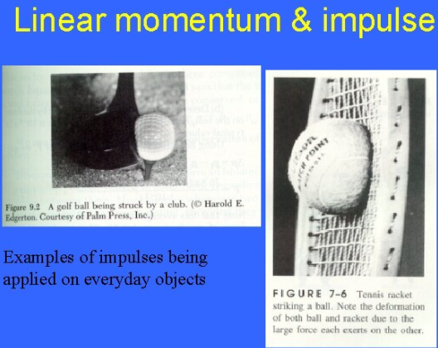

See https://www.learningctronline.com/courses for Materials and Resources.

Topics:
1. Momentum

Objectives:
- Identify and give examples of the components of momentum (mass, speed, direction) in the motion of objects.
- Calculate momentum involving elastic collisions and inelastic collisions while showing the conservation of momentum.
- Define impulse in terms of force, time, and change in momentum. Explain practical applications of impulse (e.g. sports).

TAKE NOTE (Assignments all 1 week)

- Reading (Hewitt Text)

- Momentum Impulse Worksheet

- Lab: Paper Football Activity

- Problem Set Momentum (1 week)

- Lab: Momentum & Collisions Part 1

- Lab: Momentum & Collisions Part 2

- Quiz Momentum

- Week 11 Devotional (https://www.learningctronline.com/devotional)

Text: Chapter 7 Momentum (Hewitt)

Class Notes: Use the Document provided

Homework:
- Worksheet: Momentum Impulse Worksheet
- Problem Set Momentum

Lab: Paper Football Activity

- Perform the lab as directed using the worksheet provided.
- Complete all calculations and data, showing work whenever appropriate.
- Conclusions should be answered in complete sentences that convey a complete thought.

- Save the documents into your LAB folder in the Physics folder on your desktop.
Lab: Momentum & Collisions Part 1

- Perform the lab as directed using the worksheet provided.
- Complete all calculations and data, showing work whenever appropriate.
- Conclusions should be answered in complete sentences that convey a complete thought.

- Save the documents into your LAB folder in the Physics folder on your desktop.
Lab: Momentum & Collisions Part 2

- Perform the lab as directed using the worksheet provided.
- Complete all calculations and data, showing work whenever appropriate.
- Conclusions should be answered in complete sentences that convey a complete thought.

- Save the documents into your LAB folder in the Physics folder on your desktop.

TEST: Quiz Momentum (Review)

There is a 20-minute time limit on the quiz.

Supplemental Resources (Optional)
- Momentum (Balls Colliding) Lab
- Momentum & Energy Problem Set (Basics)

http://somup.com/crhulUqDkV Inertia Ring (1:36)

http://somup.com/cYfT2diyOZ Momentum: Remember the Titans (1:29) Look for mv and direction.

https://screencast-o-matic.com/watch/cF6eodYlwS Elastic Collisions (0:56)

http://somup.com/cFXQqRniFE Conservation of Momentum (1:42) Elastic Collisions Using Newton's Cradle

http://somup.com/cYfTDqiyyO Conservation of Momentum (1:02) Inelastic Collision Using Motion Carts

https://screencast-o-matic.com/watch/cFXQqCYSEh (Bouncing Balls)
(go to 3:55 minute point in video of Newton’s Laws of Motion Demos)

https://screencast-o-matic.com/watch/cYfTYHAkLS Momentum of carts (2:15)

http://somup.com/cr1VFbqrkH Momentum & Collisions Lab Part 2 (4:45)

http://somup.com/cr1VYGqrMs Momentum & Impulse (5:20)

http://somup.com/crX62U3WSr Impulse (Watermelon) [2:28]

https://go.screenpal.com/watch/cOXhrqn4nIr Impulse (Breaking Blocks) [0:49]

