**Introduction**

**Purpose** To demonstrate the principle of work and its relationship to potential and kinetic energy.

**Discussion**

In science, **work** is the product of force and distance. The direction and motion of the force applied determines if work is done or not. A relationship exists between the force applied on an object and the distance that force operates.

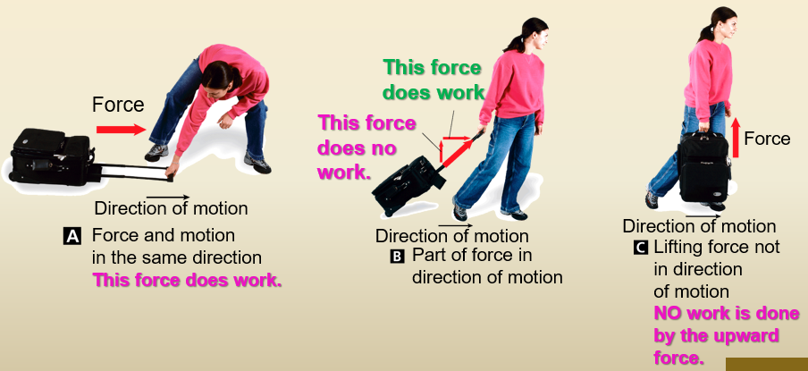

**Hypothesis**

If one drops an object, then the PE and KE can be compared from start to finish.

Rebound

distance

**Materials** Super Ball Meter stick

**Procedure**

1. Obtain a meter stick and a super ball.
2. Hold the meter stick vertically.
3. Hold the super ball at the top of the meter stick.
4. You will drop the super ball, allow it to rebound, and measure the distance of rebound to the nearest centimeter.
5. Drop the super ball for a total of five trials and calculate the average rebound distance.
6. Measure the mass of the super ball and then convert that mass into kilograms and Newtons.

**Calculations and Data**

|  |  |  |  |  |  |  |
| --- | --- | --- | --- | --- | --- | --- |
| Rebound Distance | Trial 1 | Trial 2 | Trial 3 | Trial 4 | Trial 5 | Average |
| Super Ball |  |  |  |  |  |  |

Mass of the super ball: ____

Mass of the super ball in kg: ___

Force applied by the super ball in Newtons: ____

1. How does the rebound height compare with the original height of the super ball?

2. If everything was ideal conditions and an ideal situation, do you think the rebound height would equal the original height? Explain your answer.

3. Make a sketch of the super ball (*to the right*) at its highest point before dropping it, to the point it rebounds off the floor and then to the highest point it rebounded. Label the Maximum Potential Energy and the Maximum Kinetic Energy.

4. Calculate the maximum amount of work done by the super ball when it dropped and when it rebounded. SHOW WORK. W = f x d

Work done when dropped: ___ joules

Work done on rebound: ___ joules

5. Calculate the maximum PE of the super ball. SHOW WORK. PE = mgh

6. Calculate the maximum KE of the super ball assuming it takes 0.45 s to drop to the floor. SHOW WORK. KE = ½ mv2

**Conclusions and Questions**

1. What can you say about the work done in dropping the ball versus the work done in rebounding off the floor? What factor(s) cause these two values to be unequal?

2. Calculate the maximum amount of work done by the super ball if you raise it to 2 meters off the floor. SHOW WORK. W = f x d

3. Which procedures did more work: dropping the super ball from 1 m or from 2 m?

4. In which procedures would the super ball have a greater velocity when hitting the floor, if dropping from 1 m or from 2 m?

5. How are work and PE related?

6. Relate the concept of kinetic energy to work based on this experiment.

**Calculations and Data**

|  |  |  |  |  |  |  |
| --- | --- | --- | --- | --- | --- | --- |
| Rebound Distance | Trial 1 | Trial 2 | Trial 3 | Trial 4 | Trial 5 | Average |
| Super Ball | → | → | → | → | → | 0.7 m |

Mass of the super ball: 7.5 g

Mass of the super ball in kg: 0.0075 kg

Force applied by the super ball in Newtons: 0.075 N [W = mg]

1. How does the rebound height compare with the original height of the super ball?

*It does not bounce back to the original height because of friction.*

2. If everything was ideal conditions and an ideal situation, do you think the rebound height would equal the original height? Explain your answer.

*Yes. If friction is ignored, total energy will remain constant and not transformed into heat. The maximum PE would stay the same before and after dropping.*

Max PE

3. Make a sketch of the super ball (*to the right*) at its highest point before dropping it, to the point it rebounds off the floor and then to the highest point it rebounded. Label the Maximum Potential Energy and the Maximum Kinetic Energy.

Total E = PE + KE

Max KE

4. Calculate the maximum amount of work done by the super ball when it dropped and when it rebounded. SHOW WORK. W = f x d

Work done when dropped: 0.075 joules W = 0.075 N x 1 m

Work done on rebound: 0.053 joules W = 0.075 N x 0.70 m

5. Calculate the maximum PE of the super ball. SHOW WORK. PE = mgh

*PE = mgh = (0.0075 kg)(10 m/s/s)(1 m) = 0.075 J*

6. Calculate the maximum KE of the super ball assuming it takes 0.45 s to drop to the floor. SHOW WORK. KE = ½ mv2

*v = gt = (10 m/s/s)(0.45 s) = 4.5 m/s*

*KE = ½ mv2 = ½ (0.0075 kg)(4.5 m/s)2 = 0.076 J*

**Conclusions and Questions**

1. What can you say about the work done in dropping the ball versus the work done in rebounding off the floor? What factor(s) cause these two values to be unequal?

*The work done in dropping the ball was greater than the work done in rebounding. Energy is transformed into heat (friction) and the collision of the ball with the floor is NOT perfectly elastic.*

2. Calculate the maximum amount of work done by the super ball if you raise it to 2 meters off the floor. SHOW WORK. W = f x d

Work done when dropped 2 m: 0.15 joules W = 0.075 N x 2 m

3. Which procedures did more work: dropping the super ball from 1 m or from 2 m?

*The work done in dropping the ball from 2 m is greater than the work done in dropping 1 m*

4. In which procedures would the super ball have a greater velocity when hitting the floor, if dropping from 1 m or from 2 m?

*The ball will have a greater velocity (v = gt) when dropped from a greater height*

5. How are work and PE related?

*PE incorporates work. PE = mgh and W = mg*

6. Relate the concept of kinetic energy to work based on this experiment.

*The maximum KE would equal the work done (0.0075 J in this lab) if we assume no friction.*