**Weather Components**

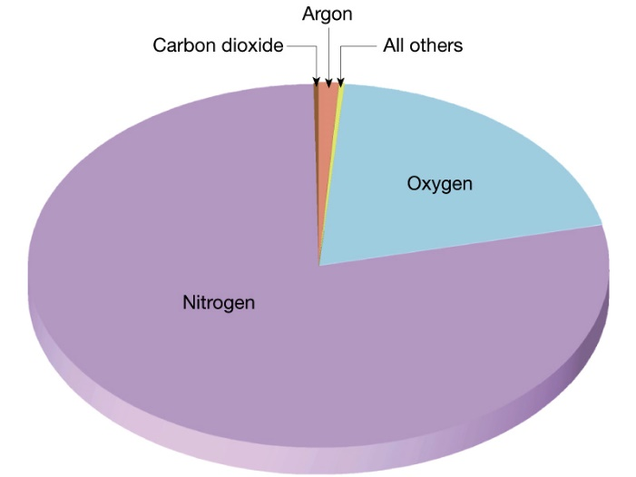 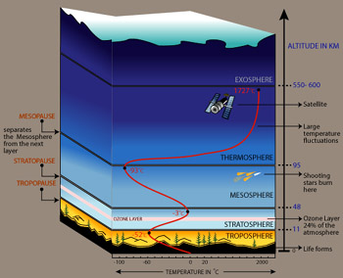

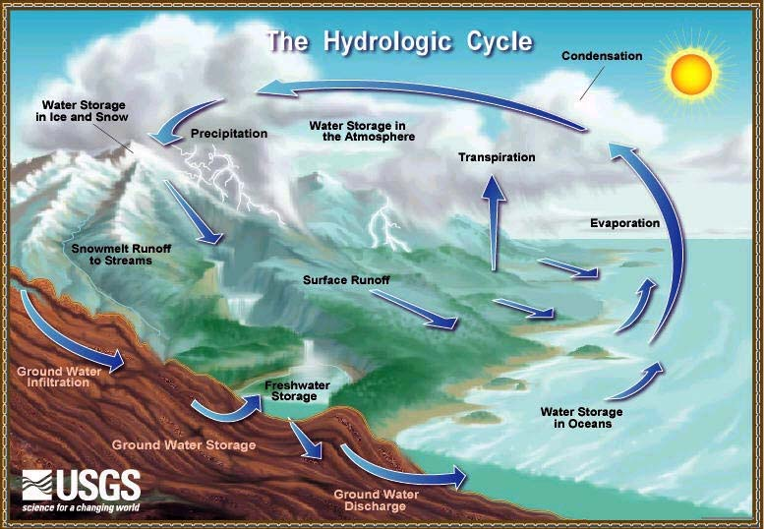

**See** [**https://www.learningctronline.com/courses**](https://www.learningctronline.com/courses) **for Materials and Resources.**

**Topics:**

1. Weather Components

**Objectives:**

1. Classify the composition of Earth’s atmosphere (gases, layers)?
2. Describe the major factors affecting weather?
3. List the major components of the hydrologic cycle.
4. Explain the various phases of water related to energy interactions.
5. Understand relative humidity & dew point related to temperature.
6. Define cloud formation and name & define the major types of clouds.
7. Explain how wind forms and factors that affect wind.

TAKE NOTE (All assignments are due by next week’s class.)

1. Weather Components PowerPoint Worksheet (class notes)
2. Types of Clouds Worksheet
3. Lab: Relative Humidity
4. Lab: How to Make a Cloud
5. Quiz Weather Components
6. Week 25 Devotional (<https://www.learningctronline.com/devotional>)

**Text**:

**Reference Material: Media, the Teacher**

**Homework**:

* Weather Components PowerPoint Worksheet
* Types of Clouds Worksheet

**Lab**: Relative Humidity

* Perform the “Relative Humidity” lab using the worksheet provided.
* Answers are provided at the end for guidance. Do not copy and paste.
* Save the document into your LAB folder in the Projects in Science folder on your desktop.

**Lab**: How to Make a Cloud

* Perform the “How to Make a Cloud” lab using the worksheet provided.
* Complete the worksheet in a formal lab report format.
* Save the document into your LAB folder in the Projects in Science folder on your desktop.

**TEST:** Quiz Weather Components

1) the academic integrity policy

* Tests must be completed **WITHOUT** referring to books, notes, the internet, people, or any outside resources.
* Students **MAY** use the approved Periodic Tables, approved Reference Tables, or approved equation (formula) sheet (provided by the teacher) along with calculators and scratch paper.

2) Take the **"in one sitting"**, meaning that once you start the test, you must complete it without interruption.

3) There is a **10-minute time limit** on this test.

4) Do NOT use RED font. Black font is best.

Supplemental Resources (Optional)

<https://screenpal.com/watch/cFQro3qRBf> (0:41) Water Cycle Animation

<https://screenpal.com/watch/cFQUFCYimD> (0:30) Clouds in an Airplane

<http://somup.com/cF6h2LnVWV> (1:05) Adiabatic Cooling (Cloud Formation)

<https://screenpal.com/watch/cF6hoOYoxj> (2:04) Global Wind Belts