Poison & Invasive Plants: Field Activity

- Use this activity to learn some of the poisonous and invasive plants near you.

- Use the Peterson’s Field Guide to Edible Wild Plants as a resource.

- Find an easily identifiable specimen for 10 (ten) of the plants listed below.
- Take a picture of the plant and insert it below the plant name.
- Check off the plants below.

[ ] Buttercup

[ ] Poison Ivy

[ ] Jimson Weed

[ ] Elderberry

[ ] Jack in the Pulpit

[ ] Skunk Cabbage

[ ] Pokeweed

[ ] Nightshade

[ ] Stinging Nettle

[ ] May Apple

[ ] Common Buckthorn

[ ] Garlic Mustard

[ ] Wild Grape

[ ]

[ ] Buttercup
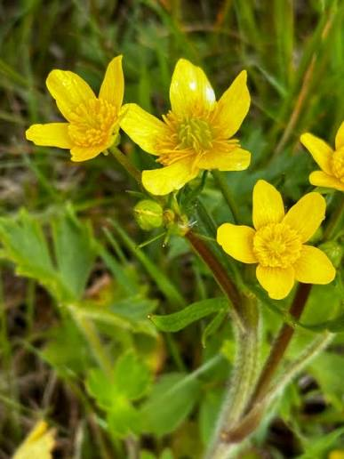

[ ] Poison Ivy
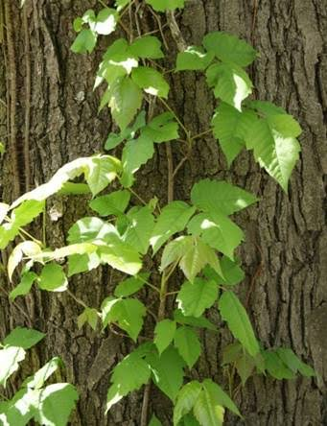

[ ] Jimson Weed
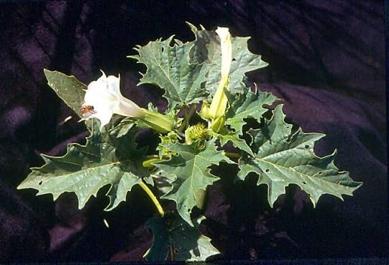

[ ] Elderberry
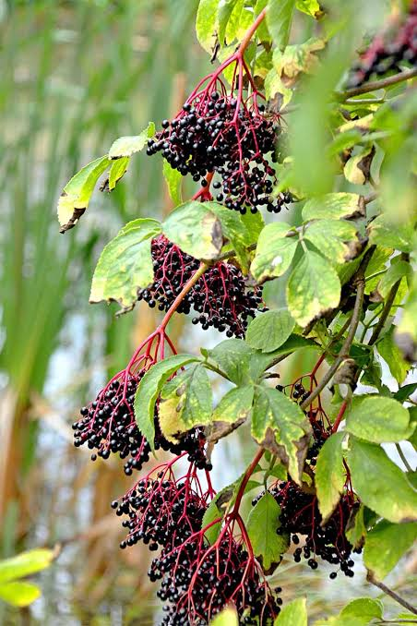

[ ] Jack in the Pulpit
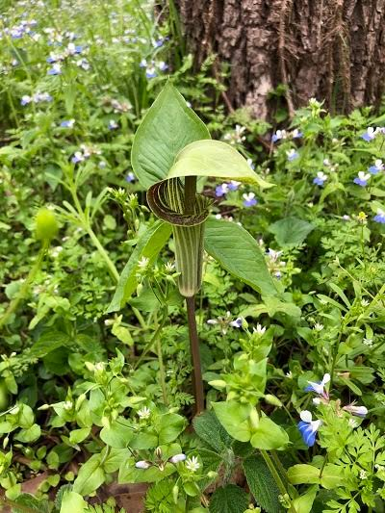
[ ] Skunk Cabbage
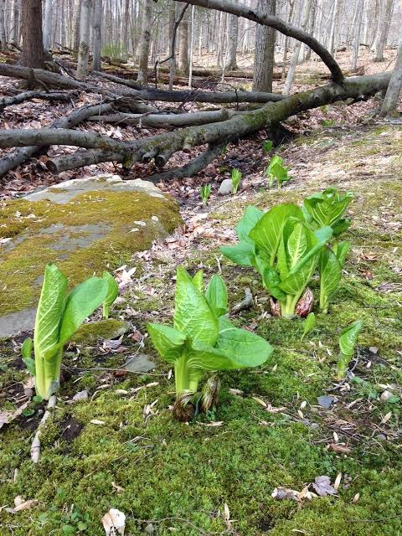

[ ] Pokeweed
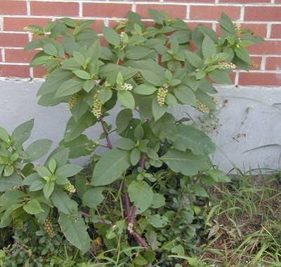

[ ] Nightshade
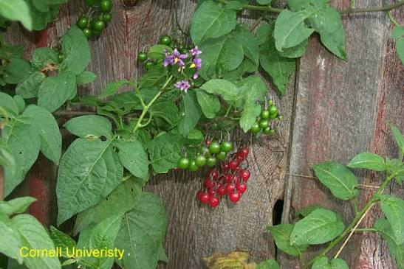

[ ] Stinging Nettle
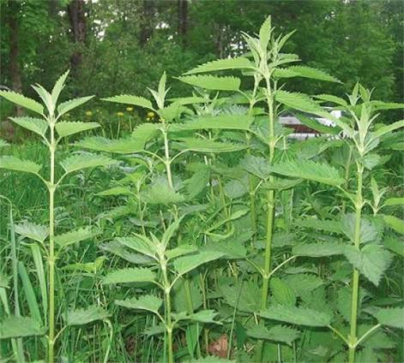

[ ] May Apple
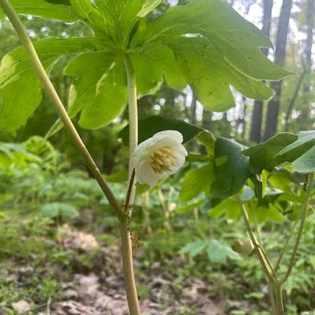
[ ] Common Buckthorn
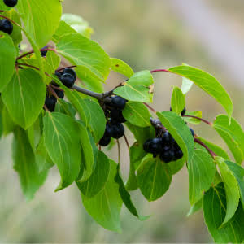

[ ] Garlic Mustard
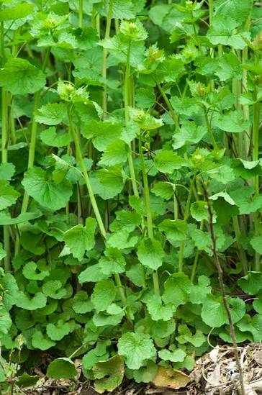

[ ] Wild Grape


 

