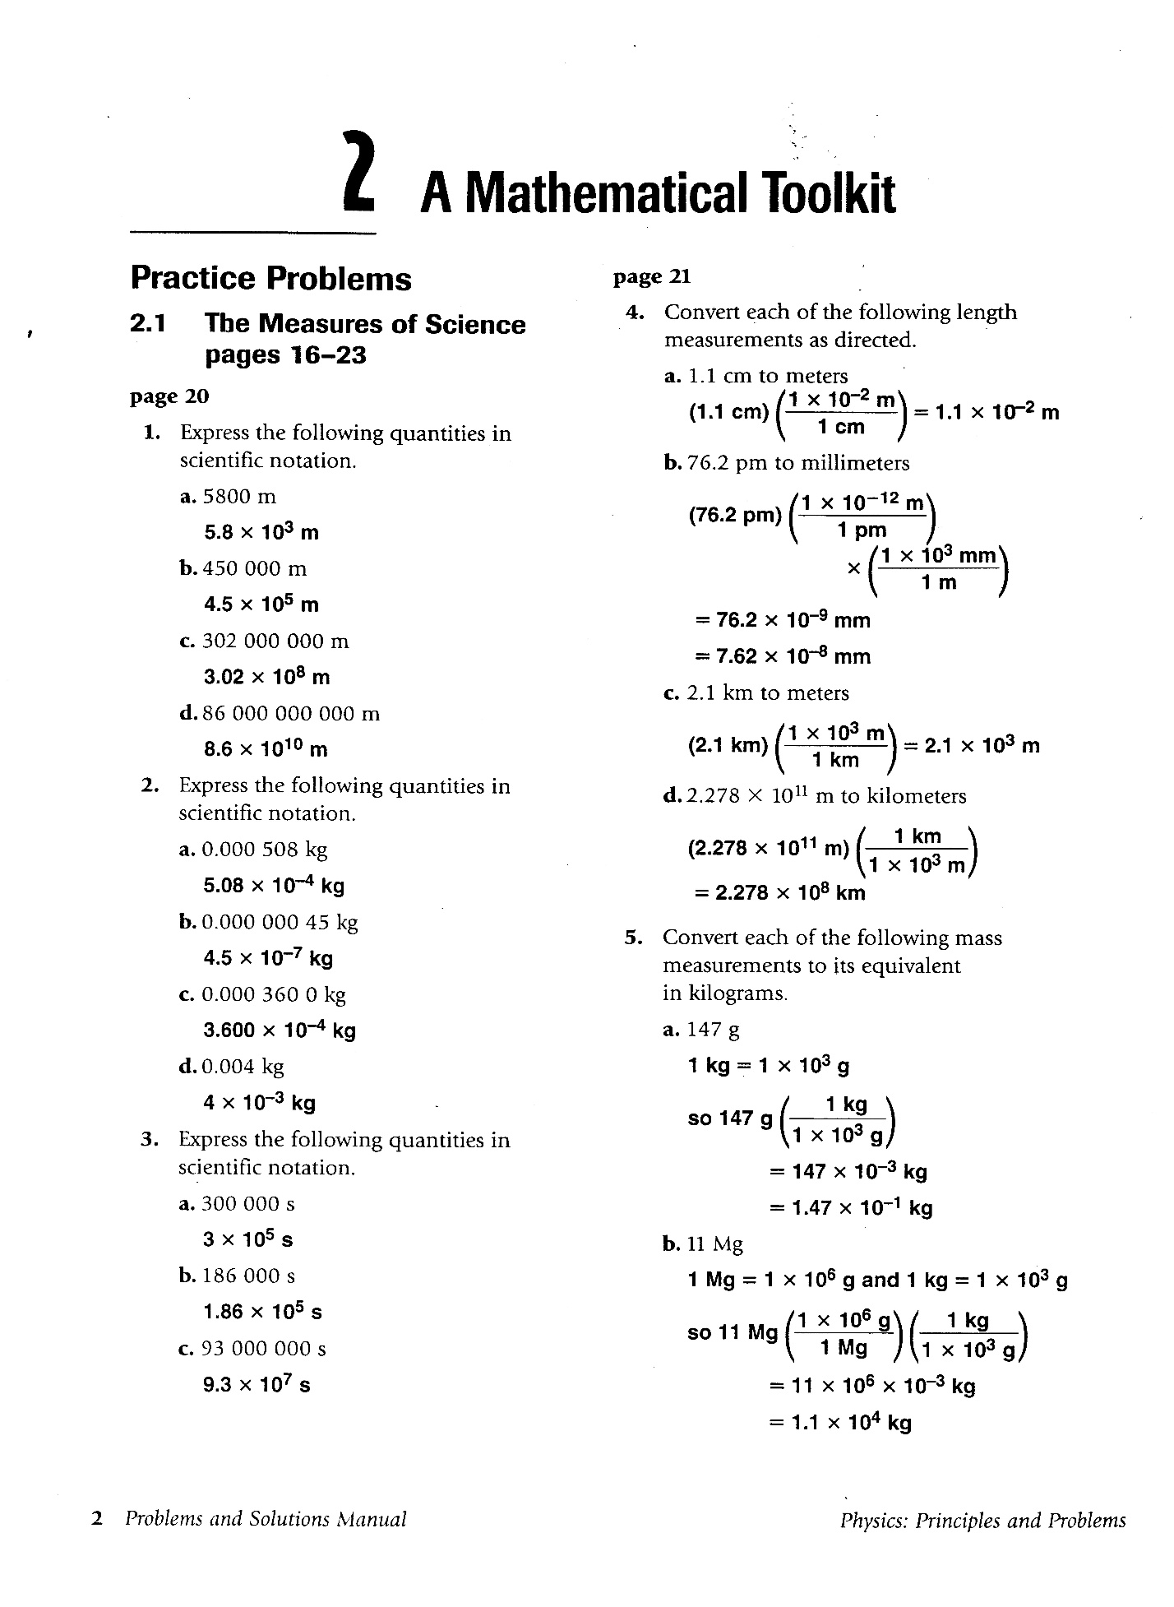
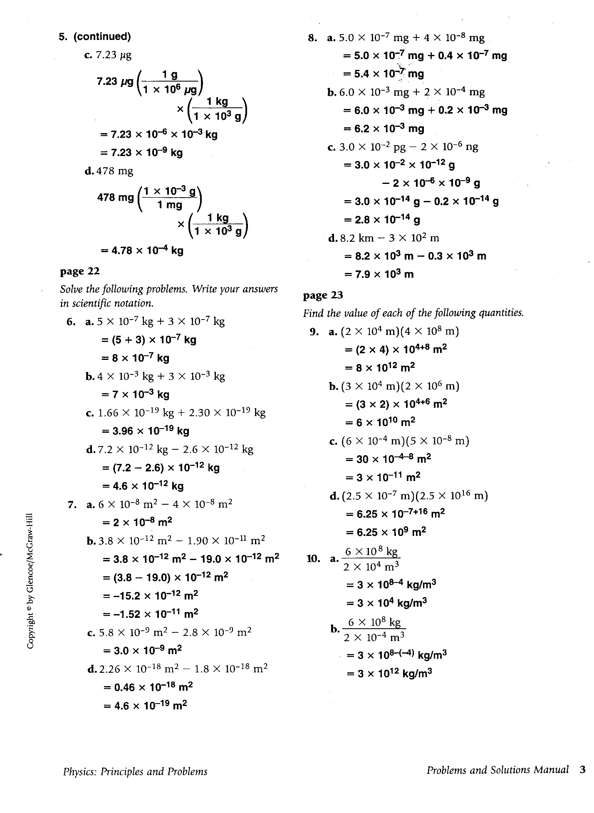
7.9 x 10⁰ km
2.8 x 10⁻⁵ ng
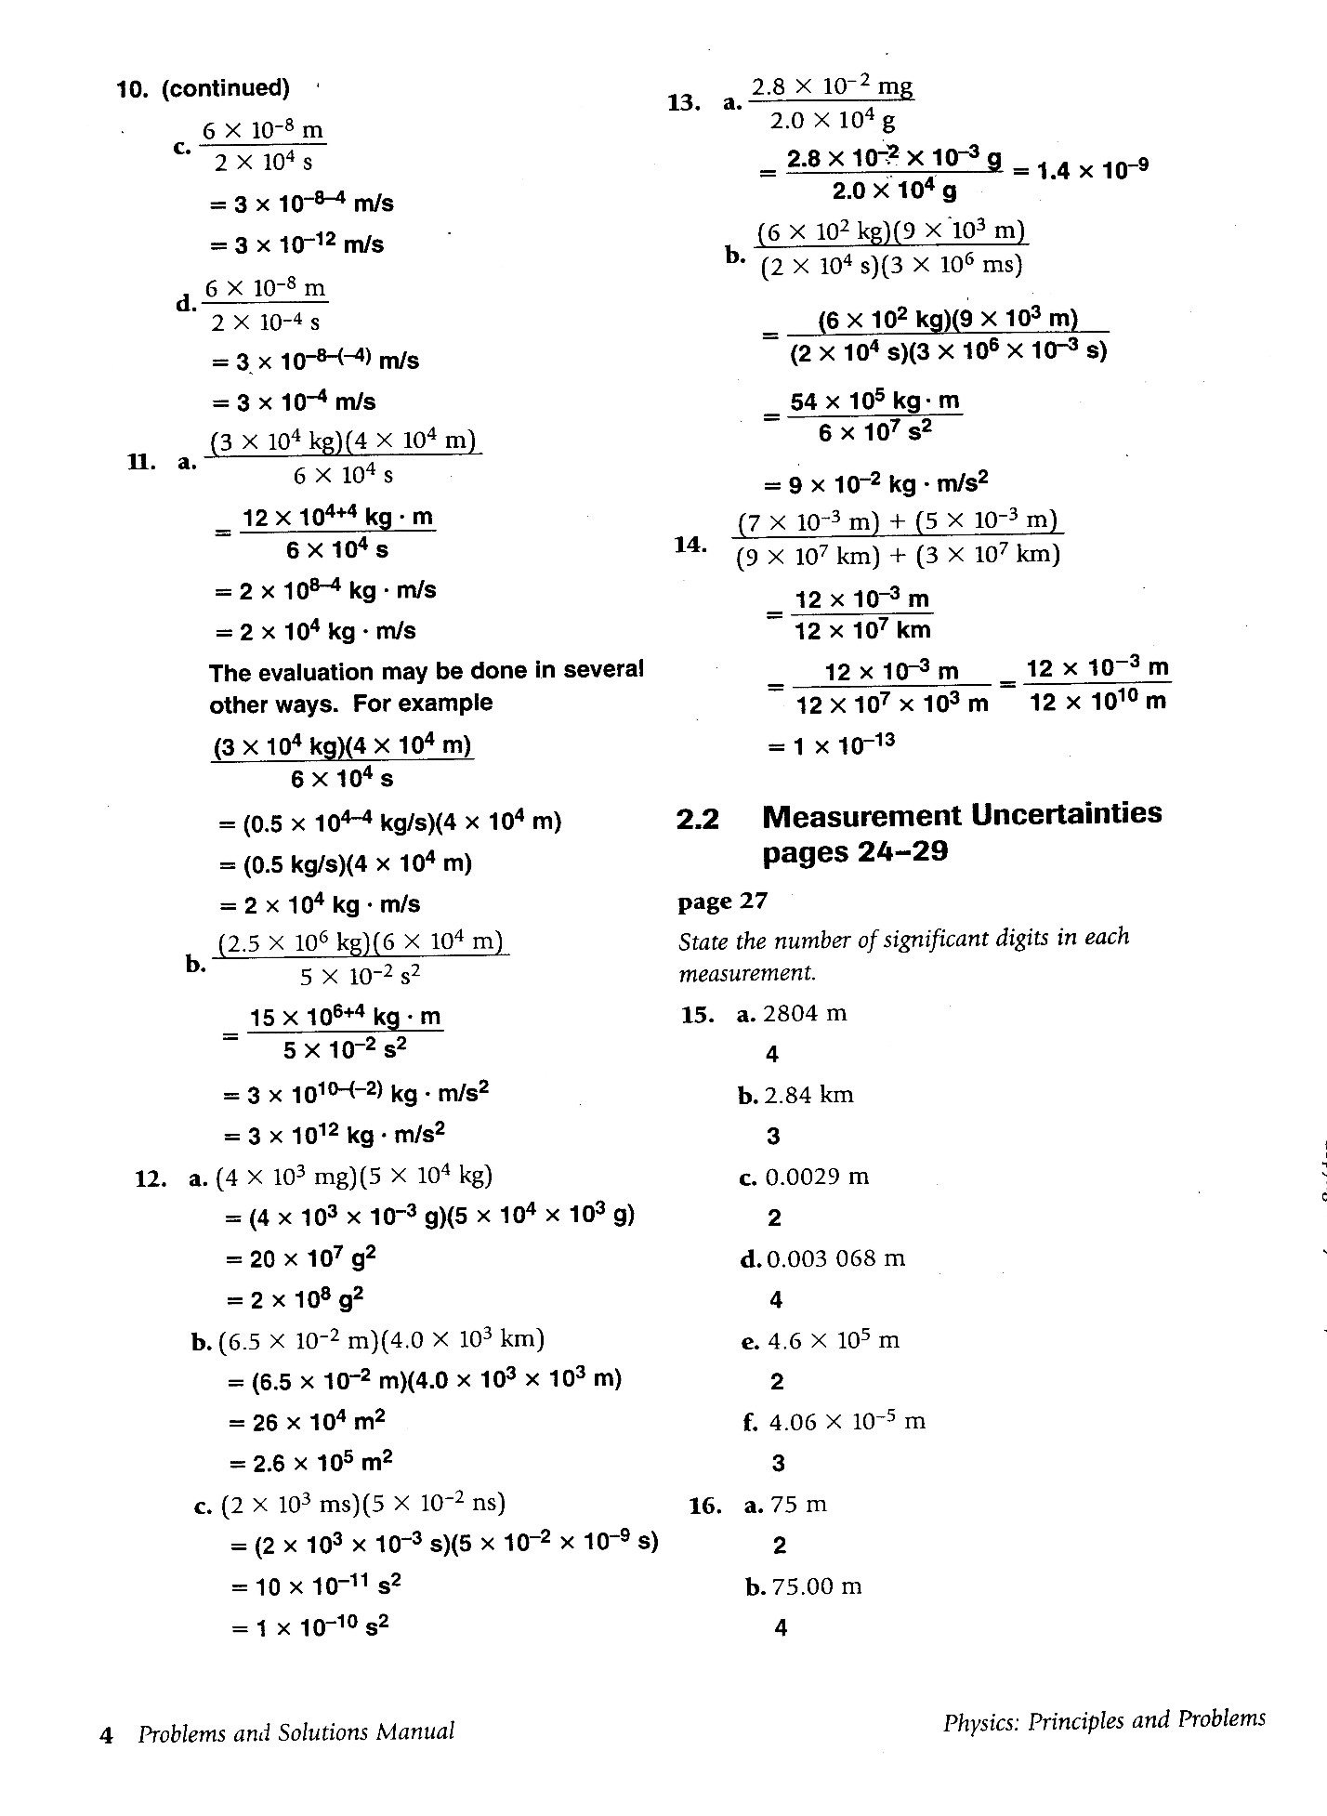
1 x 10⁻⁴ ms²
2.6 x 10⁻¹ km²
2 x 10² kg²
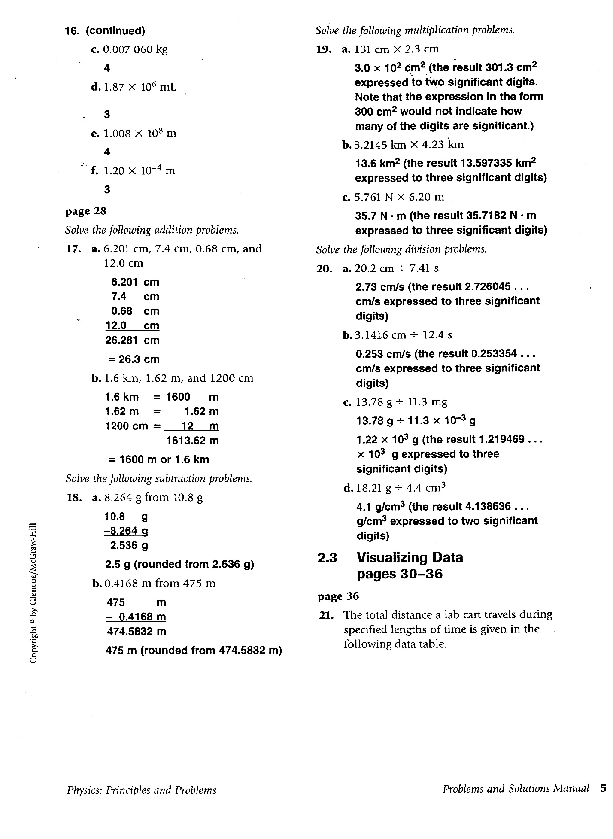

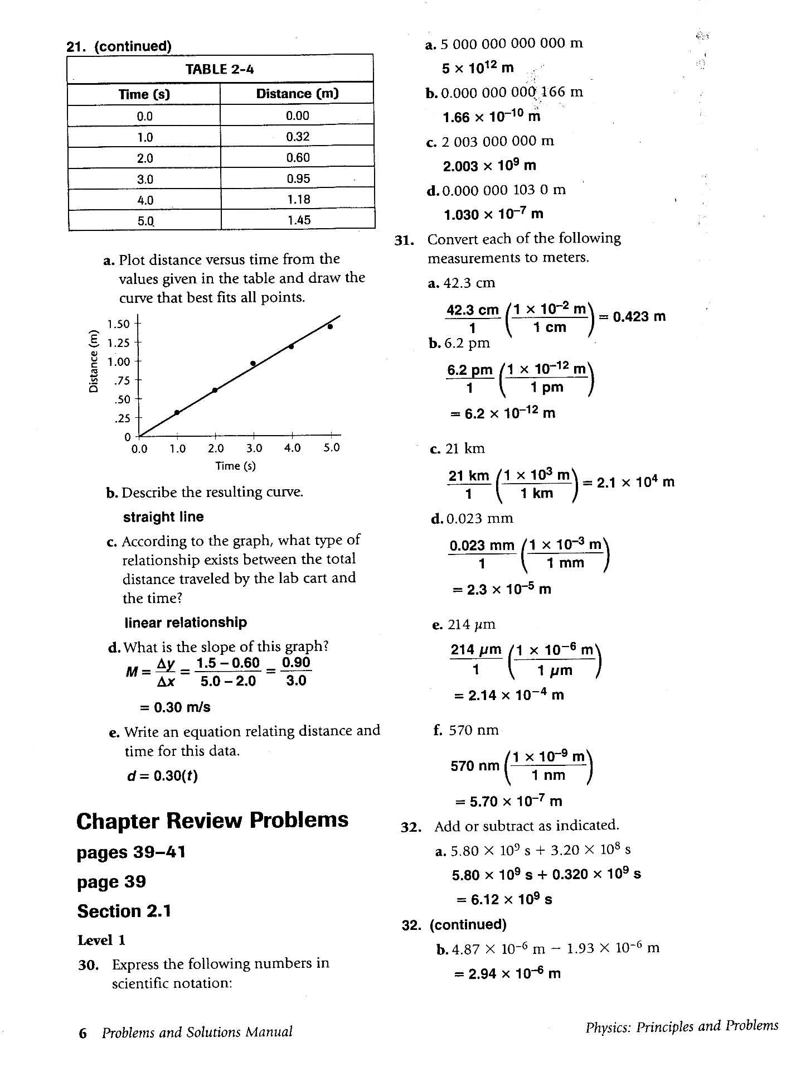
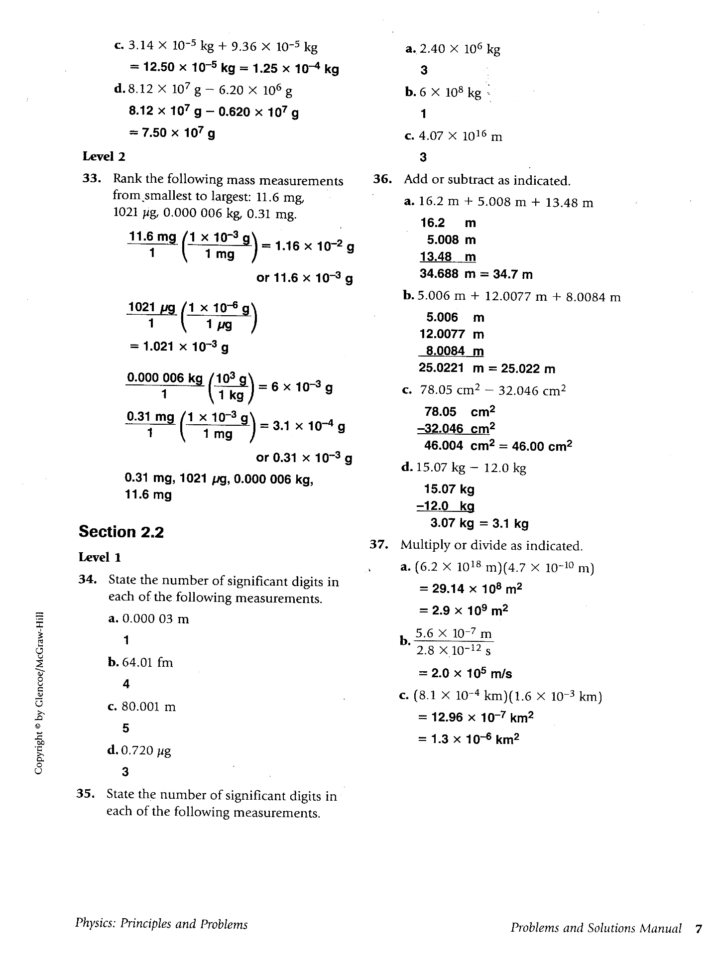
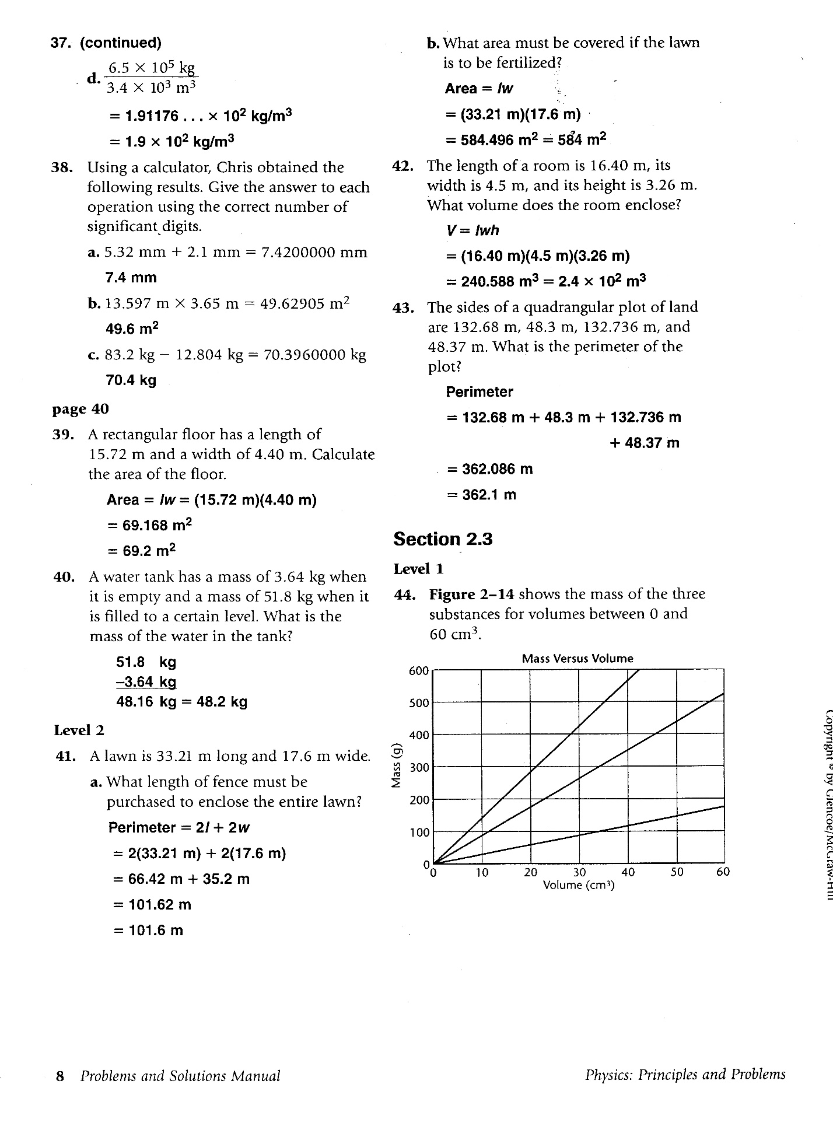
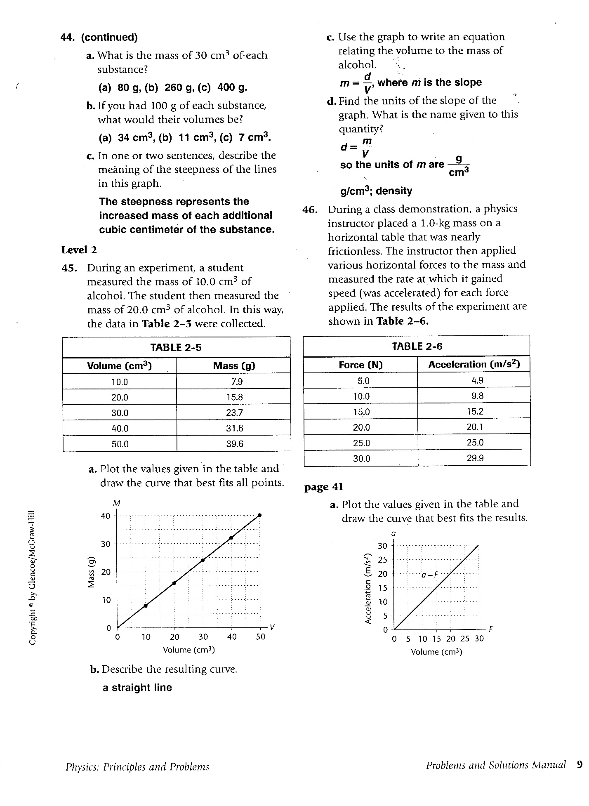

Appendix B Extra Practice Problems Chapter 2

11. A cube has an edge of length 5.2 cm. a) Find its surface area; b) Find its volume.

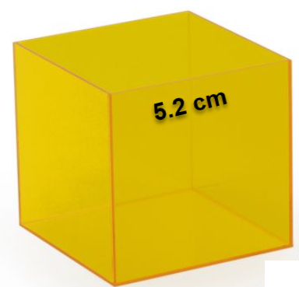 Area of 1 side 5.2 cm x 5.2 cm = 27.04 cm²
Surface Area of cube (6 sides 6 x 27.04 cm² = 162.2 cm² = 160 cm² = 1.6 x 10² cm²

Volume = L x W x H = (5.2 cm)³ = 140.6 cm³ = 140 cm² = 1.4 x 10² cm²

13. HONORS The density of gold is 19.3 g/cm³. A gold washer has an outside radius of 4.3 cm and an inside radius of 2.1 cm. Its thickness is 0.14 cm. What is the mass of the washer?

