1. It is said that Galileo dropped objects off the Leaning Tower of Pisa to determine whether heavy or light objects fall faster. If Galileo had dropped a 5.0 kg cannon ball to the ground from a height of 12 m, what would have been the change in PE of the cannon ball?

2. The 2000 Belmont Stakes winner, Commendable, ran the horse race at an average speed of 15.98 m/s. If Commendable and jockey Pat Day had a combined mass of 550.0 kg, what was their KE as they crossed the finish line?

3. A flea gains 1.0 x 10-7 J of PE jumping up to height of 0.030 m from a dog’s back. What is the mass of the flea?

4. Brittany is changing the tire of her car on a steep hill 20.0 m high. She trips and drops the 10.0 kg spare tire, which rolls down the hill with an initial speed of 2.00 m/s. What is the speed of the tire at the top of the next hill, which is 5.00 m high? (Ignore the effects of rotational KE and friction).

5. A Mexican jumping bean jumps with the aid of a small worm that lives inside the bean. If a bean of mass 2.0 g jumps 1.0 cm from your hand into the air, how much potential energy has it gained in reaching its highest point? What is its speed as the bean lands back in the palm of your hand?

6. A 35.0 kg bowling bowl is released from the top of a 100.0 m long hill with a vertical drop of 30.0 m. What is the ball’s speed at the bottom of the hill? Use the law of conservation of energy and assume no friction.

7. While on the moon, the Apollo astronauts enjoyed the effects of a much smaller gravity than on Earth. If Neil Armstrong jumped up on the moon with an initial speed of 1.51 m/s to a height of 0.700 m, what amount of gravitational acceleration did he experience?

8. The KE and PE of a block freely sliding down a ramp are shown in only one place in the sketch. Fill in the missing values.

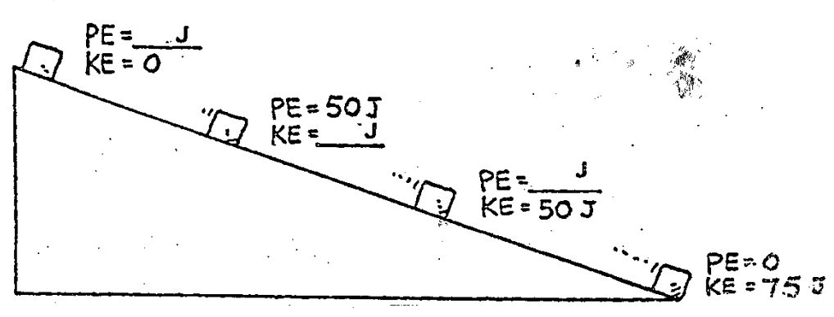

9. All the ramps shown below are 5 m high. We know that the KE of the block at the bottom of the ramp will be equal to the loss of PE (conservation of energy). Find the speed of the block at ground level in each case. And how much speed a falling object acquires in this time? This gives you the answer to Case 1.

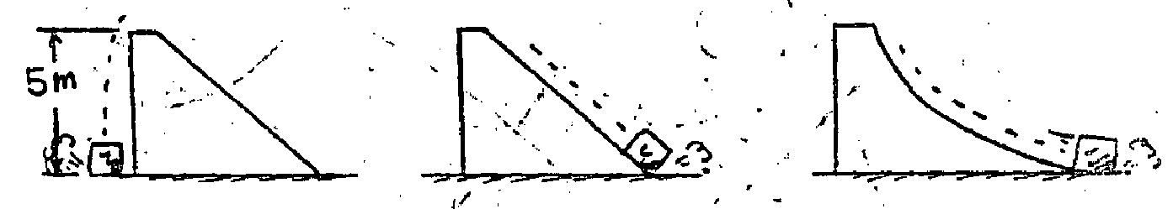

Case 1: Speed = ____ m/s Case 2: Speed= ____ m/s Case 3: Speed= ____ m/s

10. Which block gets to the bottom of the incline first? Assume no friction. Explain your answer.

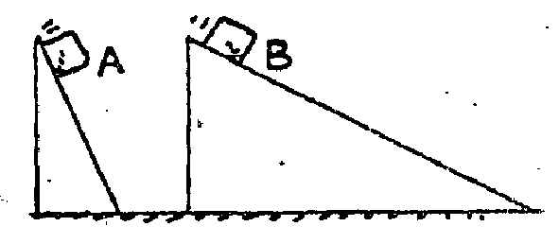

11. A big metal bead slides due to gravity along an upright friction-free wire. It starts from rest at the top of the wire as shown in the sketch below. How fast is it traveling as it passes:

Point B? Point D? Point E?

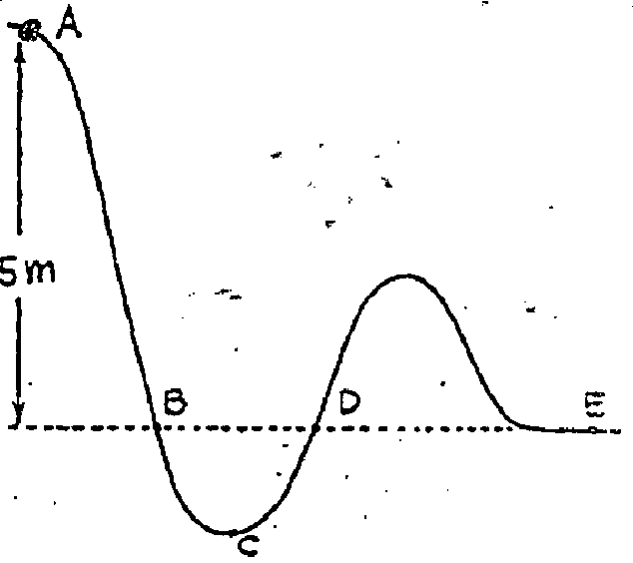

At what point does it have the maximum speed?

12. The late news reports the story of a shooting in the city. Investigators think that they have recovered the weapon and they run ballistics tests on the pistol at the firing range. If a 0.050 kg bullet was fired from the handgun with a speed of 400 m/s and it traveled 0.080 m into the target before coming to rest, what force did the bullet exert on the target? (Assume no air resistance).



13. About 50,000 years ago, in an area located outside Flagstaff, Arizona, a giant 4.5 x 107 kg meteor fell and struck the earth, leaving a 180 m deep hole now known as Barringer Crater. If the meteor was traveling at 20,000 m/s upon impact, with what average force did the meteor hit the earth?

14. A 1000 kg lead anvil is thrown off a 45 meter cliff to the ground. Air resistance is negligible. Determine the following parameters at each time frame shown. Assume conservation of energy: a. PE, b. KE, and c. instantaneous velocity.

11.25 m

33.75 m

Falling Distance0 m

22.5 m

45 m



PE _________ KE _________ velocity _________



PE _________ KE _________ velocity _________

45 m



PE _________ KE _________ velocity _________



PE _________ KE _________ velocity _________



PE _________ KE _________ velocity _________

1. It is said that Galileo dropped objects off the Leaning Tower of Pisa to determine whether heavy or light objects fall faster. If Galileo had dropped a 5.0 kg cannon ball to the ground from a height of 12 m, what would have been the change in PE of the cannon ball?

*PE = mgh = (5.0 kg)(10 m/s2)(12 m) = 600 J = 6.0 x 102 J*

2. The 2000 Belmont Stakes winner, Commendable, ran the horse race at an average speed of 15.98 m/s. If Commendable and jockey Pat Day had a combined mass of 550.0 kg, what was their KE as they crossed the finish line?

*KE = 1/2 mv2 = 1/2 (550.0 kg)(15.98 m/s2)2 = 70,224 J = 7.022 x 104 J*

3. A flea gains 1.0 x 10-7 J of PE jumping up to height of 0.030 m from a dog’s back. What is the mass of the flea?

*PE = mgh m = PE / gh = 1 x 10-7 J / [(10 m/s2)(0.030 m)] = 0.0000033 kg = 3.3 x 10-7 kg*

*That’s 0.003 grams.*

4. Brittany is changing the tire of her car on a steep hill 20.0 m high. She trips and drops the 10.0 kg spare tire, which rolls down the hill with an initial speed of 2.00 m/s. What is the speed of the tire at the top of the next hill, which is 5.00 m high? (Ignore the effects of rotational KE and friction).

20 m

5 m

2.00 m/s

V m/s

*Enet before = Enet after … Therefore, (PEb + KEb) before = (PEa + KEa) after*

*PE before = mgh = (10.0 kg)(10 m/s2)(20.0 m) = 2000 J*

*KE before = 1/2 mv2 = 1/2(10.0 kg)(2.00 m/s)2 = 20 J*

*PE after = mgh = (10.0 kg)(10 m/s2)(5.00 m) = 500 J*

*Solve for KEa = (PEb + KEb) - PEa = (2000 J + 20 J) – 500 J = 1520 J*

*KEa = 1/2 mv2 … Solve for V = √(2KEa /m) = √(2[1520 J] / [10.0 kg]) = 17.4 m/s*

5. A Mexican jumping bean jumps with the aid of a small worm that lives inside the bean. If a bean of mass 2.0 g jumps 1.0 cm from your hand into the air, how much potential energy has it gained in reaching its highest point?

*PE = mgh = (0.002 kg)(10 m/s2)(0.01 m) = 0.00020 J = 2.0 x 10-4 J*

What is its speed as the bean lands back in the palm of your hand?

*Assume conservation of energy and that no energy is lost to friction, air resistance, etc.*

*KE = 1/2 mv2 Therefore, v = √(2KE / m) = √(2[0.0002 J] / [0.002 kg) = 0.45 m/s*

6. A 35.0 kg bowling bowl is released from the top of a 100.0 m long hill with a vertical drop of 30.0 m. What is the ball’s speed at the bottom of the hill? Use the law of conservation of energy and assume no friction.

*PE = mgh = (35.0 kg)(10 m/s2)(30.0 m) = 10,500 J = 1.05 x 104 J*

100 m



*max PE = max KE*

*KE = 1/2 mv2. Therefore, v = √(2KE / m)*

*v = √(2[10,500 J] / [35.0 kg]) = 24.5 m/s*

7. While on the moon, the Apollo astronauts enjoyed the effects of a much smaller gravity than on Earth. If Neil Armstrong jumped up on the moon with an initial speed of 1.51 m/s to a height of 0.700 m, what amount of gravitational acceleration did he experience?

*PE = mgh KE = 1/2 mv2 … max PE = max KE*

*mgh = 1/2 mv2 … gh = 1/2 v2 g = v2 / 2h = (1.51 m/s)2 / (2)(0.700 m) = 1.63 m/s2*

8. The KE and PE of a block freely sliding down a ramp are shown in only one place in the sketch. Fill in the missing values.

**PE = 75 J**

**KE = 0 J**

**75**



**PE = 0 J**

**KE = 75 J**

**PE = 25 J**

**KE = 50 J**

**PE = 50 J**

**KE = 25 J**

Total Energy = PE + KE

9. All the ramps shown below are 5 m high. We know that the KE of the block at the bottom of the ramp will be equal to the loss of PE (conservation of energy). Find the speed of the block at ground level in each case. And how much speed a falling object acquires in this time? This gives you the answer to Case 1.



Case 1: Speed = 10 m/s Case 2: Speed= 10 m/s Case 3: Speed= 10 m/s

*Even though the path may be different (different incline), the total energy in the system is conserved (Total energy = PE + KE). Therefore, the maximum PE = maximum KE for each figure. PE (mgh) is based on the height of the ramp and since that does not change, the maximum PE remains constant and therefore, the maximum KE is also constant (equals the maximum PE in a frictionless environment).*

*Since the maximum KE is the same in all three paths, the maximum speed (instantaneous velocity at the bottom of the ramps) are equal. Block on A reaches bottom first; greater acceleration and less ramp distance. Although it will have the same speed at bottom, the time it takes to reach that speed is different.*

*We can determine the instantaneous velocity of an object free falling as in the figure to the left using V = gt. We determine the time by using dy = ½gt² . Where t = √2d/g. The time to free fall 5 m is 1 second. Therefore, the instantaneous velocity (v = gt) equals 10 m/s.*

10. Which block gets to the bottom of the incline first? Assume no friction. Explain your answer.



*The total energy (Total energy = PE + KE) in the system is conserved. Maximum PE (mgh) is based on the height of the ramp (how high does the block fall) and since that does not change, the maximum PE remains constant with KE = 0. Therefore, the maximum KE is also constant for both ramps since the total energy is conserved.*

*Ball A gets to the bottom first due to a greater acceleration down a shorter ramp. (Note that SPEED at the bottom, not TIME, is the same for both.)*

11. A big metal bead slides due to gravity along an upright friction-free wire. It starts from rest at the top of the wire as shown in the sketch below. How fast is it traveling as it passes:

Point B? Point D? Point E?

At what point does it have the maximum speed?



*Even though the path may be different (different incline), the total energy in the system is conserved. Therefore, the maximum PE = maximum KE for each figure. PE (mgh) is based on the height of the ramp and since that does not change, the maximum PE remains constant for points B, D & E.*

*We can determine the instantaneous velocity of an object free falling as in the figure to the right using V = gt. We determine the time by using dy = ½gt² . Where t = √2d/g. The time to free fall 5 m is 1 s. Therefore, the instantaneous velocity (v = gt) equals 10 m/s for points B, D & E.*

*Since point C has the greatest distance to fall, its maximum PE will be greatest, and therefore, its maximum KE will also be greatest and it will have the maximum speed.*

12. The late news reports the story of a shooting in the city. Investigators think that they have recovered the weapon and they run ballistics tests on the pistol at the firing range. If a 0.050 kg bullet was fired from the handgun with a speed of 400 m/s and it traveled 0.080 m into the target before coming to rest, what force did the bullet exert on the target? (Assume no air resistance).

*KE = 1/2 mv2 net f x distance = 1/2 mv2*

*net f = (1/2 mv2) / d*

*f = ½ (0.050 kg)(400 m/s)2 / 0.080 m*

*f = 50,000 N*



13. About 50,000 years ago, in an area located outside Flagstaff, Arizona, a giant 4.5 x 107 kg meteor fell and struck the earth, leaving a 180 m deep hole now known as Barringer Crater. If the meteor was traveling at 20,000 m/s upon impact, with what average force did the meteor hit the earth?

*KE = 1/2 mv2 net f x distance = 1/2 mv2*

*net f = (1/2 mv2) / d*

*f = ½ (*4.5 x 107 kg*)(20,000 m/s)2 / 180 m*

*f =* 5 x 1013 *N*

14. A 1000 kg lead anvil is thrown off a 45 meter cliff to the ground. Air resistance is negligible. Determine the following parameters at each time frame shown. Assume conservation of energy: a. PE, b. KE, and c. instantaneous velocity.

Falling Distance0 m



PE 4.5 x 10*5* J KE 0 J velocity 0 m/s

PE = mgh = (1000 kg)(*10 m/s2*)(45 m) = 4.5 x 10*5* J

KE = 0 J … no velocity



11.25 m

PE 3.4 x 10*5* J KE 1.1 x 10*5* J velocity 14.8 m/s

45 m

¾ PE + ¼ KE = total energy v = *√(2KE / m)*

22.5 m



PE 2.25 x 10*5* J KE 2.25 x 10*5* J velocity 21.2 m/s

½ PE + ½ KE = total energy v = *√(2KE / m)*



33.75 m

PE 1.1 x 10*5* J KE 3.4 x 10*5* J velocity 26.0 m/s

¼ PE + ¾ KE = total energy v = *√(2KE / m)*



45 m

PE 0 J KE 4.5 x 10*5* J velocity 30 m/s

KE is maximum KE = 1/2mv2

v = *√(2KE / m)*