**Introduction**

**Purpose**

To design an investigation about vectors by finding an equilibrant and a resultant using experimentation, graphing and mathematics.

**Discussion**

Find the resultant of the following three vectors:

a

b

c

resultant

a

b

c

a

b

R

* “a” is the **equilibrant** (equal and opposite to the resultant.

c

* Remember, one can add these vectors in more than one way to find the resultant. The resultant magnitude and direction will be the same.
* Be sure to “add” the vectors “head to tail”
* Graphic representation is very helpful, but not as accurate as using mathematical computation. This requires trigonometry (*because angles are involved*).

Vector Analysis Using Components

* Normally, vector analysis uses components based on right triangles.
* This allows one to utilize simple trigonometric and geometric functions to resolve vectors.
  + Using angle θ, the following trig functions apply:

Hypotenuse (R)

Adjacent side (x)

Opposite

side (y)

θ

Sin θ = opposite / hypotenuse

Cos θ = adjacent / hypotenuse

Tan θ = opposite / adjacent

* To find sides of a right triangle, one should use the Pythagorean theorem

R2 = x2 + y2

Vector Resolution → The process of finding the magnitude of a component in a given direction is called.

* + - Magnitudes used can be resolved into its vertical and horizontal components. This is dealing with perpendicular components.

When dealing with vector resolution for NON-right triangles, students can use the Law of Cosines when the two sides of a triangle (not the hypotenuse) and the angle in between are known.

Consider the triangle below, having sides A, B, C and corresponding angles a, b, c.

c

A

B

C

a

b

Notice that line C represents the resultant of lines A + B.

One can mathematically determine the resultant if the two sides (A & B) are known and the angle (c) between them.

The law of cosines states that C2 = A2 + B2 – 2ABcos(c).

In this lab, students use masses to create the equilibrant, but the calculations require forces. Newton’s second law of motion relates force to mass and acceleration. Force equals mass times acceleration or f = ma. Notice that the masses are all suspended from pulleys, meaning that the acceleration is downward. Downward acceleration is a force due to gravity, 9.8 m/s2. The force of a mass affected by gravity is called weight which is represented by W = mg.

**Hypothesis**

If non-right-angle vectors are measured, then resultant and equilibrant can be determined using law of cosines.

**Materials** 10 g, 15 g, 20 g, 50 g masses Spring Scale (N)

Large Pot/pan (~30 cm diameter) 3 Pulleys (if possible)

Mass Balance Thread (3 - 30 cm lengths)

Pulley Plastic Ring

Stool to hold Pot/pan (if needed)

32 pennies (each penny weighs ~2.5 g) Adhesive tape or container

4 pennies (10 g) 6 pennies (15 g)

8 pennies (20 g) 20 pennies (50 g)

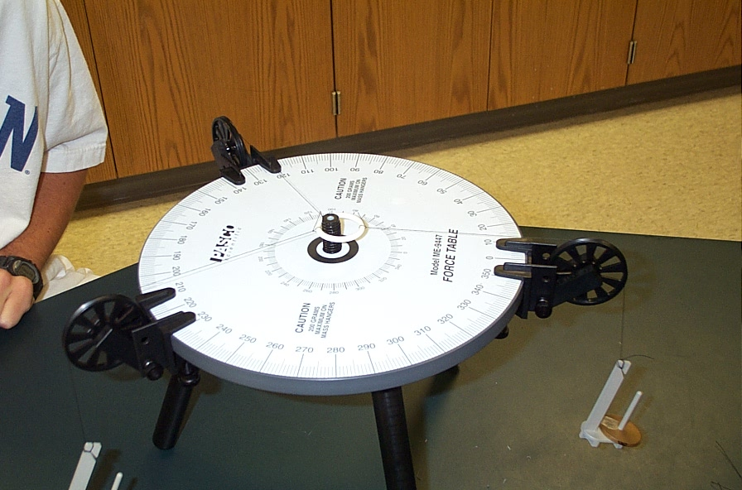

F10g

F20g

F15g

**83°**

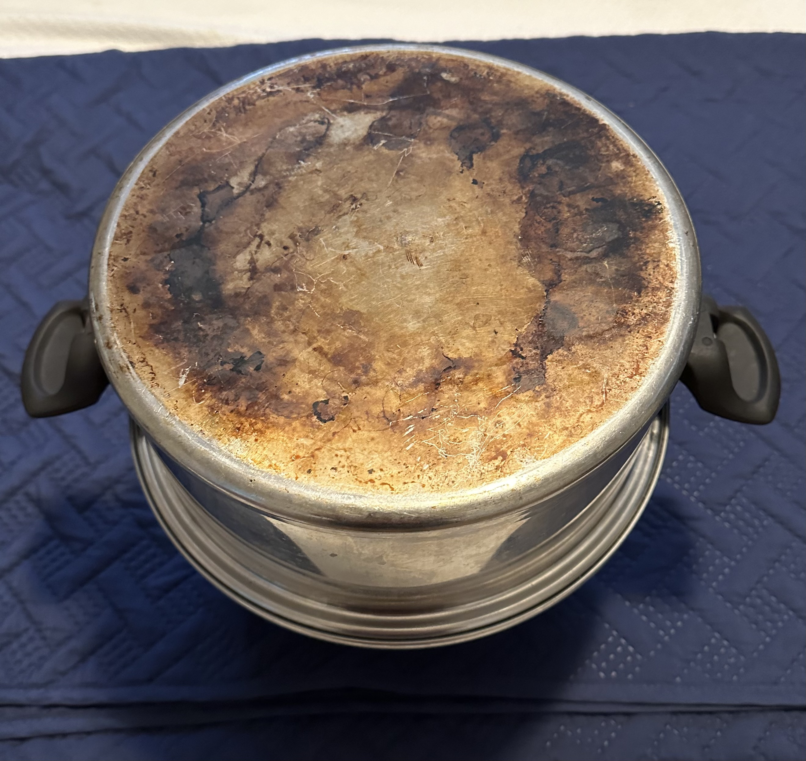

The pot is upside down on a stool or upside-down can so the masses can hang over the sides.

### Procedures

Part 1 Using Three Different Masses to investigate equilibrium

1. Use the 10 g (4 pennies), 15 g (6 pennies), and 20 g (8 pennies) masses and attempt to create equilibrium so that the masses hang freely and the ring is centered on the force table unimpeded as shown in the image.

* Find a container for the pennies or wrap them in adhesive tape so the thread can be attached.
* Attach all masses to the plastic ring using ~30 cm of thread so that the masses hang over the “force table” and the ring is balanced in the center.

1. Use a spring scale or mass balance to determine the **force** each mass represents or calculate using f = mg where g is acceleration due to gravity (9.8 m/s2).
2. Set up the “force table” using the pulleys, masses, thread and plastic ring so that the masses hang in equilibrium. The ring must stay near the center without being held.
3. Record the lengths of the masses (center to edge of “force table”) and the angle between each thread.

Part 2 Using Two Different Sized Masses to determine the resultant

1. You will calculate a mathematical answer to Part 2 before doing the actual experimentation.
2. Obtain 2 - 20 g (8 pennies) masses and a 50 g (20 pennies) mass.
3. Use a spring scale or mass balance to determine the **force** each mass represents or calculate using f = mg where g is acceleration due to gravity (9.8 m/s2).
4. Set up the “force table” using the pulleys, masses, thread and plastic ring so that the masses hang in equilibrium and so that the two 20 g masses hang 30° apart from each other.
5. Use a spring scale as the third “force” (equilibrant).
6. Record the lengths of the masses (center to edge of “force table”) and the angle between each thread.

**Calculations and Data**

*Show work for all calculations.*

**Part 1**

|  |  |  |  |
| --- | --- | --- | --- |
|  | **10 g – 15 g** | **10 g – 20 g** | **15 g – 20 g** |
| **Angle between** | ⁰ | ⁰ | ⁰ |
|  |  |  |  |
|  | **10 g** | **15 g** | **20 g** |
| **Length of thread to center ring** | cm | cm | cm |

1. Measure the angles of equilibrium of the three forces experimentally using a protractor. As a comparison, use the angle of 83° between the two masses.
2. Measure the length of each hanging mass from the center ring to the edge of the force table.
3. Calculate the resultant and the angle of equilibrium between the smallest two masses mathematically.
4. Calculate the percent error of the resultant and the angle between the smallest masses, assuming your mathematical calculations are accurate.
5. Fill in the force (Newtons) and angles of the balanced masses on the force table.
6. Take a picture of the “force table” and hanging masses and insert after the diagram below.

⁰

N

N

N

⁰

⁰

**Part 2**

|  |  |  |  |
| --- | --- | --- | --- |
|  | **20 g – 50 g** | **20 g – 50 g** | **20 g – 50 g** |
| **Angle between** | ⁰ | ⁰ | ⁰ |
|  |  |  |  |
|  | **20 g** | **25 g** | **50 g** |
| **Length of thread to center of ring** | cm | cm | cm |

1. Measure the angles of equilibrium of the three forces experimentally using a protractor. As a comparison, use the angle of 83° between the two masses.
2. Measure the length of each hanging mass from the center ring to the edge of the force table.
3. Calculate the resultant and the angle of equilibrium between the smallest two masses mathematically.
4. Calculate the percent error of the resultant and the angle between the smallest masses, assuming your mathematical calculations are accurate. As a comparison, use an equilibrant value of 630 N.
5. Calculate the percent error assuming your mathematical calculation for the equilibrant is accurate.
6. Fill in the force (Newtons) and angles of the balanced masses on the force table for both.
7. Take a picture of the “force table” and hanging masses and insert after the diagram below.

⁰

N

N

N

⁰

⁰

#### Conclusions and Questions

1. What is the resultant of the three forces in Part 1 as they hang in equilibrium? How does it compare to the equilibrant?
2. What is the resultant of the two forces in Part 2 before you measured the equilibrant? How does it compare to the equilibrant?
3. When graphically working with vectors, what method is used to add vectors?

**Calculations and Data** EXPLANATION

**PART 1** The 10 g, 15 g and 20 g can form equilibrium (hang freely by balancing each other) because the lighter masses (10 g & 15 g) can balance the 20 g mass.

First, multiply each mass by 9.8 m/s2 to convert to force into Newtons [W = mg].

Knowing that Weight = mass x gravity, we need to convert all mass to force (N)*

10 g = 0.010 kg 🡪 0.010 kg x 9.8 m/s2 = 0.098 N … 98 N

15 g = 0.015 kg 🡪 0.015 kg x 9.8 m/s2 = 0.147 N … 147 N

20 g = 0.020 kg 🡪 0.020 kg x 9.8 m/s2 = 0.196 N … 196 N

*For the sake of simplicity, we will multiply the forces by 1000 … 0.049 N x 1000 = 49 N, etc.

Drawing of Force Table in Equilibrium with 3 masses:

@ = 83° experimentally

F15g

F10g

Equilibrant

@°

F20g

F15g

F10g

Equilibrant

@°

F20g

R

F10g

Redraw one of the two vectors “head to tail.”

Draw the “R” (resultant) vector. Theoretically,

Magnitude of the resultant is equal to the equilibrant

but in the opposite direction.

Notice this is NOT a right triangle, therefore,

The Pythagorean theorem will not work.

@° is the angle between the two masses (forces),

the angle you need to confirm mathematically.

There is no easy way to find @° by using vector

components.

We can find @° indirectly or graphically.

83°

147 N

Equilibrant

83°

F20g

R

98 N

97°

We can determine the interior angle

of the triangle made using geometry.

Using supplementary angles, the interior

angle between the two sides of the triangle

Is 97°.

Since it is a non-right triangle, but we know

the two sides and the angle in between them,

we can use the law of cosines to calculate an

experimental resultant (R).

R2 = A2 + B2 – 2ABCos θ

R = √(A2 + B2 – 2ABCos θ)

R = √([98 N]2 + [147 N]2 – 2[98 N][147 N]Cos 97)

R = 186 N

Percent Error = (196 N – 186 N) / 196 N x 100 % = 5.1 % error

147 N

Equilibrant

83°

F20g

R

98 N

The easiest angle to mathematically calculate is θ,

which is opposite “R” or 196 N.

Calculate angle θ using the law of cosines.

See the calculation below:

Use the Law of Cosines to calculate the interior angle opposite the resultant by rearranging

R2 = A2 + B2 - 2ABCos θ

2ABCos θ = A2 + B2 - R2

Cos θ = (A2 + B2 - R2) / 2AB

θ = Cos-1 (A2 + B2 - R2) / 2AB

θ = Cos-1 ((98 N)2 + (147 N)2 – (196 N)2) / 2(98 N)(147 N)

θ = 104°

76°

147 N

Equilibrant

76°

F20g

R

98 N

**104**°

To determine the angle between the two smallest masses (10 g and 15 g or between the two smallest forces 98 N and 147 N), we use simple geometry as shown:

θ and @ are supplementary angles (add up to 180°) because they form a straight line.

Since we just calculated angle θ, we find @ by subtraction:

@ = 180° - θ 🡪 180° – 104° = **76°**

Percent Error = (83° – 76°) / 76° x 100 % = 9.2 % error

Final Drawing based on calculations:

Find the approximate angle between the equilibrant and the two masses: (360° – 76°)/2 = **142°**. We assumed a bisected angle, which is not true in real life.

F15 g

Equilibrant

76°

F20g

R

F10 g

F10 g

θ°

**142°**

**PART 2** Determine the force of the equilibrant experimentally if you have the equipment to do so. Calculate the percent error assuming your mathematical calculation for the equilibrant is accurate. If you do not have the proper equipment to do the lab, use an equilibrant value of 630 N.

Make a “scale” drawing of your results for part 2.

#### See Conclusion Question #2 for drawing and calculation

Percent Error = (667 N – 630 N) / 667 N x 100 % = 5.5 % error

**Conclusions and Questions**

1. What is the resultant of the three forces in Part 1 as they hang in equilibrium?

*The resultant force in Part 1 is zero because the forces cancel each other out.*

2. What is the resultant of the two forces in Part 2 before you measured the equilibrant?

*equilibrant*

150°

30°

196 N

490 N

20 g x 9.8 = 196 N

50 g x 9.8 = 490 N

*resultant*

490 N

196 N

150°

*For the sake of simplicity, we will use whole numbers as shown rather than the actual forces of 0.252 N, 0.546 N [because of the units of gravity being compatible with Newtons.]

Use the Law of Cosines to calculate the resultant: R2 = A2 + B2 - 2ABCos@

R2 = 1962 + 4902 – 2(196 N)(490 N)(Cos 150°)

R = 667 N 🡪 Force in Newtons / gravity = 68 grams

3. When graphically working with vectors, what method is used to add vectors?

*Vectors are placed “head to tail” or “tail to head” when adding or subtracting.*