Focus Questions

1. What is water’s composition?
2. What is water’s chemical formula?
3. What is polarity in terms of molecules like water?
4. What kinds of molecules can water dissolve?

Composition of Water

* _____ is an unusual compound with _____ physical properties.
* As a result, it’s the compound of _____. (*Consider John 4:14*)
* And is the most _____ compound in the _____ of Earth.
* Water consists of only _____ and _____.

Electrolysis of Water

* Water can be _____ into its constituent elements (hydrogen and oxygen) using _____.
* In theory, there should be __ molecules of H2 released for every __ molecule of O2.
* In REAL LIFE this is never the case.

How can we reduce experimental _____?

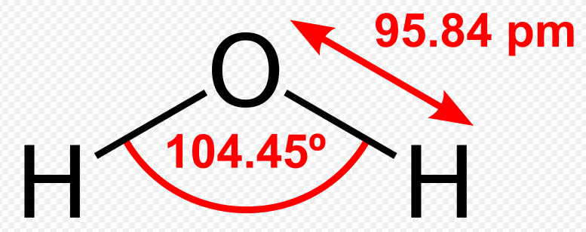

* Better _____
* Better _____
* _____ Review

Chemical _____ of Water H2O

* Use chemical _____ of elements (Periodic Table on page 320)
* Show how many atoms of each element are involved in a formula.
  + Glucose C6H12O6 has __ Carbon atoms, __ hydrogen atoms, and __ oxygen atoms in ONE molecule.
* Vinegar has __ carbon atoms, __ hydrogen atoms, and __ oxygen atoms. What is vinegar’s chemical formula?
  + C2H4O2  or CH3COOH
* NaOH is sodium hydroxide, the active ingredient in “Drano”. How many atoms of each element are represented in the formula?
  + __ Sodium __ Oxygen __ Hydrogen
* Enrichment: Al2(SO4)3 is calcium sulfate. How many atoms of each element are represented in the formula?
  + __ Aluminum __ Sulfur __ oxygen
  + *Multiply all element inside the parenthesis by the subscript “3”*

Water Chemistry

* Water (H2O) is formed by _____ bonds (sharing of electrons) between _____ Hydrogen atoms and _____ Oxygen atom.

Water is a “_____” Molecule

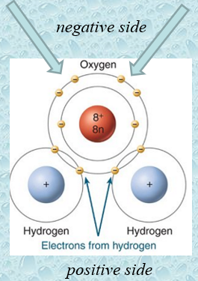

* __ Hydrogen atoms each share __ electron with one Oxygen atom in the _____ bond they make.
* The Oxygen atom has 4 remaining electrons (not used in to hold the hydrogen atoms). 🡪
* This gives the Oxygen side of the molecule a _____ charge, and the Hydrogen side a slight _____ charge.
* This creates the _____ characteristic of water (_____ side of the molecule having _____ charges)
* _____ charges _____
* Unlike charges _____

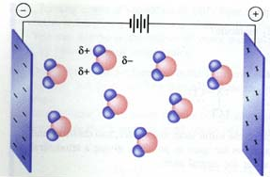

Polarity

* As a result of polarity, water molecules easily bond together.

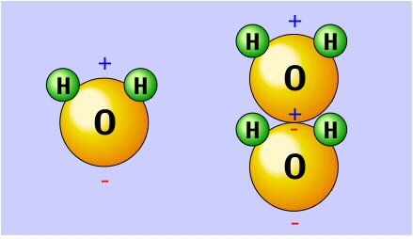

Notice that the negative end of water points towards the positive place (right).

Effects of Water’s Polarity

* Universal _____
* _____ Bonding
  + Density of Water
  + Cohesion
  + Adhesion
  + Surface Tension
  + Capillary Action
  + Water
* Many substances _____ in water so it is commonly referred to as the _____ solvent.
* Because of this, water in nature and in use is rarely pure and some properties may vary from those of the pure substance.

Water Dissolves Substances

* Because of it’s chemical composition, water is able to _____ many _____ and _____.
* Water uses it’s _____ (_____ side to attract _____ ions and it’s _____ side to attract) and dissolve _____ ions.

Dissolving Ionic Compounds

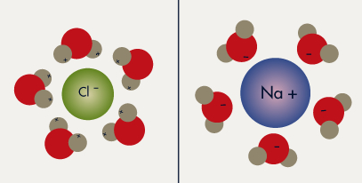

Like Dissolves Like

* Refers to "polar" and "nonpolar" solvents and solutes.
* Basic example: Water is _____. Oil is ___ polar. Water will ___ dissolve oil.
* Water is polar. Salt (NaCl) is _____ (which is considered extremely _____). Like dissolves like, that means _____ dissolves _____, so water dissolves salt.

F2 gas is a molecule composed of two atoms chemically bonded together. Is this molecule polar or nonpolar? Explain.

* Fluorine gas is _____ because the two atoms are identical so electrons pull _____ apart.

If the comb is brought near the water, will anything happen?

* When you bring the _____ comb near the faucet it is _____ to the _____ end of the water. (*in this case – to +*)

Why are water molecules polar?

* The hydrogen and oxygen atoms “fight” over the _____ they share and _____ pulls harder, making it slightly _____. The _____ end is slightly _____.

Hexane has __ carbon atoms (C) & __ hydrogen atoms (H). What is its chemical formula?

* C7H16

If a substance dissolves in water, will it dissolve in vegetable oil, a nonpolar substance?

* Vegetable oil does __ dissolve in water because water is _____ and oil is _____. “Like dissolves _____.” Water dissolves _____ and _____ compounds.

4B Water: Focus Questions

1. Why does water have so many special properties?
2. What is hydrogen bonding?
3. What kind of special properties does water exhibit?
4. What is the difference between “hard” and “soft” water?

Hydrogen Bonds

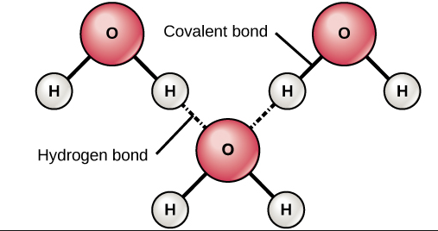 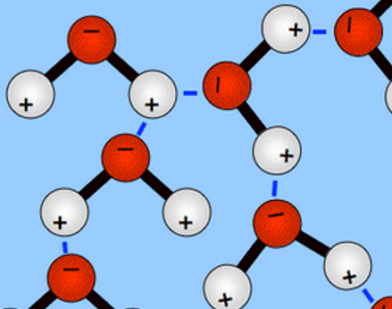

* _____ of bonds spend more time around _____ atom than around hydrogen atom … so a slight _____ charge exists.
* Because of the slight charges, and the fact that “opposites _____”, water molecules organize themselves with _____ bonding.

Unusual Property of Water

* Hydrogen forms water (H20) & other similar compounds using elements of the same “_____” 🡪 H2S, H2Se, and H2Te.
* All four molecules have _____ chemical _____ (elements in same “family”).
* The other three molecules are _____ at room temperature, but water is a _____.

D_____ of Water

* Water is the only substance whose _____ form is _____ dense than its _____ form.
* In it’s solid form (ice), water is able to _____ because the molecules are _____ further _____ as a _____ than as a liquid, making it less dense.

C_____

* The action or property of “_____” molecules _____ together
* Water is strongly cohesive due to its _____ bonds

A_____

* The action or property of “_____” molecules sticking together
* E.g. Adhesive tape

Cohesion and adhesion help explain phenomena such as _____, _____ tension and _____ action.

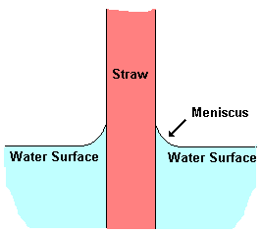 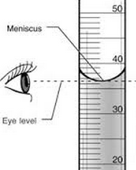

What makes water droplets the way they are; i.e. hanging onto a spider web, keeping their shape …?

* _____ causes water to form drops, _____ tension causes them to be nearly spherical, and _____ keeps the drops in place.

_____ Action

* _____ & _____ cause the liquid to work against _____.
* Cohesion holds the liquid together (sticks to _____)
* Adhesion causes the liquid to stick to the _____ of the _____

T_____

* _____ in a leaf.
* Hydrogen bonds allows _____ between water molecules and cellulose xylem wall.
* Hydrogen bonds allows _____ between water moelcules in xylem
* Uptake across root.

Surface _____

* Capillary action includes the high surface tension produced by _____ and _____.
* Mercury’s cohesion is so great it’s _____ forms a “convex” shape.

_____ Water

Bathtub faucet with built up _____ (hard water).

* Water that contains a significant quantity of dissolved _____ (like _____ and _____).
  + Ca+2 and Mg+2 ions; Limestone, chalk
* Hard water is to blame for dingy looking clothes, dishes with spots and _____, and bathtubs with lots of _____ and soap _____. Even hair washed in hard water may feel sticky and look dull.

Soft Water

* Why would soft water make you feel "not quite clean"? One reason is that when soap and mineral scum are absent, your natural _____ _____ make your skin feel _____, which some people interpret as being “_____”.
* Water _____ is the removal of _____, _____, and certain other _____ ions in hard water. The resulting soft water is more compatible with soap and extends the lifetime of plumbing.

_____ is the only substance where all _____ states of matter (solid, liquid, gas) can be readily observed in everyday life (in nature)