Gradualism Natural Selection

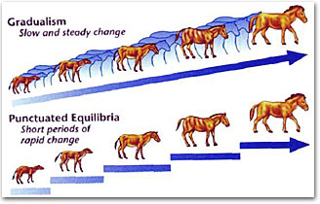

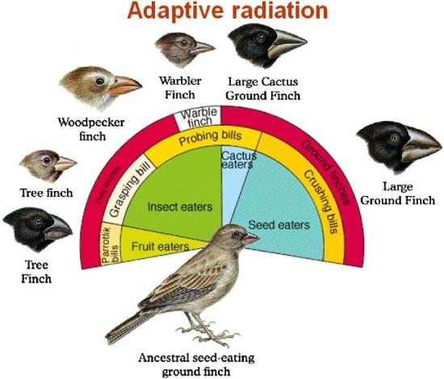

**See** [**https://www.learningctronline.com/courses**](https://www.learningctronline.com/courses) **for Materials and Resources.**

**Topics:**

1. Gradualism Natural Selection

**Objectives:**

1. Identify scientists who advocate evolution and are held in high esteem in the world.
2. Define gradualism and punctuated equilibrium, understanding their components. Explain each theory and why it exists.
3. Discuss a major problem with gradualism.
4. Define and give examples of natural selection, Hardy-Weinberg Principle, Genetic Drift, and Gene Flow.
5. Recognize the Geologic Time Scale (Eon, Epoch, Period, Era).

TAKE NOTE

1. Notes/Study Guide
2. Worksheet Darwin & Natural Selection based on Reference Material
3. Worksheet Natural Selection (based on Power Point)
4. Honors 🡪 Evolution Essay
5. Test … Creation / Evolution / Fossils / Natural Selection
6. Week 20 Devotional (<https://www.learningctronline.com/devotional>)

**Text**: Chapter 18: Evolution: History and Present State pp. 338 – 379

Read the assigned pages in the text. This is optional.

**Class Notes: PowerPoint or PDF**

**Notes/Study Guide:** Fill in the Study Guide worksheet to understand the class notes.

**Homework**: (1 week)

* Use the Darwin & Natural Selection Reference Material to complete the corresponding worksheet.
* Use the Natural Selection Power Point to complete the corresponding worksheet.
* Assignments will be “spot checked” during class or submitted via email.

**Lab**: no labs this week

**TEST:** Creation / Evolution / Fossils / Natural Selection

1) the academic integrity policy

* Tests must be completed **WITHOUT** referring to books, notes, the internet, people, or any outside resources.
* A guardian should be proctoring the test as per Learning CTR Online policy: <https://www.learningctronline.com/test-proctor-policy>

2) This test is composed of 40 multiple choice and 6 essay questions.

* The **test must be taken "in one sitting"**, meaning that once you start the test, you must complete it without interruption.
* Take a short break (5 minutes) during the test.

3) There is a **75-minute time limit** on this test. Please have the proctor write the time taken at the top of your answer sheet with their signature or initials.

4) Proctors should NOT be reading the test or engaging students during the test.

5) Do NOT use RED font. Black font is best.

Supplemental Resources (Optional)

1. Problems with Evolution … Punctuated Equilibrium
2. Evolution Natural Selection Vocabulary Crossword
3. Practice Quiz Evidence of Evolution
4. Outline of Text Chapters 17-19

[***https://somup.com/c31vDmuc3J***](https://somup.com/c31vDmuc3J) ***Incredible Creatures that Defy Evolution 1 (9:04) Dr. Jobe Martin, former evolutionist, Bombardier Beetle and Giraffe***

[***https://somup.com/c31vbiucZy***](https://somup.com/c31vbiucZy) ***Incredible Creatures that Defy Evolution 2 (11:23) Woodpecker, Golden Plover***