Name _____

Water 🡪 composed of two elements, H________ and O_______. __ Hydrogen + __ Oxygen = H2O.

* Nearly ____% of the world’s water is ______ or otherwise undrinkable. Another 2% is locked in ice caps and glaciers. That leaves just ___% for all of humanity’s needs — all it’s a___________, r___________, manufacturing, community, and personal needs.
* Water regulates the Earth’s t_________. It regulates the temperature of the human body, carries nutrients & oxygen to cells, cushions joints, protects organs and tissues, & removes wastes.
* ____% of the human brain is water and ____% of a living tree is water.
* The average total home water use for each person in the U.S. is about ____- ____ gallons a day. [*up from 50 gal/day 25 years ago*]
* The average cost for water supplied to a home in the U.S. is about $_____ for 1,000 gallons, which equals about 5 gallons for a penny.
* Frozen water (ice) is lighter than water, which is why ice ________ in water.

Water Cycle 🡪 E___________🡪 t____________ 🡪 p_____________ 🡪 i_____________

Water (H2O) is formed by __________ bonds (_________ of electrons) between two Hydrogen atoms and one Oxygen atom.

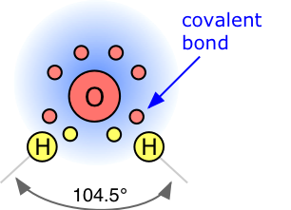

* ___ Hydrogen atoms each share 1 ________ with one Oxygen atom in the covalent bond they make.
* The Oxygen atom has 4 remaining electrons (not used in intermolecular bonds).
* This gives the Oxygen side of the molecule a _________ charge, and the Hydrogen side a slight ___________ charge.
* This creates the _________ characteristic of water (opposite side of the molecule having opposite charges)
* As a result of polarity, water molecules easily bond together.
* Because of it’s chemical composition, water is able to __________ many ions and compounds.

Water is known as the “____________ Solvent”.

* Water uses it’s negative side to attract positive ions and it’s positive side to attract and dissolve negative ions.
* Water’s ability to dissolve things is a good and a bad _________

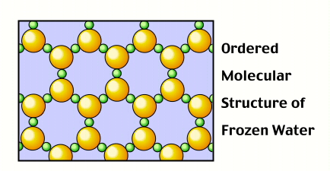

* It’s ______ that water can dissolve salt, sugar, Koolaide, etc…
* But, it’s _____ that water can dissolve toxic chemicals.
* Water is the only substance whose _______ form is ______ dense than its ________ form
* In it’s solid form of ice, water is able to _______ because the molecules are spread further ___________ as a solid than as a liquid, making it less __________.

W________ 🡪 the area of land that _________ rain and snow and drains or seeps into a marsh, stream, river, lake or groundwater.

* Berkley, Huntington Woods and Oak Park are all in the __________ River Watershed.
* In a watershed many t__________ (smaller streams) lead to larger and larger streams, lakes, and eventually to the _________.

Continental D_________

* The dividing line between two continental **____________**.
* In North America water on one side goes to the Gulf of California or the Pacific Ocean (_____)
* And the other side water goes to the Gulf of Mexico and the __________ Ocean.

W_________ – land which water runs off into.

T___________ – smaller feeder streams to larger streams.

M_________ – bends (turns) in a stream.

Stream L_____ – materials carried by a stream.

S____________ load – material carried by the flow of the water

D__________ load – material carried by the stream that is dissolved.

B___ load – material pushed along at the bottom(bed) of a stream.

Meander

* A meander is formed when the _______ water in a stream _______ the outer banks and widens its valley and the inner part of the river has less energy and deposits what it is carrying.
* The result is a *_________* pattern
* Often creates civil engineering ___________ for local municipalities attempting to maintain stable _______ and bridges

Stream Load

* The _______ matter carried by a stream.
* Streams carry solid material as a result of __________.
* Erosion and bed shear stress continually _______ mineral material from the stream ____ & banks of the stream channel, _________ this material to the regular flow of water.

Streams

* A stream is a _______ of water with a current, _________ within a bed and stream banks
* Stream B____ 🡪 is the _______ of the stream.
* Stream B_____ **🡪** The area around a stream that _________ the flow of the water.

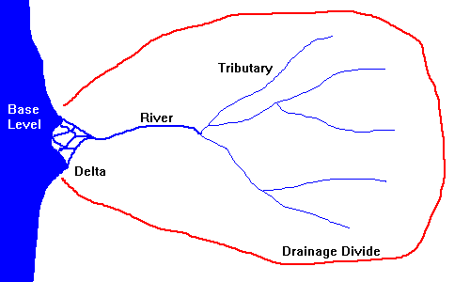

D_________ 🡪 the _________ of water moved by a stream in a given time period.

* G_________ 🡪 change in __________ of a stream over a distance.
* H__________ – ___________ of a stream.
* M_______ – where stream deposits into a _________ body of water.

Stream Features

D_______ 🡪 A triangular shaped deposit created when a stream enters a larger body of water.

F___________ 🡪 An area next to a river or stream that is subject to flooding when a stream ____________ its banks during high water times.

* S__________ deposits are made to this area during these times.

V_________ Formation

* The terms U-shaped and V-shaped are descriptive terms of __________ to characterize the form of valleys.
* A valley formed by ________ water, or *________ valley*, is usually **____ shaped**.
* A valley carved by _________ is normally **___-shaped**
* Streams that have _________, ________ gradient will have more erosive force at the base of the bed of the stream and create a ____-shape.
* Streams that have __________ gradient will have less _________ force at the base of the bed of the stream and create smoother ___-shaped beds.

W________ 🡪 Wetlands are areas that are ___________ by ground water or surface water.

* Some wetlands are ___________, others are year round, but they play an important role in plant and animal _________.
* There are many different types of wetlands, each having it’s own complex relationship with the land plants and animals in the area.
* Wetlands also are very important as natural “________” for groundwater.

G____________ 🡪 is the water located beneath the earth's surface in soil pore spaces and in the fractures of rock formations

* An a_________ is a body of water that exists in the ground.
* The water _________ is the _______ of the aquifer and is called the “Saturation Zone”.
* Groundwater is naturally replenished by surface water from precipitation, streams, and rivers when this __________ reaches the water table
* This water can be tapped for ___________, or crop _____________ by drilling wells.
* Contaminated water can filter into __________ water aquifers and infect them.
* U__________ Zone 🡪 Zone above the aquifer where water does ____ exist in large quantities.
* Saturated Zone 🡪 This is the aquifer, where water _______ between the _______ spaces of sand, gravel or clay particles.

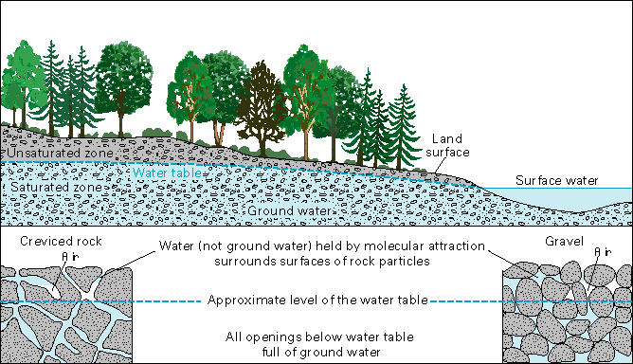

*Label the boxes on the diagram*

* Surface water quality is subject to e__________, r________, p_________, plant matter, animal waste, precipitation & other variables.
* Groundwater is normally ___________ of many contaminants, including some bacteria and viruses. These factors make groundwater an important drinking water resource.
* P___________ A_________ are aquifers that have a confining layer below the groundwater, and sits ________ the main water table.

Groundwater can be c____________

* P________ 🡪 Is the contaminated area of an aquifer.
* Contaminated aquifers move underground just like water does on the surface … it goes to the ________ points
* Ground water moves (flows) through ______, rock and ________ in the rock.
* The ______ at which water flows is dependent on the type of material it flows through.
* Different materials have different properties, allowing water to move at different rates.
  + A_____________ are impermeable (do not allow water through)

Permeability and Porosity

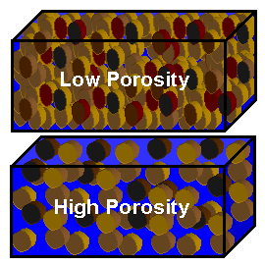

* P____________ refers to the ability of water to flow through a given material.
* If something is impermeable, water ________ flow through it at all (e.g. aquitard).
* P_________ refers to the amount of open space in a given material.
* Material that has _______ porosity (*more _________ space*) will have high permeability (water can ________ flow through) and vice versa.
* S_____/C_____ - _____ porosity/Low Permeability
* S______ – medium porosity/Medium Permeability
* G________ – _______ porosity/high permeability

Groundwater D__________

* Some regions are heavily dependent on groundwater for their _________.
* Mostly of these places are _________ communities, where irrigation is used heavily.
* What is most of the groundwater used for? ______________
* As the ____________ has increased, the groundwater use has increased.

**L______ use decisions and stream erosion**

* C__________ is an ___permeable surface –does not absorb water, water runs over the surface.
* Due to more homes, streets and businesses being built in places that previously had grass and farmlands, water would _________ increases and the water gets to streams more __________.
* This increased the erosive force in these streams, which led to more _________ of the streams.

**N____-P_______ S_______ Water Pollution**

* ____________ are added to water from many __________ sources
* Rainfall or snowmelt produces “________” that picks up and carries natural and human-made pollutants, ___________ them into lakes, rivers, wetlands, coastal waters, groundwater (underground sources of drinking water).
* Contaminated storm water washes off parking lots, roads, highways, and lawns containing debris, oil, fertilizers, pesticides, and much more.

|  |  |
| --- | --- |
| Residential Runoff | Urban Runoff |
| Oil & Gas | Oil & Gas |
| Antifreeze | Industrial Waste |
| F | C________ Products |
| P | P_______ & Solvents |

* Combined S________ Overflow (CSO) is a discharge containing a mixture of storm water and domestic _______ that occurs when the sewer system has ___________ flow capacity during a rain event.
* NPS is the leading cause of _______ pollution in the United States today, with polluted runoff from ___________ the primary cause.

**P________ Source Water Pollution**

* When pollution is ___________ added to the water system from a distinct ___________ source
  + The Exxon Valdez _______ spill
  + Factory outlets that inject __________ directly into surface or groundwater

ANSWERS

Water 🡪 composed of two elements, Hydrogen and Oxygen. 2 Hydrogen + 1 Oxygen = H2O.

* Nearly 97% of the world’s water is salty or otherwise undrinkable. Another 2% is locked in ice caps and glaciers. That leaves just 1% for all of humanity’s needs — all its agricultural, residential, manufacturing, community, and personal needs.
* Water regulates the Earth’s temperature. It regulates the temperature of the human body, carries nutrients & oxygen to cells, cushions joints, protects organs and tissues, & removes wastes.
* 75% of the human brain is water and 75% of a living tree is water.
* The average total home water use for each person in the U.S. is about 80- 100 gallons a day. [*up from 50 gal/day 25 years ago*]
* The average cost for water supplied to a home in the U.S. is about $2.00 for 1,000 gallons, which equals about 5 gallons for a penny.
* Frozen water (ice) is lighter than water, which is why ice floats in water.

Water Cycle 🡪 Evaporation 🡪 transpiration 🡪 precipitation 🡪 infiltration

Water (H2O) is formed by covalent bonds (sharing of electrons) between two Hydrogen atoms and one Oxygen atom.



* 2 Hydrogen atoms each share 1 electron with one Oxygen atom in the covalent bond they make.
* The Oxygen atom has 4 remaining electrons (not used in intermolecular bonds).
* This gives the Oxygen side of the molecule a negative charge, and the Hydrogen side a slight positive charge.
* This creates the polar characteristic of water (opposite side of the molecule having opposite charges)
* As a result of polarity, water molecules easily bond together.
* Because of it’s chemical composition, water is able to dissolve many ions and compounds.

Water is known as the “Universal Solvent”.

* Water uses it’s negative side to attract positive ions and it’s positive side to attract and dissolve negative ions.
* Water’s ability to dissolve things is a good and a bad property.



* It’s good that water can dissolve salt, sugar, Kool aide, etc…
* But, it’s bad that water can dissolve toxic chemicals.
* Water is the only substance whose solid form is less dense than its liquid form
* In it’s solid form of ice, water is able to float because the molecules are spread further apart as a solid than as a liquid, making it less dense.

Watershed 🡪 the area of land that catches rain and snow and drains or seeps into a marsh, stream, river, lake or groundwater.

* Berkley, Huntington Woods and Oak Park are all in the Clinton River Watershed.
* In a watershed many tributaries (smaller streams) lead to larger and larger streams, lakes, and eventually to the ocean.

Continental Divide

* The dividing line between two continental **watersheds**.
* In North America water on one side goes to the Gulf of California or the Pacific Ocean (West)
* And the other side water goes to the Gulf of Mexico and the Atlantic Ocean.

Watershed – land which water runs off into.

Tributaries – smaller feeder streams to larger streams.

Meanders – bends (turns) in a stream.

Stream Load – materials carried by a stream.

Suspended load – material carried by the flow of the water

Dissolved load – material carried by the stream that is dissolved.

Bed load – material pushed along at the bottom(bed) of a stream.

Meander

* A meander is formed when the moving water in a stream erodes the outer banks and widens its valley and the inner part of the river has less energy and deposits what it is carrying.
* The result is a *snaking* pattern
* Often creates civil engineering problems for local municipalities attempting to maintain stable roads and bridges

Stream Load

* The solid matter carried by a stream.
* Streams carry solid material as a result of erosion.
* Erosion and bed shear stress continually remove mineral material from the stream bed and banks of the stream channel, adding this material to the regular flow of water.

Streams

* A **stream** is a body of water with a current, confined within a bed and stream banks
* Stream Bed 🡪 is the bottom of the stream.
* **Stream Bank 🡪** The area around a stream that directs the flow of the water.



Discharge 🡪 the volume of water moved by a stream in a given time period.

* Gradient 🡪 change in elevation of a stream over a distance.
* Headwaters – beginning of a stream.
* Mouth – where stream deposits into a larger body of water.

Stream Features

Delta 🡪 A triangular shaped deposit that is created when a stream enters a larger body of water.

Floodplain 🡪 An area next to a river or stream that is subject to flooding when a stream overflows its banks during high water times.

* Sediment deposits are made to this area during these times.

Valley Formation

* The terms U-shaped and V-shaped are descriptive terms of geography to characterize the form of valleys.
* A valley formed by flowing water, or *river valley*, is usually **V shaped**.
* A valley carved by glaciers is normally **U-shaped**
* Streams that have steeper, taller gradient will have more erosive force at the base of the bed of the stream and create a V-shape.
* Streams that have lower gradient will have less erosive force at the base of the bed of the stream and create smoother U-shaped beds.

Wetlands 🡪 Wetlands are areas that are saturated by ground water or surface water.

* Some wetlands are seasonal, others are year round, but they play an important role in plant and animal habitat.
* There are many different types of wetlands, each having it’s own complex relationship with the land plants and animals in the area.
* Wetlands also are very important as natural “filter” for groundwater.

Groundwater 🡪 is the water located beneath the earth's surface in soil pore spaces and in the fractures of rock formations

* An aquifer is a body of water that exists in the ground.
* The water table is the top of the aquifer and is called the “Saturation Zone”.
* Groundwater is naturally replenished by surface water from precipitation, streams, and rivers when this recharge reaches the water table
* This water can be tapped for drinking, or crop irrigation by drilling wells.
* Contaminated water can filter into ground water aquifers and infect them.
* Unsaturated Zone 🡪 Zone above the aquifer where water does not exist in large quantities.
* Saturated Zone 🡪 This is the aquifer, where water exists between the open spaces of sand, gravel or clay particles.



*Label the boxes on the diagram*

* Surface water quality is subject to erosion, runoff, pollution, plant matter, animal waste, precipitation & other variables.
* Groundwater is normally filtered of many contaminants, including some bacteria and viruses. These factors make groundwater an important drinking water resource.
* PERCHED AQUIFERS are aquifers that have a confining layer below the groundwater, and sits above the main water table.

Groundwater can be contaminated

* Plume 🡪 Is the contaminated area of an aquifer.
* Contaminated aquifers move underground just like water does on the surface … it goes to the lowest points
* Ground water moves (flows) through soil, rock and cracks in the rock.
* The rate at which water flows is dependent on the type of material it flows through.
* Different materials have different properties, allowing water to move at different rates.
  + Aquitards are impermeable (do not allow water through)

**Permeability and Porosity**



* Permeability refers to the ability of water to flow through a given material.
* If something is impermeable, water cannot flow through it at all (e.g. aquitard).
* Porosity refers to the amount of open space in a given material.
* Material that has high porosity (*more open space*) will have high permeability (water can easily flow through) and vice versa.
* Silt/Clay - Low porosity/Low Permeability
* Sand – medium porosity/Medium Permeability
* Gravel – high porosity/high permeability

Groundwater Depletion

* Some regions are heavily dependent on groundwater for their economy.
* Mostly of these places are farming communities, where irrigation is used heavily.
* What is most of the groundwater used for? Irrigation
* As the population has increased, the groundwater use has increased.

**Land use decisions and stream erosion**

* Concrete is an impermeable surface –it does not absorb water, water runs over the surface.
* Due to more homes, streets and businesses being built in places that previously had grass and farmlands, water would run-off increases and the water gets to streams more quickly.
* This increased the erosive force in these streams, which led to more erosion of the streams.

**Non-Point Source Water Pollution**

* Pollutants are added to water from many different sources
* Rainfall or snowmelt produces “runoff” that picks up and carries natural and human-made pollutants, depositing them into lakes, rivers, wetlands, coastal waters, groundwater (underground sources of drinking water).
* Contaminated storm water washes off parking lots, roads, highways, and lawns containing debris, oil, fertilizers, pesticides, and much more.

|  |  |
| --- | --- |
| Residential Runoff | Urban Runoff |
| Oil & Gas | Oil & Gas |
| Antifreeze | Industrial Waste |
| Fertilizer | Cleaning Products |
| Pesticides | Paint & Solvents |

* Combined Sewer Overflow (CSO) is a discharge containing a mixture of storm water and domestic waste that occurs when the sewer system has exceeded flow capacity during a rain event.
* NPS is the leading cause of water pollution in the United States today, with polluted runoff from agriculture the primary cause.

**Point Source Water Pollution**

* When pollution is DIRECTLY added to the water system from a distinct individual source.
  + The Exxon Valdez oil spill
  + Factory outlets that inject chemicals directly into surface or groundwater