Cytology

Definition: the study of the basic unit of structure and function of living organisms ( cell).

Cell History and the Establishment of the Cell Theory

History

- Cells were not known until the invention and development of microscopes ~1590 AD

- Janssen Brothers – first compound microscope (more than one lens)

- Anton Von Leeuwenhoek & Robert Hooke (Mid 1600’s)

- AVL: Lens grinder (made a spectacle of himself)
- AVL: Observed “animalcules” – described living organisms from pond water (e.g. “cavorting beasties”)
- 300X microscope
- RH: looking at CORK introduced the term: CELL (“big spaces,” “little rooms”)

- Robert Brown (1831)

- Coined the term “NUCLEUS” as a small, dense, round body common in plant cells

- Matthias Schleiden and Theodor Schwan (1838-39)

“Theodor and walk in”

- Schleiden (German Botanist) – all plant tissues are made up of cells (organized in the form of cells)
- Schwann (Zoologist) – all animals are made up of cells
- Together they introduced the first aspect of the Modern Cell Theory

- Rudolf Virchow (1858)

- Pathologist (disease doctor)
- Introduced the second part of the cell theory
- All living things (cells) come from pre-existing cells (“Biogenesis”) – where a cell exists, there must have been a pre-existing cell just as an animal or plant arise from an animal or plant

- Felix Dujardin (1860’s)

- Recognized the existence of one celled organisms

Spontaneous Generation versus Biogenesis

- The big issue to explain where life comes from.

- Abiogenesis

- life arises from non-living entities
- came from myths, superstition and incorrect / poor observations & experimentation

- mice came from hay + dirty rags + 21 days (the gestation period of a mouse)
- frogs and earthworms came from the sky (clouds) – “raining cats & dogs”
- eels arose from slime on the bottom of lakes and rivers
- decaying meat develops into maggots (fly pupa)

- Tried to explain the “VITAL” principle but really was an excuse to remain stubbornly ignorant

- Biogenesis

- Redi – experimentally disproved #4 above in the 1600’s

- used jars with meat and cover (the meat spoiled but no maggots formed)
- used jars with meat and NO cover (maggots)
- used jars with meat and a screen for a cover (the meat spoiled but no maggots)

- proved that flies do not come from meat
- discovered the “VITAL” principle of AIR
- Redi used solid experimentation (control and one variable or experimental factor)

- Needham – (1700’s) – tried to prove Spontaneous Generation

- boiled broth (chicken, lamb, corn) and sealed the jars
- broth would become clouded
- under a microscope, micro-organisms could be observed

- lying/cheating in results to gain fame (e.g. the missing link; in 1983 a report claimed that 2/3 of NON-prescription drugs were ineffective)
- Needham did not thoroughly boil the broth nor seal the jars tightly

- Spallanzani

- Directly proved Needham’s work was in error
- Thoroughly boiled broth; tightly sealed the jars
- Found NO micro-organisms under the microscope
- Elimination or leaving out of the VITAL principle

- Pasteur

- Also attacked Needham’s claims
- Hypothesized that inactive “spores” carried by air were activated in the broth
- Developed a swan-necked flask for his experiments

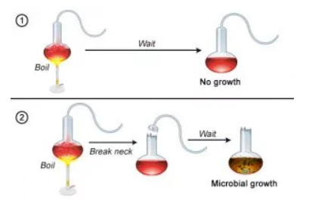

- Pasteur found that the broth could support micro-organisms, but proper boiling kills them … micro-organisms could only return if the broth was exposed to air

Modern Cell Theory

- All living things are composed of cells
- All cells rise from other cells (Biogenesis)
- All the metabolic reactions of a living organism take place within cells (LIFE FUNCTIONS)

Cytological Tools

- Microscopes – “micro” (small) & “scope” (to look at) – important in the discovery of cells

- Magnification and resolution

- magnification – an increase in the apparent size of an image
- resolution – the ability to get a sharp, clear image OR the ability to separate two points
- as magnification increases, resolution decreases

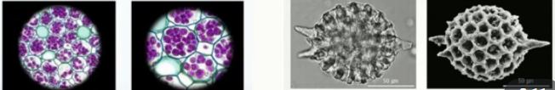

- Stereoscopic / Binocular Dissection Microscope

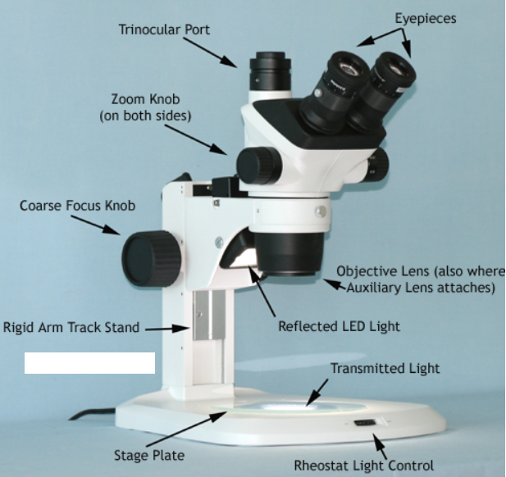

- Description

- allows vision of opaque objects (light cannot pass through them)
- uses reflected light
- high resolution despite low magnification

- Advantages

- allows actual appearance of an object (not reversed or inverted)
- 3-dimensional view

- Disadvantages

- low magnification (5 to 50 X)
- cannot distinguish small objects (cells, etc.)

- Standard light compound microscope

- Practical ($500 to $2000)
- Can use staining techniques – often kills specimen, however
- Magnification up to 400X – 2000 X – above this, light is refracted too much to give a clear image
- Resolution as low as 0.2 um (micrometers) – Red blood cells (7 um)
- Image inverted and reversed (letter “e” lab)

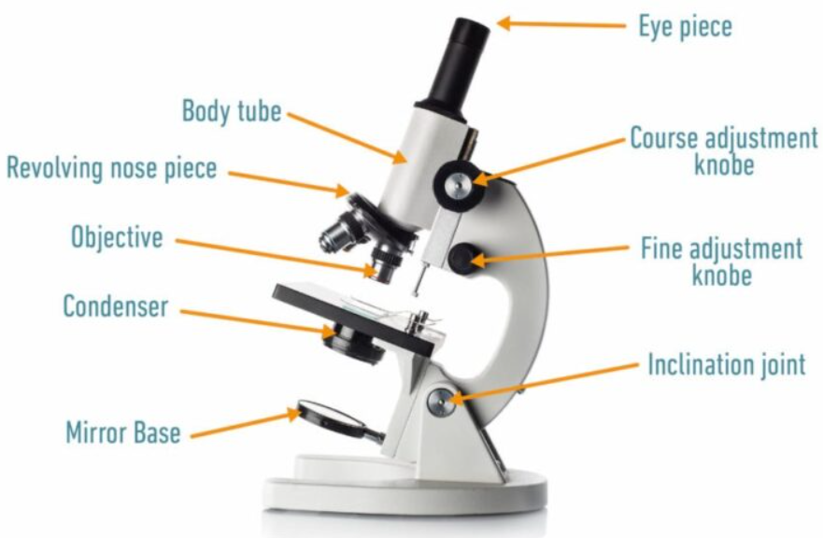

- Phase Constant Microscope

- Same resolution and magnification potential as a compound microscope (1800 – 2000 X)
- Designed to create contrast between parts of a cell or specimen by using small differences in the speed of light.
- USED TO VIEW LIVE SPECIMEN

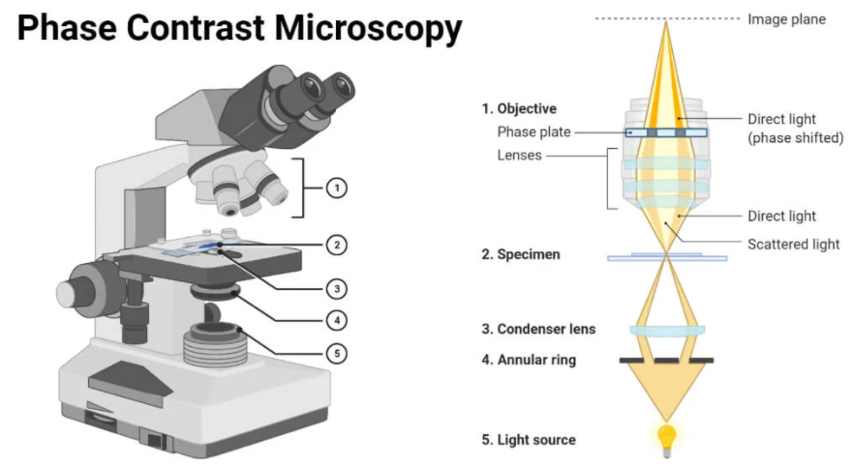

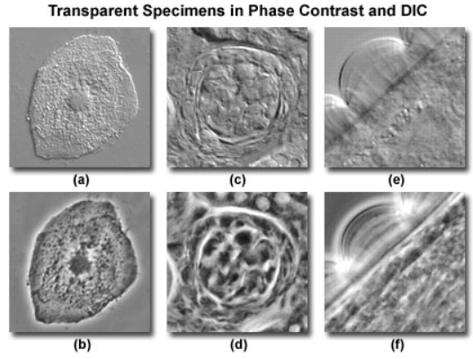

- Ultraviolet microscope – uses UV light

- Radio // microwave // infrared // visible (ROYGBIV) // ultraviolet // X-ray // gamma
>100 m 1m 10⁻⁴ m 10⁻⁷ m or 4000-7000 A 1000 A < 1 A

- Resolution as low as 2000 Angstroms (10⁻¹⁰ m)
- Allows observation of chromosomes within the nucleus

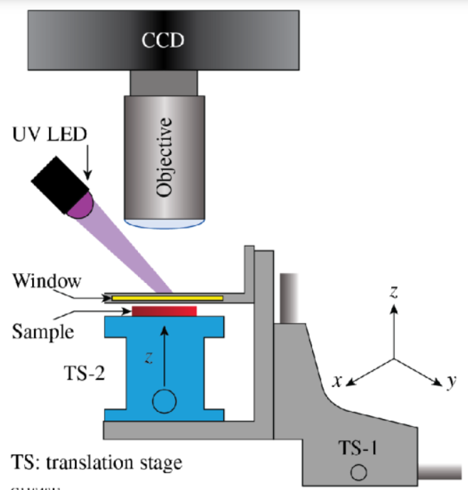

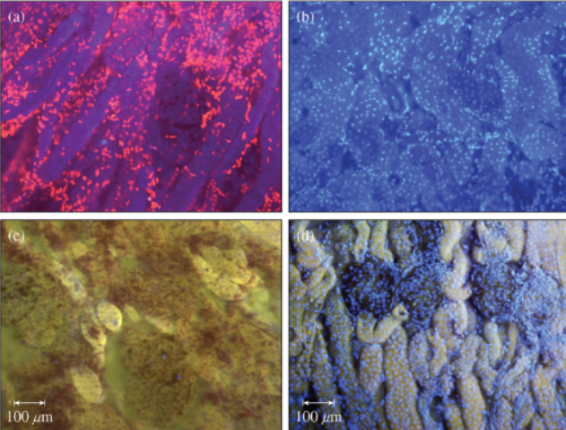

- Electron microscope
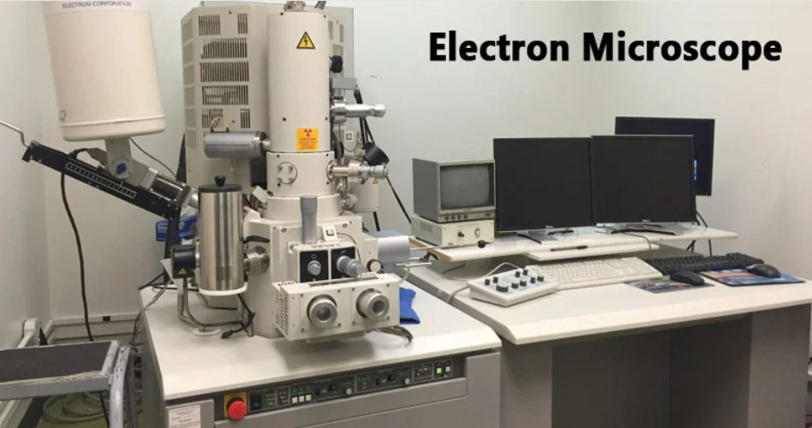
- Advantages

- Electrons are guided by a series of magnets, through the specimen onto a photographic plate
- Magnification up to 1 million X
- Resolution as low as 10 angstroms (A)

- Disadvantages
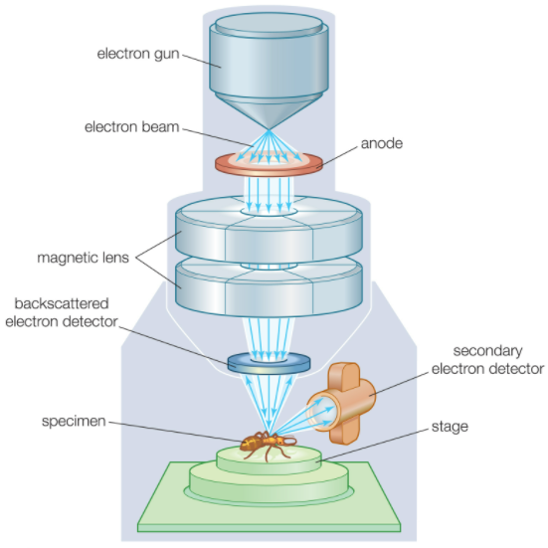

- specimen sections are extremely thin (fragility)
- specimen must be dry (dead)
- VACUUM needed to allow movement of electrons

- SCANNING ELECTRON MICROSCOPE

- Same magnification and resolution potential
- Views only the OUTER surface of an organism
- 3 dimensional

- Microtome
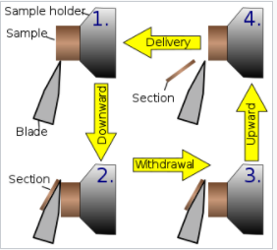

Preparing for the Microtome
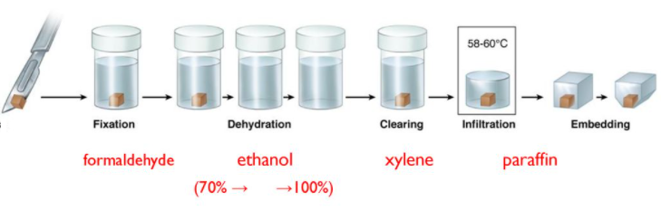
- An instrument used that can slice tissues into extremely small or thin sections so that light can readily pass through the specimen & fine detail can be observed
- Specimen preparation –
- Alcohol bath (remove water in specimen)
- Fixative
- Embedding in a paraffin bath
- melt paraffin away
- Slice (microtome) and mount on slide
- stain
- Slices as thin as 10 um
- Karyotyping Microtus pennsylvanicus (field mouse)

- Micro-dissection Instruments

- Tiny tools that enable the biologist to dissect cells or parts of cells and to remove or transplant cell structures from cell to cell
- Must be seen through a compound microscope (up to 2000 X magn.)
- Very precise; tedious & time consuming
- Eye surgery or other kinds of microsurgery
- Can be used to work with cytoplasmic or nuclear organelles

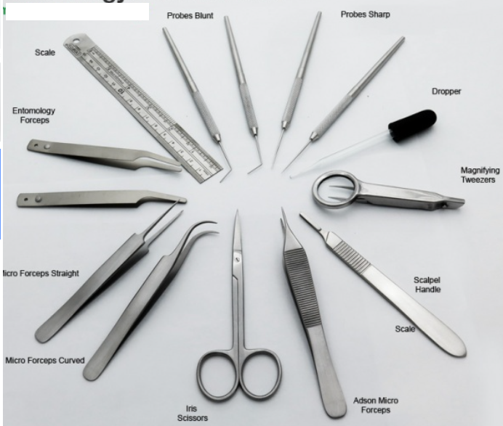

- Ultracentrifuge
Less
dense
- Spins cells around at very high speeds, causing cell components to separate into layers according to the density of the components present in the sample
- Denser components settle to the bottom of the centrifuged samples
denser
- Allows for larger samples to be tested

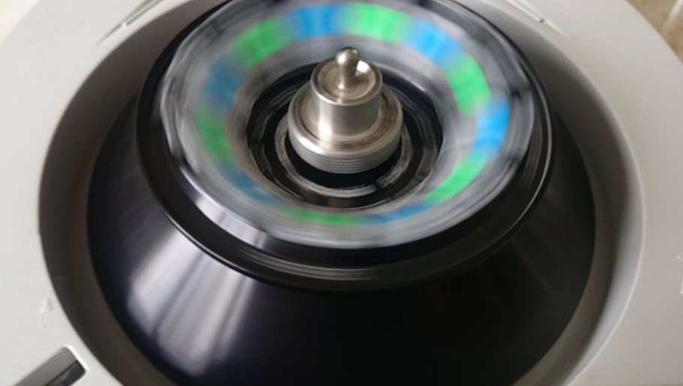

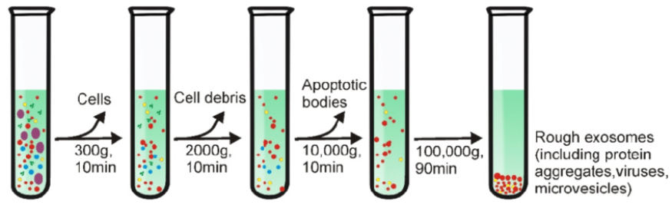

- Chromatography

- Further separation of chemical substances that centrifuging could not (e.g. proteins to amino acids)
- Uses capillary action to draw substances up the chromatography paper according to density

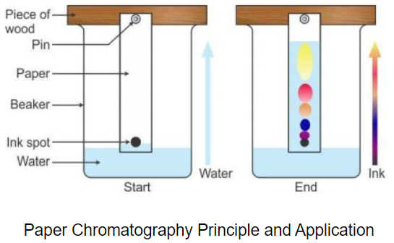

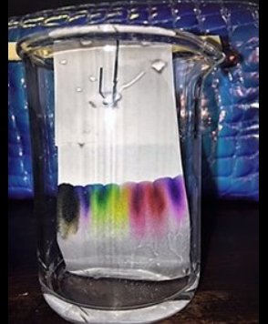

Generalized Cell Structure

Cell size

- 0.5 to 40 um (microns/micrometers) - Most cells are small and can only be distinguished with the use of a microscope
- A few cells are quite large such as bird eggs and nerve cells (up to 3-4 feet long)
- Why are cells so small?

- the nucleus can exert proper control over the entire cell
- to pass needed materials across the cell membrane is based on surface area and volume
- ½ gallon (1 container) with 6 surfaces
- 8 containers with 48 surfaces for materials to pass over

ACTIVITY: Hand out a piece of scrap paper. Have students measure the length and width of the sides. Multiply the dimensions to find the surface area.

Fold the paper in half and tear carefully. Fold each half in half again and tear carefully. Now measure the L and W of every single side, multiplying L X W in each case. Add all the “area” measurements to get a total.

- as volume increases, surface area decreases
- cells are normally circular/spherical so more surface is available
r
Surface area = related to r² ( ∏r² )

Volume = related to r³ ( 4∏r³ / 3 )

Radius: r = 2 r = 3 r = 4

S.A./Vol.: 4/8 9/27 16/64
One half one third one fourth

Best absorption less absorption

- reactions in cells must be quick and efficient

Demo: Sponge to demonstrate surface area to volume ratio
- Use a larger sponge and soak it in water
- Ring out the sponge into a container and mark where the water level comes up to (use masking tape below the level)
- Cut the sponge into four equal sized pieces
- Repeat the process using the four pieces and empty the water into the same container noting the level the water rises to

Gross Structure and Function of a Cell

- Cell wall

- a plant structure that is unique to plants
- gives rigidity and support to the plant cell
- made up of cellulose and lignin

- Protoplasm

- The living, functional part of the cell
- Discovered by Johannes Purkinje, Max Schultze & Justus Von Liebig

- Cell membrane

- regulates movement of materials into and out of the cell
- creates a boundary for the protoplasm
- 90 angstrom thick (9 x 10⁻⁹ m)
- also called the plasma membrane – made up of lipids and protein
5) Life Functions: sensitivity, absorption

- Nucleus

- control center of the cell
- Life Functions: reproduction, regulation, homeostasis

- Cytoplasm

- carries on most of the cell activity (life functions)
- Life Functions: assimiliation, respiration, transportation, digestion, growth
Cell membrane

Cell wall

Nucleus

Cytoplasm

- Life Function Cycle
Respiration
- “breathing”
- ENERGY
Ingestion
Digestion
Absorption
Assimilation

Reproduction
Growth
Locomotion
Irritability
Secretion

Excretion
Egestion

Detailed Cell Structure

Cell or Plasma Membrane

- Structure

- two layers of phospholipids with proteins floating in the lipids like icebergs
- some proteins remain on the outer surface of the cell membrane
- other proteins extend all the way through the membrance and act as gates for substances entering the cell
Phosphate “head”
Protein
gate
Lipid “tail” - hydrophobic

- Function

- creates a separate environment within so biochemical processes of life can take place
- regulates materials that enter and leave a cell – PERMEABILITY
- interacts with other cells to form tissues
- recognizes attacking viruses, diseases & antibodies
- responds to hormones (chemical regulators of life functions)
- involved in cell division with the nucleus
- Directing traffic across the cell membrane

- Passive transport

- No energy is needed on the part of the cell
- Some molecules dissolve in the lipid layer
- Other molecules dissolve in water and move through the protein gates (tiny pores in the cell membrane)
- A concentration gradient exists
Olean, New York – Ripley’s Believe It or Not
“coasting uphill”

- Diffusion

- Movement of molecules from a region of HIGH concentration to a region of LOW concentration
- Aerosol cans, ink in water, odors, smoke

- Osmosis

- Movement of WATER from a region of HIGH concentration to a region of LOW concentration through a semi-permeable membrane
- Diffusion of water

- Isotonic or Iso-Osmotic Environment
80% water
20% salt, minerals, undissolved materials
Iso-toner gloves (Dan Marino) – “same as hands”
Most environments do not match this scenario
80% water

- Hypo-tonic or Hypo-Osmotic Environment

Consider a balloon full of water that empties
80% water

90% water

- Hyper-tonic or Hyper-Osmotic Environment
- Consider filling a balloon full of water until if bursts
- Animal cells would burst
- Plant cells can withstand the pressure due to cell wall
90% water
10% salt, minerals, undissolved materials
80% water

- Plasmolysis

- Special type of osmosis where water is LOST by a cell to the surrounding environment

- Active transport

- The USE of ENERGY to move materials into and out of cells through the cell membrane
- ATP is the energy used (universal fuel of plants and animals) – made during aerobic respiration in the mitochondria in [Glycolysis] Kreb’s cycle and Cytochrome chain)

- Phagocytosis

- engulfing of materials (larger in size) by cells
- seen with a compound microscope
- common in amoeba, paramecium, euglena (one-celled organisms)

Enzymes digest food, vacuole releases particles
Attaches to cm
engulfment
Vacuole forms

- Pinocytosis

- movement of smaller molecules through the cell membrane
- involves VACUOLES which close over the fluids or materials and carry them to the cell membrane to release outside the cell
- e.g. the wrapping of proteins by the Golgi apparatus – the membrane fuses with the cell membrane and dumps the contents outside the cell

Cytoplasm

- The complex, watery material outside the nucleus and inside the cell membrane.
- The cytoplasm can be divided into two portions:

- Hyaloplasm

- The clear, fluid portion of the cytoplasm composed of water, salts, sugars, proteins, fats and oils, ATP, amino acids, enzymes, Minerals (P, Na, K), nucleotides (DNA), etc.
- It is composed of tiny “buttresses” the equivalent of skeleton bones running throughout the cell called “microtubules”
- Organelles

- Endoplasmic Reticulum

- Membrane structure forming a system of tubes and flattened sacs which is continuous with the nuclear membrane
- Divides the cell into separate compartments. Therefore, different chemical products and activities can be segregated
- Circulation system of the cell – transport substances (mostly proteins) which the cell manufactures for use in other sections of the cell or outside the cell

- Two Types:

- smooth ER – no ribosomes
- rough ER – has ribosomes associated with it

- Ribosomes – 250 angstroms = 25 um

- May be found freely in the cytoplasm but are more normally found attached to the endoplasmic reticulum
- Manufacture proteins (protein synthesis) – amino acids are assembled into enzymes and other proteins

- Golgi apparatus

- Consists of stacks of flat, membranous sacs that are piled one on top of the other
- Packaging center of the cell
- Receives molecules of protein from the ER cavities, wraps up large numbers of these molecules into a single membranous envelope and send the package on its way to the cell’s surface (plasma membrane)
- Stores proteins in an inactivated state to be activated in the futrue by altering the protein
- Some components of the cell wall (plants) are assembled in the golgi body and transported to the cell wall

- Lysosomes

- Concentrated packets of digestive enzymes produced by the golgi apparatus and ER
- They exist in ANIMAL cells only – not in plant cells (plant cells have their own organelle to accomplish the same function)
- FUNCTION: digestion of materials engulfed by protozoans and white blood cells (lymphocytes) – digest bacteria and diseases

2. Organelles - continued
d. lysosomes

- AUTOLYSIS: destruction of the cells programmed to die
- Metamorphosis in insects and amphibians
- Exposure to certain carcinogens
- Starvation
- Destruction of cells injured by the lack of oxygen

- More than 30 hereditary diseases are linked to the lack of digestive enzymes in the lysosomes
- Arthritis is the leaking of the lysosome enzymes which digest sinovial fluid for the joints

- Mitochondria

- Characteristics:

- Largest organelle found within the cell
- Rod-shaped
- Outer and inner membranes
- Number per cell varies drastically depending on the tissue (e.g. liver 2500/cell; amoeba 500,000/cell)
- Contain hereditary material (DNA) and can make copies of themselves

- Function

- POWERHOUSE of the cell – converting glucose into the cells universal energy source: ATP
- Involved in the breakdown of fatty acids and amino acids so as to recover their energy
Christae
- Involved in the formation of urea (metabolic waste) which will be expelled eventually by the kidneys
Outer Membrane
Inner Membrane
- May hold clues to certain diseases such as cirrhosis of the liver (replacement of liver tissue with fat tissue), muscular distrophy, bursitis or arterial diseases.

- Plastids

- Membrane-bound organelles found only in plants and algae
- Possess internal membrane systems that may be folded intricately
- Three types:

- Leucoplasts

- Stores starch or sometimes proteins and/or oils
- Likely to be numerous in storage organs such as roots (e.g. potatoes)
- Colorless

- Chromoplasts

- Contain pigments and are associated with the bright orange and yellow colors of fruits, flowers and vegetables

- Chloroplasts

- Chlorophyll-containing plastids in which photosynthesis occurs

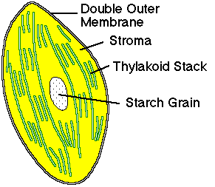
GRANUM (stack of Thylakoids) internal membrane structures where enzymes are found that carry on photosynthesis
STROMA
LAMELLA
Light capturing reactions; contain chlorophyll and pigments
STROMA dense solution full of C based compounds en route to sugar (energy)

Cilia and flagella

- Long, thin structures that extend from the surface of many types of cells (9 – 2 arrangement)
- Flagella are longer than the cilia
- There are normally more cilia/cell than flagella/cell
- FUNCTION
- Movement of the cell itself (paramecium)
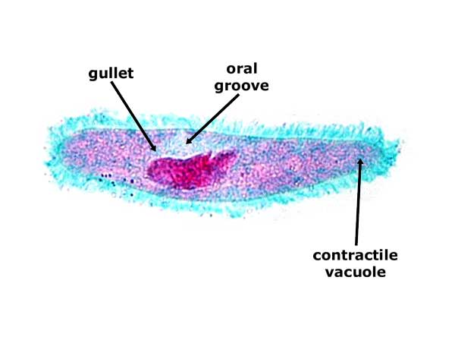

- Movement of materials across the surface of the cell membrane in various tissues (e.g. sperm, respiratory tract cells)

- Centrioles

- TWO small cylinders containing nine microtubule triplets (9 – 0 arrangement)
- Analogous to “bones” of the skeleton
- Found in animal cells only
- Located near nucleus – function related to cell division in the formation of spindle fibers to pull the cell apart during mitosis
- Similar in structure to cilia or flagella

- Vacuoles

- A space in the cytoplasm filled with water and solutes and are surrounded by a membrane
- Found primarily in plants where they tend to be large
- Also found in animals where they tend to be small
- FUNCTION – storage of water, enzymes, food, etc.

Nucleus

- Robert Brown first discovered the nucleus, but didn’t know its function; Anton Von Leewenhook saw but had no idea what it was.

- Usually the most conspicuous structure in the cell
- Responsible for CONTROL

  - Directs chemical activity of the cell (metabolism)
  - Cell reproduction (cell division)
  - Cell differentiation – cells take on differences (specialization) and can form into different tissues

- STRUCTURE

- Nuclear membrane

- A double membrane with pores and is continuous with the endoplasmic reticulum of the cytoplasm

- Chromosomes

- Thread-like structures composed of DNA (genes) and they exert control over the cell genetically
- Only visible during cell division when they come together and form “chromatin”
- Organisms of the same species normally have the same number of chromosomes in all body cells
  - Humans 46 Radish 18
  - Horse 66 Cabbage 18
  - Dog 78 Cat 38
  - Lobster 200

- Nucleolus

- Appear to be TWO nucleoli, but there may be more
- The nucleus is the site of ribosome construction and are responsible for protein synthesis

Plant Cell Wall

- located outside the cell membrane of plants
- composed of a complex carbohydrate (cellulose) & lignin (chain of amino acids)
- non-living structure
- does not discriminate against materials entering or leaving the cell

- Structure

- See text page 186

- Function

- Withstands wide fluctuations in water concentrations inside and outside the cell
- Gives structural support to plants (rigidity)

Comparison of Plant and Animal Cells

- TRANSPARENCY comparing plants cells with animal cells

Cell Structure | Plants | Animals
Cell Wall | Yes | No
Vacuoles | Large | Small, few
Plastids | Yes | No
Centrioles | No | Yes
Lysosomes | No | Yes

Activity for Understanding Cell Structure

- Use the concept of a HOUSE and a SCHOOL

- Draw an overall “blueprint” of your building

- Label various rooms in your building

- Label the function of the rooms in the building

- Make a comparison between the ROOMS (and their functions) for the house and the school

