#### Work

1. What does the word “work” mean to you?

* Hand out scrap paper and have students write their comments
* Is studying work? Is life guarding work? Do people “go to work”?
* General, specialized, technical definitions

<http://somup.com/cFX2bhniR8> Work & Power Song (3:30)

2. WORK = a force applied on an object and the distance that force operates.

* Pick up a book
* Throw a ball
* Carry a book at the same height (NO WORK DONE)

W = f x d

Joules = newtons x meters

3. **ACTIVITY**: “Rebound Measurements”

4. How do PE and KE relate in terms of work?

* Compare potential energy (mgh) with Work (f d)

*mg = f in newtons; f x h = f x d*

* Whenever work is done, energy is expended

5. If we do physical work over time, we call this POWER

* Compare a car that does 0 to 60 in 5 seconds versus 10 seconds
* Power = f x d / time

# Power = Work / time

* Horsepower (foot pounds per second) … English measurement units
* Watts (joules per second) … metric measurement units

<http://somup.com/cFX2bQniR9> Work & Power Hockey (5:03)

**Problem 1**: A 900 N mountain climber scales a 100 m cliff. How much work is done by the mountain climber?

W = f x d W = 900 N x 100 m W = 90,000 joules

* *How powerful is the mountain climber if he took 3 hours to climb the mountain?*

3 hours = 3 (60 min/hr)(60 sec/min) = 10,800 s

90,000 j / 10,800 s = 8.3 Watts

* *What if the mountain climber only took 1 hour to climb the mountain?*

1 hour = 1 (60 min/hr)(60 sec/min) = 3,600 s

90,000 j / 3,600 s = 25 Watts

**Problem 2**: A small motor does 4000 joules or work in 20 seconds. What is the power of the motor in watts?

# P = W / t P = 4000 j / 20 s P = 200 watts

# SIMPLE MACHINES

<http://somup.com/cFX2qNniWH> Simple Machines Overview (3:02)

* Help us do work – “makes work easier”
* The actual work output DOES NOT change
* Work OUTPUT = FR x dR 🡪 “resistance”
* Work INPUT = FE x dE 🡪 “effort”
* Force and distance are inversely proportional, meaning as one increases, the other decreases. For instance, if the force of doing the work is decreased, the distance must increase.

**Effort Force** – force needed to do the work on an object (force input)

**Resistance Force** – the force of the object itself (force output) … usually the object’s **weight**

**Mechanical Advantage** – how much a machine helps us do the work

MA = dE / dR = FR / FE

6 Types of Simple Machines

INCLINED PLANES – *a slanted surface which decreases the effort force*

SCREWS – *an inclined plane wrapped around a cylinder*

WEDGE – *an inclined plane that moves … the longer the wedge the less effort force*

LEVERS – *a rigid bar that is free to pivot, or move about, a fixed point (fulcrum)*

2nd class: Hole punch, Stapler, Gas Knob, Universal Weights, Mail box

Go to Physical Science notes PPT – 14B to distinguish classes of levers

PULLEYS -  *a rope, belt, or chain wrapped around a grooved wheel which can change the direction of a force or the amount of effort force*

WHEEL AND AXLE – *two circular objects of different sizes (wheel = the largest object; axle = the smaller object)*

* *Screwdriver*
* *Bicycles*
* *Ferris wheel*
* *Gears*
* *Adjustable wrenches*
* *Doorknobs*
* *Steering wheels*

Wheel & Axle (2 min)

<http://www.youtube.com/watch?v=XlZYPFDjTJM>

Simple Machines normally DECREASE the effort force or angle

* Therefore, they INCREASE the effort distance
* But the actual **WORK DONE or work output does not change**

###### Work Output = FR x dR 🡪 usually the “weight” being moved and the vertical

###### distance it is being moved

###### Work Input = FI x dI 🡪 based on the “effort” put into to accomplish the work

###### output

### LAB: Simple Machines

* **Classes of Levers ACTIVITY**
* **Working with Pulleys Worksheet**

**Simple Machines Project Example:**

<http://www.youtube.com/watch?v=m8W2w9eCitc> Kris Hamilton, Elvin Chen, Trent Wolter

<http://www.youtube.com/watch?v=yw1fn7Nbv8c&feature=youtu.be> Paul Ghafari Arti Vllasaliu

###### Mechanical Advantage

###### Machines have actual mechanical advantage of a machine and ideal mechanical advantage.

###### The mechanical advantage of a machine is the number of times that the machine increases an input force.

* Because friction is always present, the actual mechanical advantage of a machine is always less than the ideal mechanical advantage.

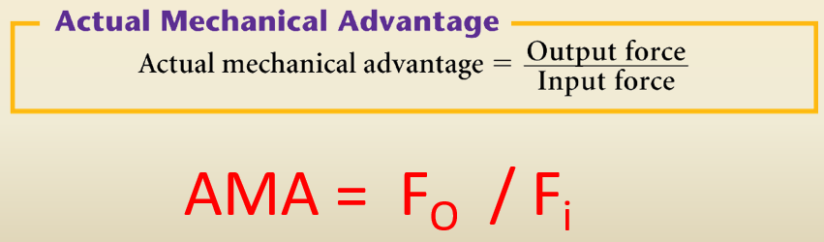

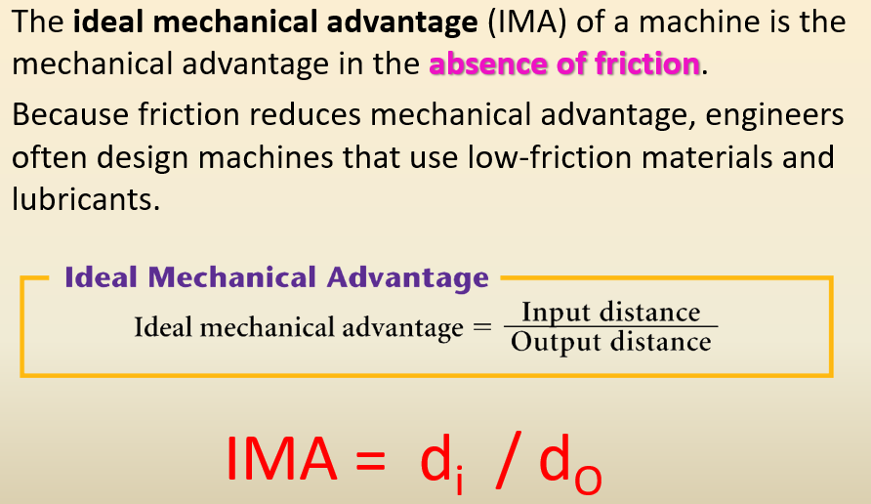

Mechanical Advantage (wedge) = length / width

Mechanical Advantage (screw) = pitch / circumference (of the shaft)

🡪 Pitch = The distance between two adjacent screw threads

= length of screw “turns” / height of screw

Mechanical Advantage (wheel & axle) = radius of wheel / radius of axle

**Compound Machines**: 2 or more simple machines combined

<http://somup.com/cFX2YfniWP> *(3:47)* … “This too shall pass”

**Efficiency**

Work Output = Work Done

Work Input Energy Used

* An ideal machine puts out 100% efficiency … meaning that it does all of the useful work intended
* This never happens in reality because **energy is transferred** and therefore, lost as heat
* Energy is transferred in all machines
* Car wheels (mechanical energy, friction of brake pads turns energy into heat)
* Ropes on the pulleys have friction and therefore, lose energy as heat
* Electricity (energy) is converted into heat (for our homes) and lighting
* Dishwasher uses heat energy to produce steam, plus mechanical energy of the water moving to clean dishes
* Most complex machines give off a lot of waste (e.g. human body 55% efficient; automobiles are 25-40% efficient)

EFF = AMA 🡪 Actual Mechanical Advantage

IMA Ideal Mechanical Advantage