Compass Orienteering

Bearings and General Information

I. Directions: “points” on a map

N

E

S

W

Cardinal Points

- north (N)
south (S)
east (E)
west (W)

- general directions on a map

north = up
east = right The symbol above is found on all maps
south = down
west = left
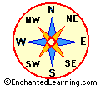
- Inter-cardinal Points

1. northeast (NE) = up + right
northwest (NW) = up + left
southeast (SE) = down + right
southwest (SW) = down + left

16 points of direction

NNE
SNE
NSE
NNW
SNW
SSE
NNW
SSW
north northeast (NNE)
south northeast (SNE)

north southeast (NSE)
south southeast (SSE)

north northwest (NNW)
south northwest (SNW)

north southwest (NSW)
south southwest (SSW)

Using direction points is inaccurate and cumbersome
- One can use “degrees” of a circle for accuracy and ease of use.
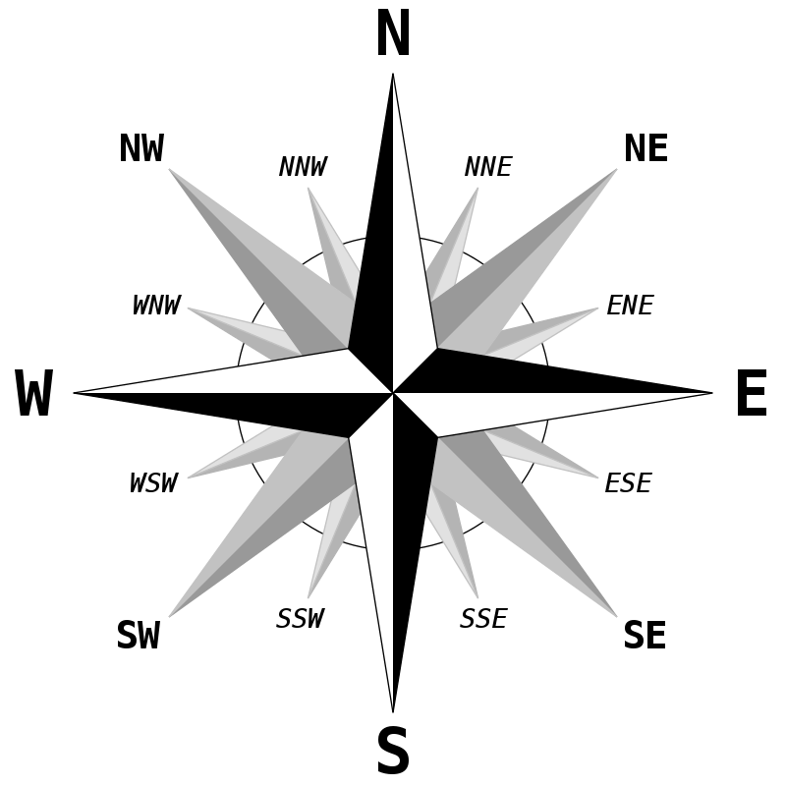

West-northwest (WNW)
North-northwest (NNW)
North-northeast (NNE)
East-northeast (ENE)
East-southeast (ESE)
South-southeast (SSE)
South-southwest (SSW)
West-southwest (WSW)

Basics of the Field Compass
6
2
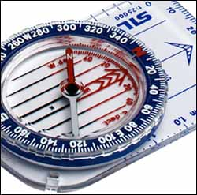

- Parts of a SILVA Compass
3
5
- English Scale (inches)
7
4
- Metric Scale (centimeters)
- Direction of Travel Arrow
- North Sign (Arrow)
- Magnetic Needle (red end points to magnetic north)
1
- 360 Degree Dial
- Orienting Lines (used for mapping)

- Silva Compass Diagram
360◦
0◦

Silva is a name brand for field compasses
315◦
45◦
The numbers in section “A” are shown
on the Silva compass above

90◦
270◦
225◦
135◦

Degrees of a Circle
180◦

- 360 degrees or “points”
- Allows for much greater accuracy than using cardinal and inter-cardinal points
- Mariners or aviation compasses
- use latitude and longitude
- each degree subdivided into 60 minutes
- each minute subdivided into 60 seconds

Types of Bearings

Field or Compass Bearing

- A fixed point indicating a specific direction from magnetic north
- Magnetic north is indicated by the red end of the magnetic needle on a compass
- Field bearings can tell a person what general direction they are travelling or give the general direction an object is in relation to them

Map Bearing

- A fixed point from one place to another on a map
- North (N) is marked by meridians or grid lines

Magnetic Declination
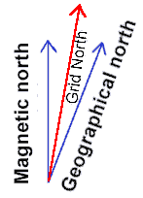
- The angle between TRUE north (geographic North) and magnetic north represents Magnetic Declination.
- Magnetic north is presently located in the Upper Hudson Bay area ~450 miles from true north.
- Declination is produced because the earth is tilted on its axis
- Most topographic maps (maps that show elevation and other land features) give information about declination
- Declination can be ignored when using field bearings or if accuracy is not an important factor

D. Magnetic Declination for the United States

The line of zero declination runs from magnetic north through Lake Superior and across the western panhandle of Florida. Along this line, true north is the same as magnetic north. If you are working west of the line of zero declination, your compass will give a reading that is east of true north. Conversely, if you are working east of the line of zero declination, your compass reading will be west of true north. The exact amount that you need to adjust the declination on your compass to reconcile magnetic north to true north is given in the map legend to the left of the map scale.

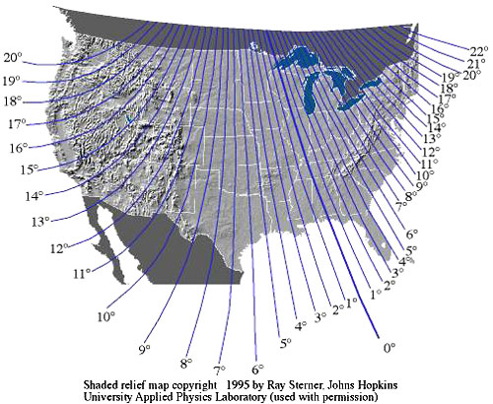

Walking a Bearing
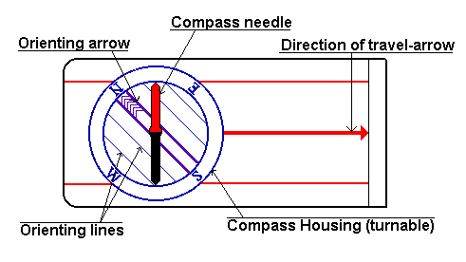

Facing a Bearing

- Set bearing to desired point (degree) on the compass: turn the 360 Degree Dial until the desired point is at “Read Bearing Here” on your field compass

- Hold compass (in hand) level enough to allow the magnetic needle to swing freely. Don’t tilt the compass!

- Be sure the “direction of travel arrow” points straight ahead of you at all times.
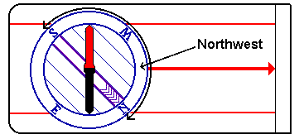

- Orient yourself by turning your body until the RED END of the magnetic (compass) needle rests inside the compass arrow (N Sign Arrow OR “orienting Arrow”).
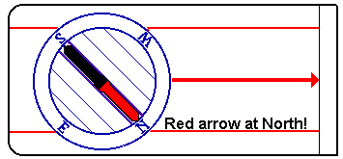

- Look up in the direction indicated by the “direction of Travel Arrow.”

Finding a Landmark

- Once you are facing a bearing and have the RED END of the magnetic needle inside the COMPASS ARROW, carefully raise the compass to eye level

- Start with compass at waist
- Lift compass toward eye level
- Tilt the front of compass up slightly to help find a landmark

- Look straight ahead using the “direction of Travel Arrow” as your reference line.

- Chose a landmark like a tree or pole that is as far away as possible (a close landmark will cause your bearing to be inaccurate because you adjust your bearing while walking. Even a small bearing adjustment causes great error over a distance.)

Walking a Bearing

- Keep your eyes directly on the landmark

- Do not look at the compass while walking the bearing, if you do:

- The bearing will change as you walk along

- The further you walk, the greater the error of your bearing

- Distance

- Pace off a specified number of steps while walking directly toward the landmark you chose.

- Once you have walked this particular bearing, stop. You are ready to set a new bearing.

- Using Field Bearings to Find Direction
1 Starting Position
2
3

Triangle Method

- Uses THREE (3) points of direction
- Round trip (start and finish at the same point)
120 º
120 º
120 º
- Add 120 degrees to each field bearing
Circle = 360º

Triangle = 3 points

3 √ 360 º = 120 º

4. Example of Walking a bearing with the Triangle Method

- Set “Read Bearing Here” to 60◦
3
1
60 º
300 º
180 º
2
25 paces
- Find a landmark a far distance away
- Walk 25 paces toward first landmark
- Add 120◦ to previous bearing (60◦ + 120◦) = 180◦
- Find a second landmark a far distance away
- Walk 25 paces toward second landmark
- Add 120◦ to second bearing (180◦ + 120◦) = 300◦
- Find a third landmark a far distance away
- Walk 25 paces toward third landmark
- You should be back at the starting point

1
2
3
4
90 º
90 º
90 º
90 º
90 º
90 º
90 º
90 º

Square Method

- Uses FOUR (4) points of direction
- Round trip (start and finish at the same point)
- Add 90 degrees to each field bearing

Circle = 360º

Square = 4 points

4 √ 360 º = 90 º

- Example
- Set “Read Bearing Here” to 100º
- Find a landmark a far distance away
- Walk 30 paces toward first landmark
1
190 º
30 paces
4
3
2
100 º
10 º
280 º
- Add 90º to previous bearing (100º + 90º) = 190º
- Find a second landmark a far distance away
- Walk 30 paces toward second landmark
- Add 90º to second bearing (190º + 90º) = 280º
- Find a third landmark a far distance away
- Walk 30 paces toward third landmark
- Add 90º to third bearing (280º + 90º) = 10º
- Find a fourth landmark a far distance away
- Walk 30 paces toward the fourth landmark
- You should be back at the starting point

