Heading
Title
Introduction

Purpose
To examine images of fossils in order to learn about fossils and their role in history.

Discussion
Some people deny the existence of fossils … that is not good science nor good reasoning.
Fossils are the remains or traces of organisms from the past and are always found in sedimentary rock. The study of fossils is called Paleontology.
Types of fossils: preserved, cast, mold, petrified, trace, carbonized. Fossils are the remains of a previously-living life form. Organisms that die rarely leave behind bones that fossilize.
When an animal dies in nature, its body is quickly pulled apart by vultures and other scavengers, big and small. Decomposers like bacteria, fungi, and insects, and physical factors such as water, wind, and sunlight, further break down the body, leaving few remains. Occasionally, PARTS of a dead organism escape decay. If the right conditions exist, then parts of a dead animal can be fossilized before they decay completely.
Trace fossils preserve evidence of an organism’s activities or behaviors. Examples of trace fossils include footprints, nests, eggs, worm burrows, gizzard stones, and even feces.
Sometimes, the remains of an organism are preserved in a virtually unaltered state, meaning that the original composition of the organism is largely intact. Materials such as ice, volcanic ash, amber, asphalt, peat bog, and lake sediment can preserve remains in this way.
Most of the time, however, remains become altered through environmental exposure and decay. There are several types of fossilization processes that can alter an organism’s remains.
In the case of petrification, minerals seep into the remains of an organism and crystallize over long stretches of time, forming a stone version of the original organism.
Carbonization is like making a “carbon copy” of an organism. The carbon contained within the remains of a soft-bodied animal or plant forms a stamp-like impression on the sediment, while the remaining molecules break down.
A mold fossil forms when the remains of an organism leave a mark, an imprint, in sediment that hardens before the organism rots or is washed away.
Sediment can then fill in that mold, forming what looks like a sand or clay version of the organism; this is called a cast fossil. (Molds and casts may sound like trace fossils, but they are considered body fossils because they preserve an aspect of an organism’s anatomy rather than its activity.) A good way to understand the difference between molds and casts is to compare ice to the icetray. In other words, the tray is the mold and the ice is the cast.
One major inference from observing the fossil record is the lack of “intermediates”. This is strong evidence against gradualism since evolution proposes that organisms changed into new species over long periods of time.

Materials 10 images of fossils
Procedures

1. Examine the fossil images.

2. Fill out the Calculations and Data Sheet.

Calculations and Data

 | Type of Fossil | What is it a fossil of? | Diagram of Fossil
1 |  |  | 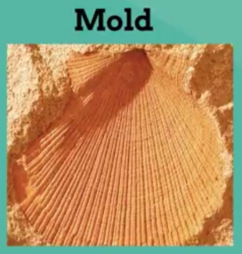
2 |  |  | 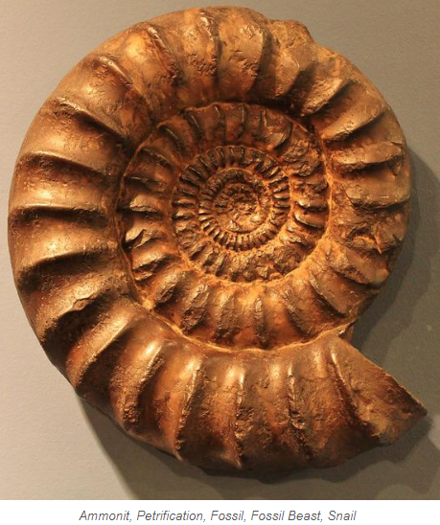
3 |  |  | 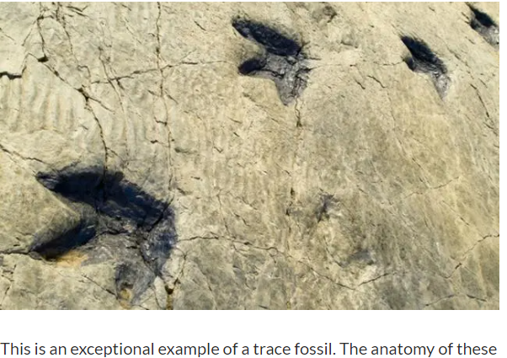
4 |  |  | 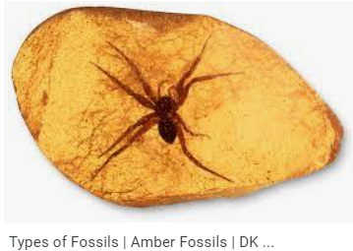
5 |  |  | 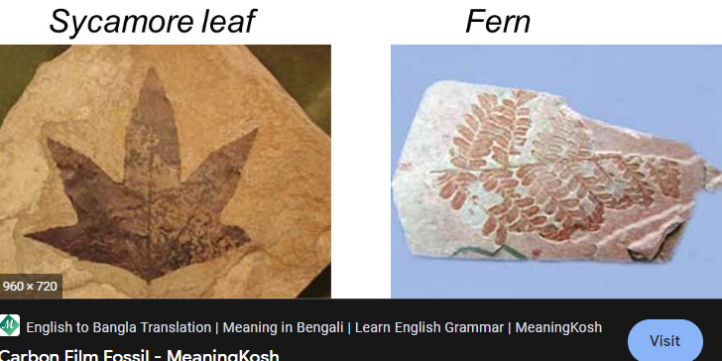

 | Type of Fossil | What is it a fossil of? | Diagram of Fossil
6 |  |  | 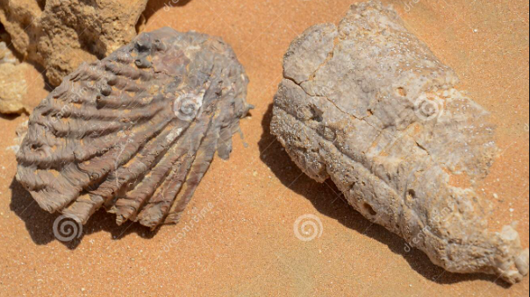
7 |  |  | 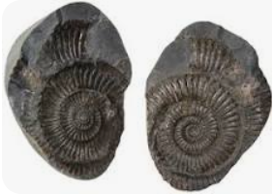
8
9 |  |  | 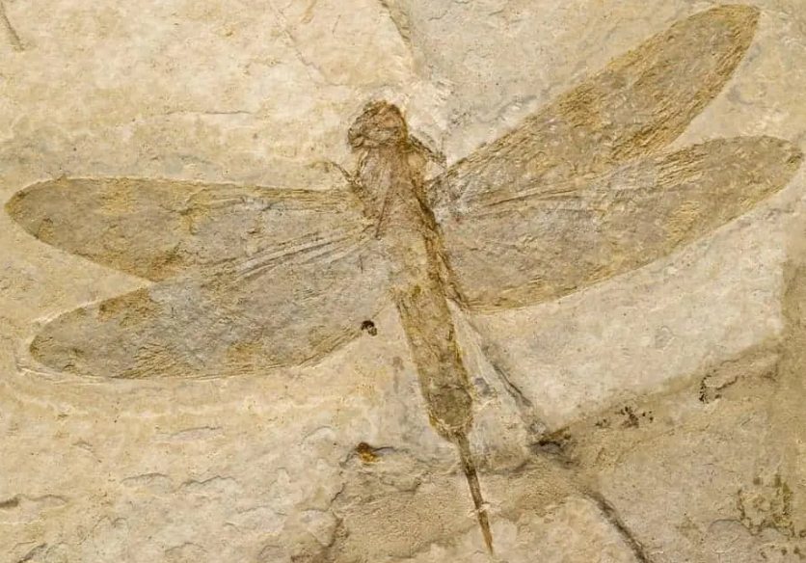
10 |  |  | 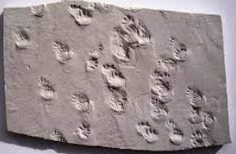

Conclusions and Questions

1. Define what is a fossil and where are they found?

2. List six types of fossils.

3. Which type of fossil would scientists be able to extract DNA from? Explain why this is not possible with other fossils.

4. What type of scientist studies fossils? List some things they can discover from fossils.

5. Suppose you are examining layers of sedimentary rock. In one layer you discover the remains of an extinct relative of the polar bear. In a deeper layer you discover the fossil of an extinct alligator. What can you hypothesize about the changes over time in this area’s environment?

6. What observation can be made with the fossil record that is strong evidence against gradualism?

Answer Key

 | Type of Fossil | What is it a fossil of? | Diagram of Fossil
1 | mold | shell
2 | Petrified | Snail Shell
3 | Trace | Footprints
4 | Preserved (amber) | Insect (spider)
5 | Carbonized | Leaf

 | Type of Fossil | What is it a fossil of? | Diagram of Fossil
6 | Petrified | Shells
7 | Mold & Cast | Ammonites
8 | Carbonized | Fern
9 | Preserved | Insect
10 | Trace | Footprints

Conclusions and Questions

1. Define what is a fossil and where are they found?

Fossils are the remains or traces of organisms from the past and are always found in sedimentary rock.

2. List six types of fossils.

Mold, cast, petrified, preserved, carbonized, trace

3. Which type of fossil would scientists be able to extract DNA from? Explain why this is not possible with other fossils.

Amber or frozen … would allow scientists to extract DNA from because the organisms are preserved. All of the other fossils are NOT the actual organism, but a “remnant” (imprint, cast) of the organism. The organisms have been replaced by minerals.

4. What type of scientist studies fossils? List some things they can discover from fossils.

Paleontologists study fossils. Fossils show 1) various life forms, 2) found in stratified layers of sedimentary rock (deposition), 3) older fossil layers usually found under younger fossil layers, 4) fossils are not grouped together in the same layer, implying that Noah’s flood is not the only source of fossils

5. Suppose you are examining layers of sedimentary rock. In one layer you discover the remains of an extinct relative of the polar bear. In a deeper layer you discover the fossil of an extinct alligator. What can you hypothesize about the changes over time in this area’s environment?

Based on the organisms/fossils found, the environments are very different. For example, the deeper layer (older) had alligators, implying a warm, moist climate. The higher layer (younger) having the relative of the polar bear implies a cold, dry climate.

6. What observation can be made with the fossil record that is strong evidence against gradualism?
One major inference from observing the fossil record is the lack of “intermediates”. This is strong evidence against gradualism since evolution proposes that organisms changed into new species over long periods of time. There is ample evidence of “microevolution” (small transitional changes from organism to organism), but no speciation.

