Roots

Three basic functions of roots are to absorb _____ and minerals, _____ food, and _____ the plant. The two basic root systems are _____ and _____. The type of root system in which there is a single large root with all branches being much smaller is the _____ system. The type of root system in which all the branches of the roots are about the same size is the _____ system. In carrots and sweet potatoes, the root systems are modified for storage. Climbing roots and prop roots are types of _____ root systems that originate not from roots and give stability to the plant or tree.

The tissue that forms a starlike pattern in the center of the roots and transports water is _____. The zone of _____ exists above the root cap and has rapid mitosis from the apical meristem. Meristematic cells increase in length in the zone of _____. The surface area for absorption is increased by the presence of root _____. The outer layer of the root is the _____. The tip of the root is protected by the root _____. The maturation of meristem cells takes place in the zone of _____ where dermal, ground, and vascular tissue are formed. Branch roots grow from the _____.

Label the parts of the root (in the text boxes)

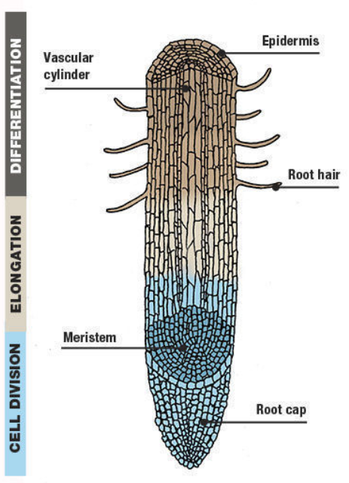

Zone of
Zone of
Zone of

Cross Section of a Root
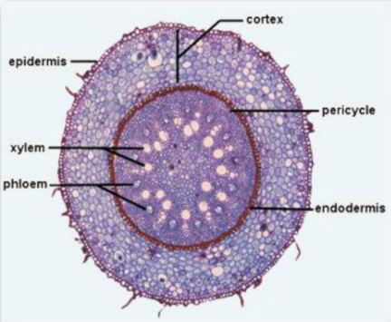

Dicot root

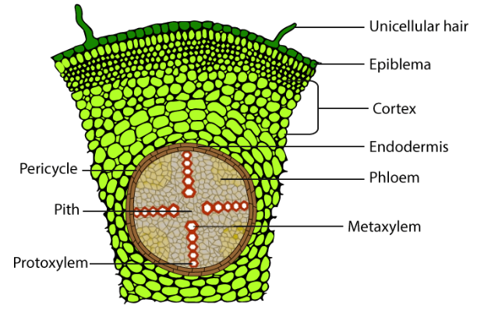

Stems

The stem is the organ that produces and holds the leaves. Most stems grow upward against the force of gravity. However, there are some stems called _____ that grow underground. An example of a plant with rhizomes is the _____ (Bryophyta). And still other stems called tubers that grow underground and are adapted for the storage of food (e.g. potatoes).

In herbaceous dicots the stem is soft, green, and juicy. A cross section shows that there are many _____ bundles arranged in a circle around a central area of _____. The vascular bundles consist of conducting tissues: the _____ transports mainly water and minerals, and the _____ transports sugar. The herbaceous stem is enclosed by a thin epidermis.

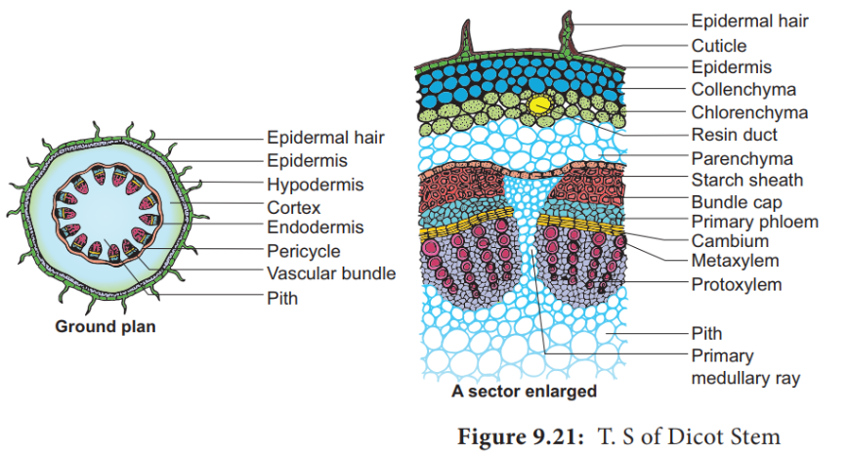

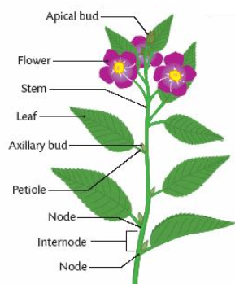

Monocot Stem

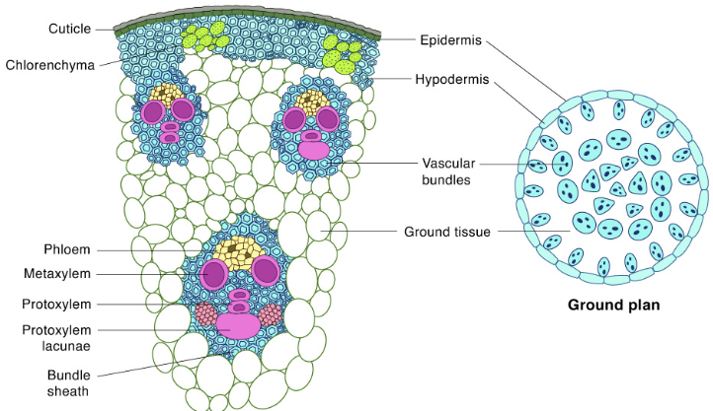

WOODY Stems

In the stem of woody dicots, the _____ tissue is arranged in concentric rings rather that in bundles. The center of the stem consists of _____, which adds turgor to the stem for support. Around it is a ring of xylem, then a ring of cambium, a ring of phloem, the cortex, and the epidermis.

With each growing season, the _____ produces new xylem on its _____ side and new phloem on its _____ side. The seasonal growth of cambium produces _____ rings. Only the newer, outer layers of xylem actually carry fluid (sap) and is called _____. The inner layers of xylem and fibers form the _____. As the tree grows, the inner core of heartwood gets larger and larger.

Bark is produced by meristematic cells. The bark consists of the secondary phloem, cork cambium and cork.

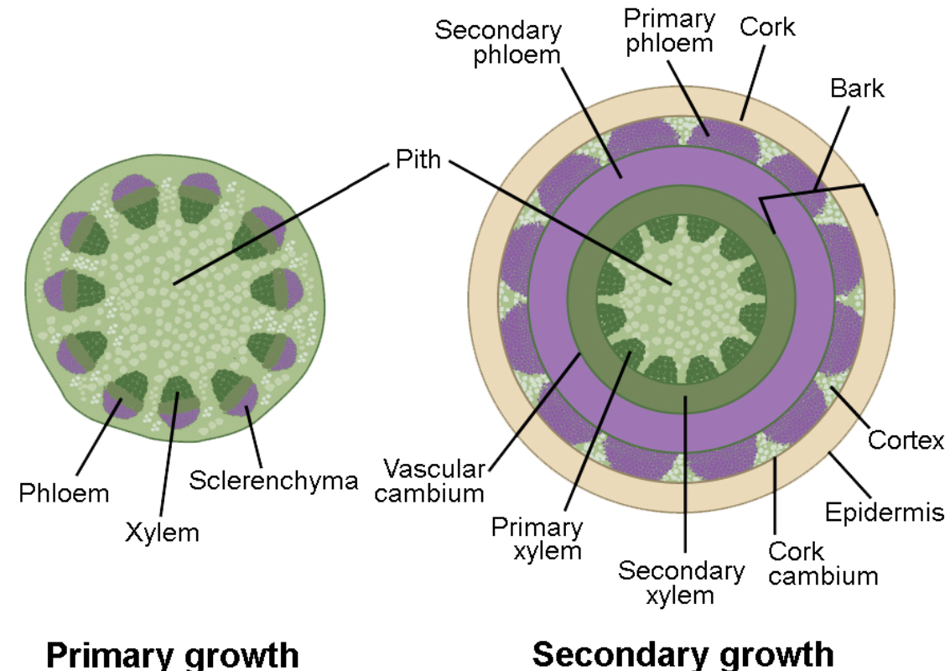

The arrangement of vascular tissues in woody dicots is in _____ rings. Whereas in herbaceous dicots, the vascular tissues form may _____ vascular _____.

Annual Rings
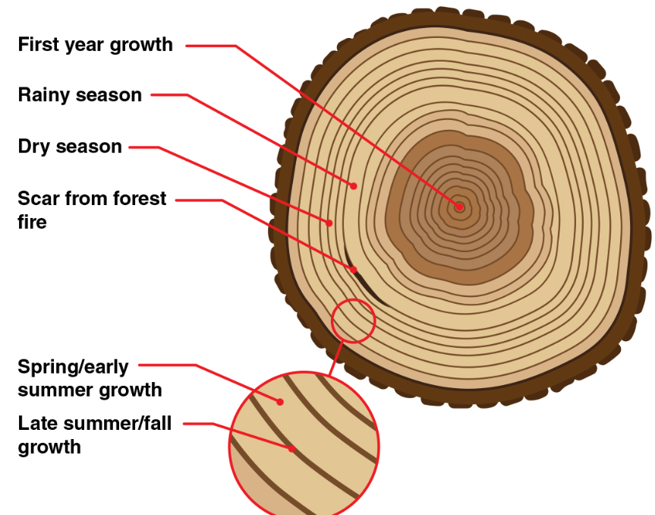

If you’ve ever seen a tree stump, you’ve probably noticed that the top of a stump has a series of concentric _____. These rings can tell us how old the tree is, and what the weather was like during each year of the tree’s life. The light-colored rings represent wood that grew in the _____ and early _____, while the dark rings represent wood that grew in the late _____ and fall. One light ring plus one dark ring equals one _____ of the tree’s life.

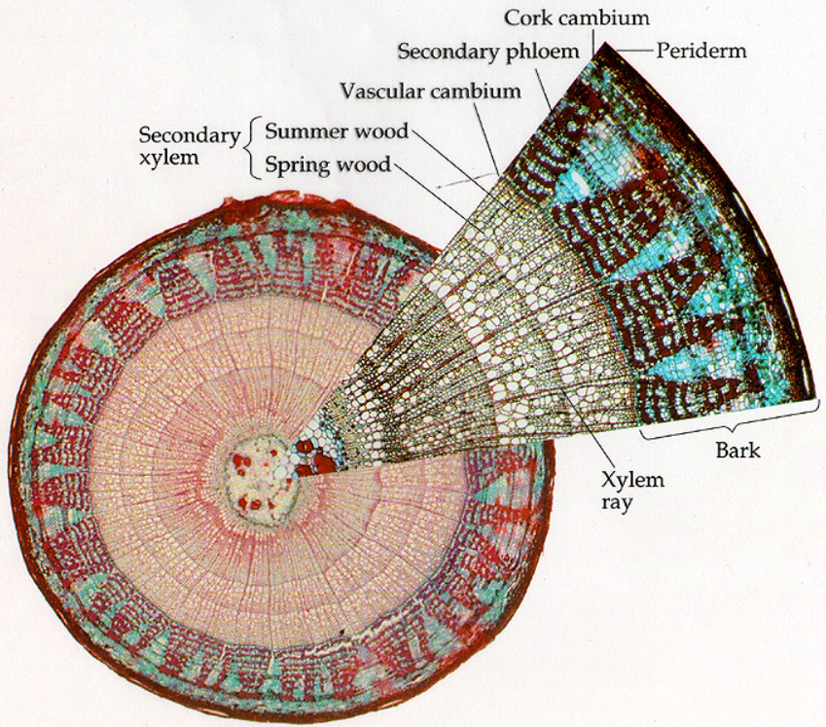

Photosynthesis (color absorption)

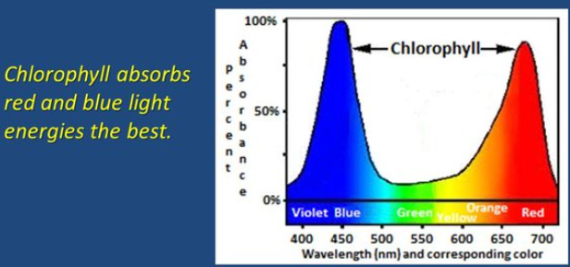

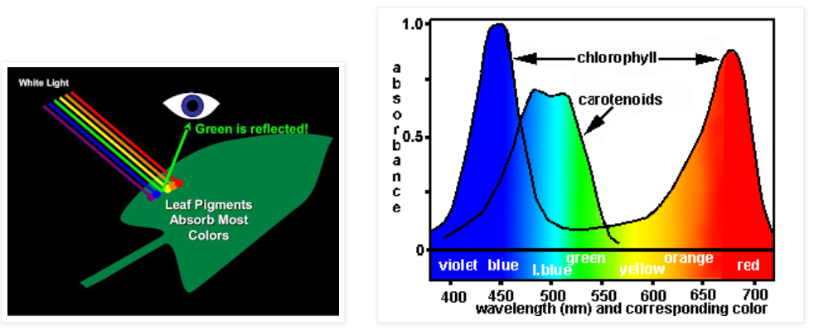

Carotenoids: orange pigments that protect chlorophyll from damage by the formation of single oxygen atoms (free radicals). They can also absorb wavelengths of light that chlorophyll cannot absorb, and pass on some of the energy from the light to chlorophyll. They absorb strongly in the blue-violet range. Carotenoids are usually masked by the green chlorophylls.

Leaves

Leaves are the major _____ organ of plants. They are generally attached to the stem by a _____. The thin, flat part of the leaf is the _____. The outer surfaces of the leaf are covered by a thin, waxy _____ that cuts down on water loss. The _____ secretes the cuticle and is one cell thick surrounding the leaf. In the epidermis, two bean-shaped _____ cells regulate the size of the openings in the leaf, called _____. The stomata allow exchange of gases and water with the environment. The main photosynthetic tissue in the leaf is the _____ between the upper and lower epidermis. Near the upper surface of the leaf, the mesophyll contains densely packed chloroplasts in the _____ layer, also called _____ cells that store food and allow growth of the leaf. Beneath this layer are the loosely packed, moist cells of the _____ mesophyll. _____ cells are unevenly elongated cells that provide support and flexibility to the petiole, leaf veins, and stem, allowing them to bend without breaking.

Monocots generally show _____ veins, while dicots generally show _____ or pinnate veins. Veins contain the vascular tissue.

Anatomy of a Leaf

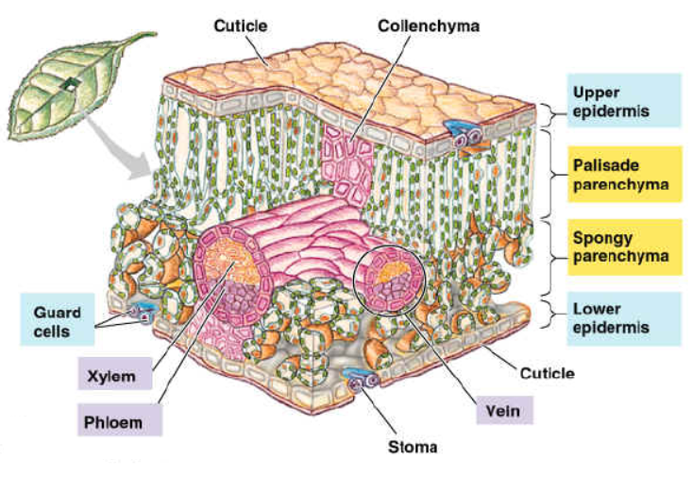

(opening)

Roots

Three basic functions of roots are to absorb water and minerals, store food, and anchor the plant. The two basic root systems are tap roots and fibrous roots. The type of root system in which there is a single large root with all branches being much smaller is the taproot system. The type of root system in which all the branches of the roots are about the same size is the fibrous root system. In carrots and sweet potatoes, the root systems are modified for storage. Climbing roots and prop roots are types of adventitious root systems that originate not from roots and give stability to the plant or tree.

The tissue that forms a starlike pattern in the center of the roots and transports water is xylem. The zone of cell division exists above the root cap and has rapid mitosis from the apical meristem. Meristematic cells increase in length in the zone of elongation. The surface area for absorption is increased by the presence of root hairs. The outer layer of the root is the epidermis. The tip of the root is protected by the root cap. The maturation of meristem cells takes place in the zone of differentiation where dermal, ground, and vascular tissue are formed. Branch roots grow from the pericycle.

Label the parts of the root (in the text boxes)

Cross Section of a Root
Dicot root

Stems

The stem is the organ that produces and holds the leaves. Most stems grow upward against the force of gravity. However, there are some stems called rhizomes that grow underground. An example of a plant with rhizomes is the fern (Bryophyta). And still other stems called tubers that grow underground and are adapted for the storage of food (e.g. potatoes).

In herbaceous dicots the stem is soft, green, and juicy. A cross section shows that there are many vascular bundles arranged in a circle around a central area of pith. The vascular bundles consist of conducting tissues: the xylem transports mainly water and minerals, and the phloem transports sugar. The herbaceous stem is enclosed by a thin epidermis.

Monocot Stem

WOODY Stems

In the stem of woody dicots, the vascular tissue is arranged in concentric rings rather that in bundles. The center of the stem consists of pith, which adds turgor to the stem for support. Around it is a ring of xylem, then a ring of cambium, a ring of phloem, the cortex, and the epidermis.

With each growing season, the cambium produces new xylem on its inner side and new phloem on its outer side. The seasonal growth of cambium produces annual rings. Only the newer, outer layers of xylem actually carry fluid (sap) and is called sapwood. The inner layers of xylem and fibers form the heartwood. As the tree grows, the inner core of heartwood gets larger and larger.

Bark is produced by meristematic cells. The bark consists of the secondary phloem, cork cambium and cork.

The arrangement of vascular tissues in woody dicots is in concentric rings. Whereas in herbaceous dicots, the vascular tissues form may separate vascular bundles.

Annual Rings

If you’ve ever seen a tree stump, you’ve probably noticed that the top of a stump has a series of concentric rings. These rings can tell us how old the tree is, and what the weather was like during each year of the tree’s life. The light-colored rings represent wood that grew in the spring and early summer, while the dark rings represent wood that grew in the late summer and fall. One light ring plus one dark ring equals one year of the tree’s life.

Photosynthesis (color absorption)

Carotenoids: orange pigments that protect chlorophyll from damage by the formation of single oxygen atoms (free radicals). They can also absorb wavelengths of light that chlorophyll cannot absorb, and pass on some of the energy from the light to chlorophyll. They absorb strongly in the blue-violet range. Carotenoids are usually masked by the green chlorophylls.

Leaves

Leaves are the major photosynthetic organ of plants. They are generally attached to the stem by a petiole. The thin, flat part of the leaf is the blade. The outer surfaces of the leaf are covered by a thin, waxy cuticle that cuts down on water loss. The epidermis secretes the cuticle and is one cell thick surrounding the leaf. In the epidermis, two bean-shaped guard cells regulate the size of the openings in the leaf, called stomata. The stomata allow exchange of gases and water with the environment. The main photosynthetic tissue in the leaf is the mesophyll between the upper and lower epidermis. Near the upper surface of the leaf, the mesophyll contains densely packed chloroplasts in the palisade layer, also called parenchyma cells that store food and allow growth of the leaf. Beneath this layer are the loosely packed, moist cells of the spongy mesophyll. Collenchyma cells are unevenly elongated cells that provide support and flexibility to the petiole, leaf veins, and stem, allowing them to bend without breaking.

Monocots generally show parallel veins, while dicots generally show net or pinnate veins. Veins contain the vascular tissue.

Anatomy of a Leaf

