Electric Circuits & Magnetism Chapter 20B & 21
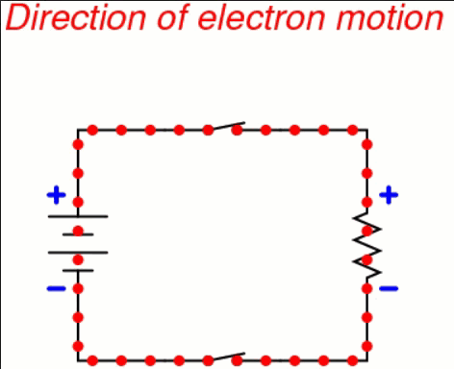

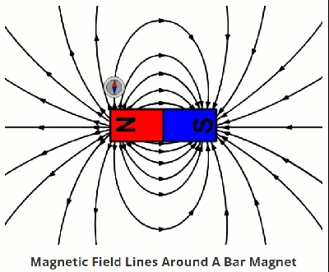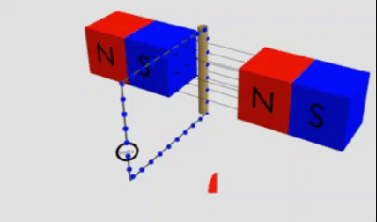

See https://www.learningctronline.com/courses for Materials and Resources.

Topics:
1. Electric Circuits & Magnetism

Objectives:
- Define & explain aspect of electric force (charged ions, forces of attraction & repulsion, Coulomb’s Law, Electric Fields).
- Understand component of electric current and be able to calculate each related to Ohm’s Law (voltage, current, resistance).
- Distinguish between induction and conduction related to transfer of charges.
- Distinguish between static electricity and circuits.
- Describe, draw, and explain the types of circuits (series, parallel, combination).
- Recognize practical applications of electric force & circuits (transmission, overloading).
- Define magnetism, magnetic fields, and electromagnetic induction.

TAKE NOTE

- Guided Reading Note-Taking Worksheet (Pearson Text) (1 week)

- Pearson Concepts in Action Worksheets

- Lab Electric Circuits

- Lab Electromagnetism

- Test Electricity & Magnetism

- Class Song: Don’t You Know it’s Time for Class Now!

- Week 26 Devotional (https://www.learningctronline.com/devotional)

Pearson Text Chapter 20-21: Electric Circuits & Magnetism pp. 628-655

Guided Reading Note-Taking Worksheet:
Complete the worksheet for Chapter 21: Magnetism (21.1 – 21.3).

Class Notes: PowerPoint or PDF Circuits, Power & Magnetism

Homework:
- 20.3 Electric Circuits Worksheet (Pearson Concepts in Action)

- 21.2 Electromagnetism Worksheet (Pearson Concepts in Action)

- Assignments will be “spot checked” during class or submitted via email.

Lab: Electric Circuits

- Complete the lab using the worksheet provided.
- Save the documents into your LAB folder in the Physical Science folder on your desktop.

Lab: Electromagnetism

- Complete the lab using the worksheet provided.
- Save the documents into your LAB folder in the Physical Science folder on your desktop.

- Assignments will be “spot checked” during class or submitted via email.

TEST: Electricity & Magnetism
1) the academic integrity policy

- Tests must be completed WITHOUT referring to books, notes, the internet, people, or any outside resources.
- Students MAY use the approved Periodic Tables, approved Reference Tables, or approved equation (formula) sheet (provided by the teacher) along with calculators and scratch paper.
- A guardian should be proctoring the test. Proctoring means to monitor the following:

2) The test is composed of 20 multiple choice questions and some written problems.

- The multiple-choice test must be taken "in one sitting", meaning that once you start the test, you must complete it without interruption. (40 minutes)

- Take a short break (5-10 minutes)

- The written portion of the test must be taken "in one sitting", meaning that once you start the test, you must complete it without interruption. (30 minutes)

3) There is a 90-minute time limit on this test. Please have the proctor write the time taken at the top of your answer sheet with their signature or initials.

4) Proctors should NOT be reading the test or engaging students during the test.

5) Do NOT use RED font. Black font is best.

Supplemental Resources (Optional)
- Vocabulary Crossword Chapter 20-21
- Electricity & Magnetism Review
- Lab Magnetism
- Lab Magnetic Field Lines
- Electric Devices PPT
- Pearson 21.1 Magnets & Fields WS

http://somup.com/cFX2Yxnjc3 Electric Circuits (Lighting a Plastic Bulb; The Famous Electric Pickle!) (2:17)

http://somup.com/cFXjenninr Electric Pickle (2:07) Stephen Spangler

http://somup.com/cbeoDuRtf Electric Circuits (PHET simulation) (5:46)

http://somup.com/cbeobfRt3 Electromagnetism (PHET simulation) (3:23)

http://somup.com/cYhq2ljaLU Do Not Refuse Him Who Speaks Hebrews 12:25-29; God is in Control (7:10)

