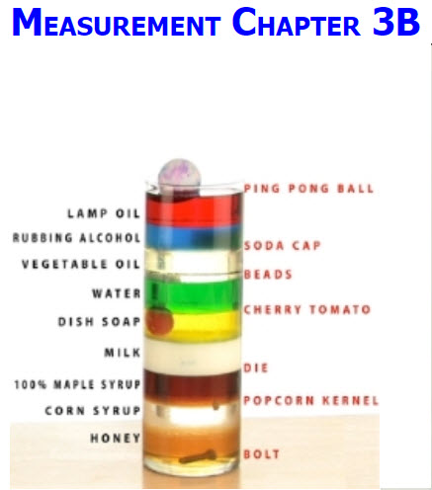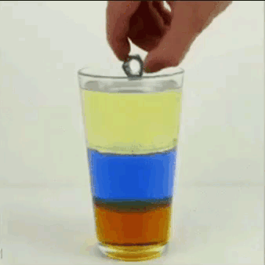

See https://www.learningctronline.com/courses for Materials and Resources.

Topics:
- Scientific Measurement

Objectives:
- Use the Metric System versus the English System
- Write numbers & do calculations in scientific notation.
- Evaluate Accuracy & Precision in Measurements (significant figures)
- Calculate Percent Error as a Measure of Precision
- Understand & Use Units of Mass, Volume, Distance (emphasize Metric)
- Identify the temperature units that scientists commonly use
- Understand & Calculate Density
- Learn to solve problems using dimensional analysis (factor Labeling)

TAKE NOTE

- Notes / Study Guide

- Lesson Check/Sample problems or Alternative Worksheets

- Density Lab for a Formal Lab Report (procedures, calculations and data)

- Honors practical application of accuracy/precision; personal study guide

- Measurement Test

- Week 5 Devotional (https://www.learningctronline.com/devotional)

Text: Chapter 3: Scientific Measurement pp. 84-99

Read the assigned pages in the text.

Class Notes: PowerPoint or PDF

Notes/Study Guide: Fill in the Chapter 3 worksheet to understand the class notes.

Homework: TEXT
(1) Answer the KEYED "Lesson Check" questions at the end of each of the chapter.

(2) Answer the "Sample problems" found in the "Sample Problem" boxes throughout the chapter. An answer KEY is provided for you to use to self-correct your homework problems.

- Put your answers into complete thoughts in a Word document. Do NOT just put the answer, but write a phrase or sentence that you can study from for your tests. Save your work in a WORD document and SAVE into your HOMEWORK folder in the Chemistry folder on the desktop.

- Assignments will be “spot checked” during class or submitted via email.

Alternate Homework:
- Scientific Notation Practice
- Factor Labelling Practice
- Significant Figures Practice

HONORS (research a practical application for Accuracy and Precision) … [no less than 1 hour, no more than 2 hours] or Density Virtual Lab (see Supplemental Resources).

Lab: Density Lab (Formal Lab Report)
Perform the "Density: A Characteristic Property" lab using the Density Lab Worksheet provided. This would include doing the calculations so you practice determining density of various items. You will write up a Formal Lab Report following the guidelines in the Lab Report Format Document within 11 days.
However, you can wait to do the Formal Lab Report until AFTER you take the tests for this unit. The formal Lab Report is due FOUR (4) days AFTER next week's class (11 days from today).
- DO NOT FORGET to subtract out the mass of the graduated cylinder before trying to calculate the mass of the substance alone. Otherwise, your density calculations will be incorrect.
- Give units for all measurements.
- Be sure to SHOW WORK for the density calculations in the Calculations and Data section.
- Include at least THREE PICTURES or IMAGES of your observations and/or objects that you used to calculate the density (e.g. show the object on the electronic scale for mass and the volume in the graduated cylinder). Explain the relevance of the image to the lab. Images must be 600 pixels or less.
Ideally, a picture should be included for each item. You must include a picture of Experiment 5 results.
- There are questions that you need to include in the Conclusion Section of the lab report which are in the Density Lab Worksheet. Do NOT copy and paste or leave these questions, but label their number and make statements. Make sure you answer them in complete sentences that convey a complete thought, giving evidence from the lab experiment to support your answers.
http://somup.com/crQ0IArKB3 (8:55) ... This video goes over how to write the lab report.
Consider using the Lab Report Checklist to ensure that you include ALL aspects of the Formal Lab Report. This is a Formal Lab Report and must be done technically correct.

TEST: Measurement
1) the academic integrity policy

- Tests must be completed WITHOUT referring to books, notes, the internet, people, or any outside resources.
- Students MAY use the approved Periodic Tables, approved Reference Tables, or approved equation (formula) sheet (provided by the teacher) along with calculators and scratch paper.
- A guardian should be proctoring the test. Proctoring means to monitor the following:

2) The test is composed of 20 multiple choice questions and some written problems.

- The multiple-choice test must be taken "in one sitting", meaning that once you start the test, you must complete it without interruption. (40 minutes)

- Take a short break (5-10 minutes)

- The written portion of the test must be taken "in one sitting", meaning that once you start the test, you must complete it without interruption. (30 minutes)

3) There is a 70-minute time limit on this test. Please have the proctor write the time taken at the top of your answer sheet with their signature or initials.

4) Proctors should NOT be reading the test or engaging students during the test.

5) Do NOT use RED font. Black font is best.

Supplemental Resources (Optional)
- Density Virtual Lab

Factor Labelling (Converting Units) Class Notes (8:57)
-------------------------------------------------
Density Demonstration (Intensive Property) ctr (1:02) ... two cans of pop
Density: An Intensive Property ctr (1:12) ... Beware of Whacky Scientists!
Measuring Density Part 1 ctr (0:17) ... distinguishing regular versus irregularly shaped objects
Measuring Density Part 2 ctr (2:57) ... measuring mass and volumes of various objects to determine density.
Calculating Density http://somup.com/crnlDvD2GC (7:01) ... "I love density" & the criss-cross method
No One Can Serve Two Masters, His Eye is on the Sparrow (7:23)

Triangle & Criss-Cross Methods (Dealing with Variables) http://somup.com/crnlDvD2GC (7:01)

