Free Fall Speed

1. Aunt Minnie gives you $10 per second for 4 seconds. How much money do you have after 4 seconds?

2. A ball dropped from rest picks up speed at 10 m/s per second. After it falls for 4 seconds, how fast is it going?

3. You have $20, and Uncle Harry gives you $10 each second for 3 seconds. How much money do you have after 3 seconds?

4. A ball is thrown straight down with an initial speed of 20 m/s. After 3 seconds, how fast is it going?

5. You have $50 and you pay Aunt Minnie $10/second. When will your money run out?

6. You shoot an arrow straight up at 50 m/s. When will it run out of speed?

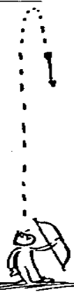
7. Based on #6, what is the arrow’s speed 5 seconds after you shoot it?

8. Based on #6-7, what is the arrow’s speed after 6 seconds? 7 seconds?

Free Fall Distance

1. Speed is one thing; distance another. Where (what distance) is the arrow that was shoot up at 50 m/s when it runs out of speed?

2. How high will the arrow in question 1 be 7 seconds after being shot up at 50 m/s?

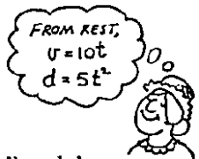
3. Aunt Minnie drops a penny into a wishing well and it falls for 3 seconds before hitting the water.
a. How fast is it going when it hits?

b. How far down is the water surface?

c. What is the penny’s average speed during its 3 second drop?

4. Aunt Minnie didn’t get her wish, so she goes to a deeper wishing well and throws a penny straight down into it at 10 m/s. How far does this penny go in 3 seconds? (assume it doesn’t hit the water)

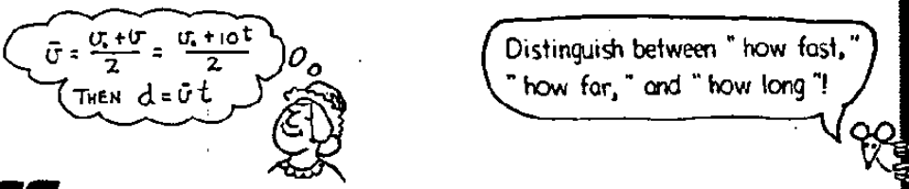
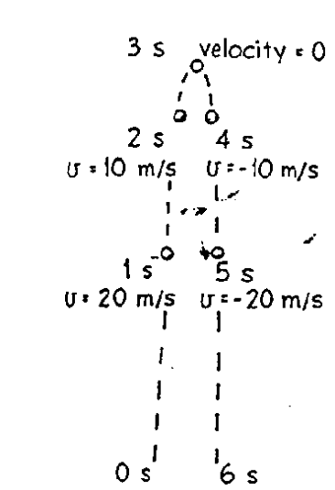
Free Fall Straight Up and Down

Assume negligible air resistance and g = 10 m/s².

1. The 1st velocity - distance columns of the table below shows the velocity data of the figure (at the right) for times t = 0 s to t = 8 s. Complete the table. Distances traveled are from the starting point (the displacements).

2. The 2nd velocity - distance columns are for a greater initial velocity. Complete the table. Distances traveled are from the starting point (the displacements).

3. The 3rd velocity - distance columns don’t specify an initial velocity. Choose your own (except 30 or 40 m/s) and complete the table. Distances traveled are from the starting point (the displacements).
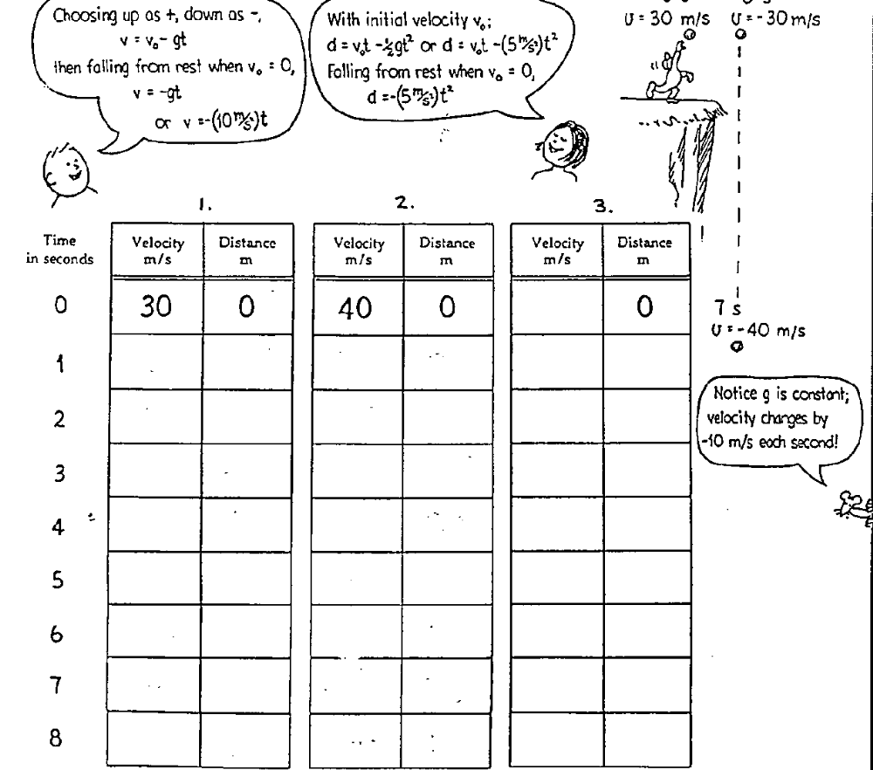
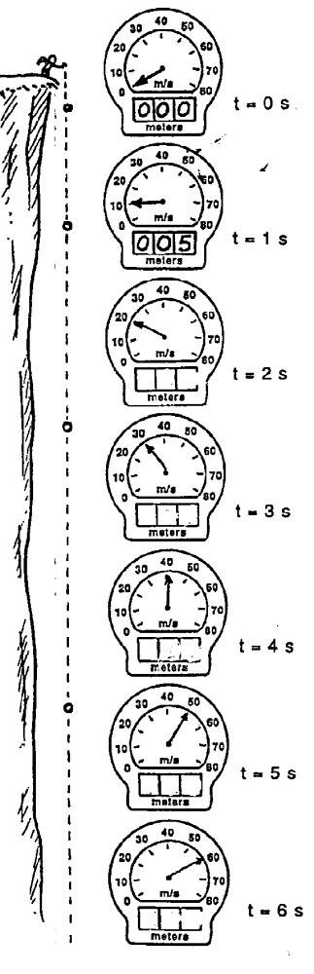
Free Fall Off A Cliff

4. A rock dropped from the top of a cliff picks up speed as it falls. Pretend that a speedometer and odometer are attached to the rock to show readings of speed and distance at 1 second intervals. Both speed and distance are zero at time = zero (see sketch). Note that after falling 1 second the speed reading is 10 m/s and the distance fallen is 5 m. The readings for succeeding seconds of fall are not shown and are left for you to complete. So draw the position of the speedometer pointer and write in the correct odometer reading for each time. Use g = 10 m/s² and neglect air resistance.

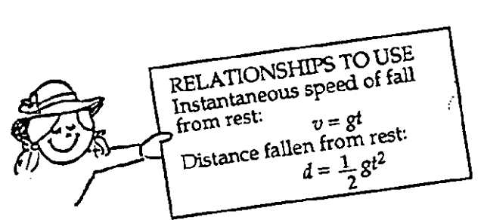

a. The speedometer reading increases by the same amount, ________ each second. This increase in speed per second called ________________.

b. The distance fallen increases as the square of the ___________________________.

c. If it takes 7 seconds to reach the ground, then its speed at impact is ____________m/s².The total distance fallen is ___________ meters, and its acceleration of fall just before impact is ____________m/s².

Free Fall Speed

1. Aunt Minnie gives you $10 per second for 4 seconds. How much money do you have after 4 seconds?

This is an instantaneous rate much like instantaneous velocity.
Instantaneous rate = $10/s x 4 s = $40.00 after 4 s

2. A ball dropped from rest picks up speed at 10 m/s per second. After it falls for 4 seconds, how fast is it going?

Instantaneous rate =10 m/s x 4 s = 40 m/s… this correlates to v = v_{i} + at
- v_{i} = 0 in this case because the ball was dropped from rest

3. You have $20, and Uncle Harry fives you $10 each second for 3 seconds. How much money do you have after 3 seconds?

Instantaneous rate $20 + ($10 x 3 s) = $50 … … this correlates to v = v_{i} + at

4. A ball is thrown straight down with an initial speed of 20 m/s. After 3 seconds, how fast is it going?

Instantaneous rate 20 m/s + (10 m/s² x 3 s) = -50 m/s …this correlates to v = -v_{i} + (-g)t
- v_{i} = 20 m/s in this case
- Free fall implies that acceleration due to gravity is acting on the object (-10 m/s²) in the same direction as the throw (therefore, the throw is considered in the negative direction, like gravity).

5. You have $50 and you pay Aunt Minnie $10/second. When will your money run out?

Instantaneous rate ($50 - $0/s) / ($10/s) = 5 s … … this correlates to v = v_{i} + gt
which can be rewritten to solve for time: t = (v – v_{i}) / g
- vi = 0 in this case because you start at time zero with $50. You lose $10 after the 1st second.

6. You shoot an arrow straight up at 50 m/s. When will it run out of speed?

Instantaneous rate (50 m/s - 0 m/s) / (10 m/s²) = 5 s … … this correlates to vf = vi + gt
which can be rewritten to solve for time: t = (vf – v_{i}) / g
- v_{f} = 0 m/s in this case because the arrow stops at its peak. Gravity acts against the arrow which begins at a velocity of 50 m/s. You lose 10 m/s each second due to gravity.
- Free fall implies that acceleration due to gravity is acting on the object (-10 m/s²) in the opposite direction as the throw (gravity is downward, negative, in this case).

7. Based on #6, what is the arrow’s speed 5 seconds after you shoot it?

v = v_{i} + gt = 50 m/s + (-10 m/s²)(5 s) = 50 m/s – 50 m/s = 0 m/s
8. Based on #6-7, what is the arrow’s speed after 6 seconds? 7 seconds?

The arrow has already reached its highest point and velocity at the 5 s mark. Therefore, it begins to fall to the earth and will be influenced by gravity.

The 6 s point is actually 1 s from the new starting position.

v = v_{i} + gt where vi = 0 m/s = 0 m/s + (-10 m/s²)(1 s) = -10 m/s
- Free fall implies that acceleration due to gravity is acting on the object (10 m/s²) in the same direction as the throw (therefore, the throw is considered in the negative direction, like gravity).

The 7 s point is actually 2 s from the new starting position.

v = v_{i} + gt where vi = 0 m/s = 0 m/s + (-10 m/s²)(2 s) = -20 m/s
- Free fall implies that acceleration due to gravity is acting on the object (10 m/s²) in the same direction as the throw (therefore, the throw is considered in the negative direction, like gravity).

Free Fall Distance

1. Speed is one thing; distance or displacement is another. Where (what distance) is the arrow that was shoot up at 50 m/s when it runs out of speed? In other words, how high did it fly?

From the previous problems, we calculated that the arrow hit it highest point in 5 s.
d = v_{i}t +½ gt² = (50 m/s)(5 s) + ½ (-10 m/s²)(5s)² = 250 m – 125 m = -125 m

2. How high will the arrow in question 1 be 7 seconds after being shot up at 50 m/s?
7 s
5 s

The arrow has already reached its highest point and velocity at the 5 s mark. Therefore, it begins to fall to the earth and will be influenced by gravity. The 7 s point is actually 2 s from the new starting position OR 5 s from the initial starting position, but in the opposite direction.

d = v_{i}t + ½ gt²(50 m/s)(7s) +½ (-10 m/s²)(7s)²
= 350 m – 245 m = 105 m

Since the arrow is 2 s from the highest point, it would have fallen 20 m.
We calculated this from d = ½ gt² = ½ (10 m/s²)(2s)² = 20 m
The highest point is 125 m – 20 m (2 s fall) = 105 m, confirming our answer.

3. Aunt Minnie drops a penny into a wishing well and it falls for 3 seconds before hitting the water.
a. How fast is it going when it hits?

v = v_{i} + gt where vi = 0 (from rest) = (-10 m/s²)(3 s) = -30 m/s

b. How far down is the water surface?

d = v_{i}t + ½ gt² since vi = 0 (from rest), d = ½ gt² = ½ (-10 m/s²)(3 s)²= -45 m

c. What is the penny’s average speed during its 3 second drop?

Avg v = total distance / time = ∆d/t = (d₂ – d₁) / t = (45 m – 0 m) / 3 s = 15 m/s

OR in this case, avg v = (v_{f} + v_{i}) / 2 = (30 m/s + 0 m/s) / 2 = 15 m/s

4. Aunt Minnie didn’t get her wish, so she goes to a deeper wishing well and throws a penny straight down into it at 10 m/s. How far does this penny go in 3 seconds? (assume it doesn’t hit the water)

Notice, this time, the penny was thrown at an initial velocity.
d = v_{i}t + ½ gt² (-10 m/s)(3 s) + ½ (-10 m/s²)(3 s)²= -30 m – 45 m = -75 m
The velocity is in the downward direction so it is considered negative.
According to frame of reference, since the penny and gravity are going in the same direction, you could consider this positive motion looking from the top of the well down into the well.

Free Fall Straight Up and Down

Assume negligible air resistance and g = 10 m/s².

1. The 1st velocity - distance column of the table below shows the velocity data of the figure (at the right) for times t = 0 s to t = 8 s. Complete the table. Distances traveled are from the starting point (the displacements).

2. The 2nd velocity - distance columns are for a greater initial velocity. Complete the table. Distances traveled are from the starting point (the displacements).

3. The 3rd velocity - distance columns don’t specify an initial velocity. Choose your own (except 30 or 40 m/s) and complete the table. Distances traveled are from the starting point (the displacements).

UP: v = v_{i} + (-g)t DOWN: v = v_{i} - (-g)t

d = v_{i}t+ ½(-g)t² OR d = v_{i}t - ½gt²

Starting v = 30 m/s … 3 s to peak

Starting v = 40 m/s …4 s to peak

Starting v = 10 m/s … 1 s to peak

Time  s | Velocity  m/s | Distance (m)  v_{i}t - ½gt² |  | Velocity  m/s | Distance (m)  v_{i}t - ½gt² |  | Velocity  m/s | Distance (m)  v_{i}t - ½gt²
0 s | 30 | 0 |  | 40 | 0 |  | 10 | 0
1 s | 20 | 30 - 5 = 25 |  | 30 | 40 - 5 = 35 |  | 0 | 10 - 5 =5
2s | 10 | 60 - 20 = 40 |  | 20 | 80 - 20 = 60 |  | -10 | 20 - 20 = 0
3 s | 0 | 90 - 45 = 45 |  | 10 | 120 - 45 = 75 |  | -20 | 30 - 45 = -15
4 s | -10 | 120 - 80 = 40 |  | 0 | 160 - 80 = 80 |  | -30 | 40 - 80 = -40
5 s | -20 | 150 - 125 = 25 |  | -10 | 200 - 125 = 75 |  | -40 | 50 - 125 = -75
6 s | -30 | 180 - 180 = 0 |  | -20 | 240 - 180 = 60 |  | -50 | 60 - 180 = -120
7 s | -40 | 210 - 245 = -35 |  | -30 | 280 - 245 = 35 |  | -60 | 70 - 245 = -175
8 s | -50 | 240 - 320 = -80 |  | -40 | 320 - 320 = 0 |  | -70 | 80 - 320 = -240
Free Fall Off A Cliff

4. A rock dropped from the top of a cliff picks up speed as it falls. Pretend that a speedometer and odometer are attached to the rock to show readings of speed and distance at 1 second intervals. Both speed and distance are zero at time = zero (see sketch). Note that after falling 1 second the speed reading is 10 m/s and the distance fallen is 5 m. The readings for succeeding seconds of fall are not shown and are left for you to complete. So, draw the position of the speedometer pointer and write in the correct odometer reading for each time. Use g = 10 m/s² and neglect air resistance.

20 m
45 m

a. The speedometer reading increases by the same amount, 10 m/s each second. This increase in speed per second called acceleration.
80 m

b. The distance fallen increases as the square of the time multiplied by ½ the gravity.

c. If it takes 7 seconds to reach the ground, then its speed at impact is 70 m/s. [v =gt]
125 m

The total distance fallen is 245 meters, and its acceleration of fall just before impact is10m/s².
[d = ½gt²] The acceleration due to gravity is always the same no matter what point you determine it.
180 m

