Lab: The Scientific Method – Optical Illusions

Introduction

Purpose To apply the scientific method to optical illusions.

Discussion

1. Observation: question, use senses, collect and organize data, identify problems, etc.

2. Hypothesis: proposed solution to accurate observation.

3. Experiment: “controlled” testing with intent to make conclusions.

4. Theory: Scientific practice helps one recognize patterns in order to solve them quicker. (Theories offer us recognizable patterns and explanations.)

6. A law means that there are no known exceptions in the natural world under the same conditions.

Hypothesis

If various illusions are presented, then the entire scientific process will be experienced in solving them.

Materials metric ruler

Procedures:

For each illusion, predict a possible solution. Go with your first impression. Don’t assume it’s an optical illusion. Then measure with a metric ruler (show units).

Calculations and Data

1. Which line is longer, AB or CD? _____

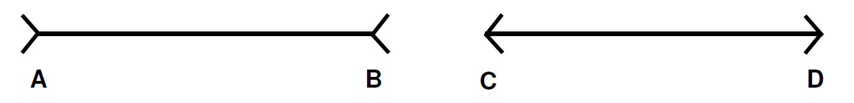
What are the actual lengths of the two lines AB = _____ CD = _____

2. Which line is longer EF or GH? _____
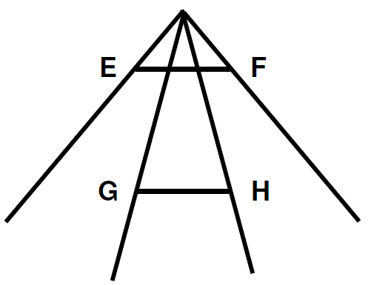

What are the actual measurements? EF = _____ GH = _____

3. Which Circle is larger? A or B _____
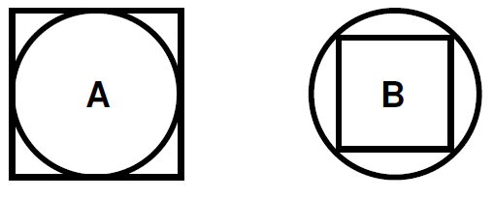
What are the actual measurements? _____

4. Which center circle is largest? Guess: _____

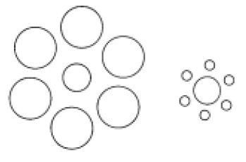

What are the actual measurements? _____

5. Which line appears longest, AB or BC? Guess: _____

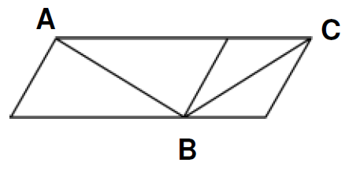

What are the actual measurements? _____

6. Do you only see black shapes on white or a word? _____

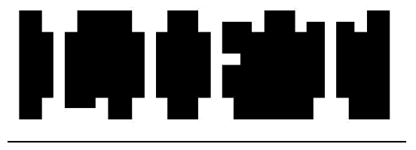

Write the word: _____

7. Which line continues straight through the diagram, A or B? Guess: _____

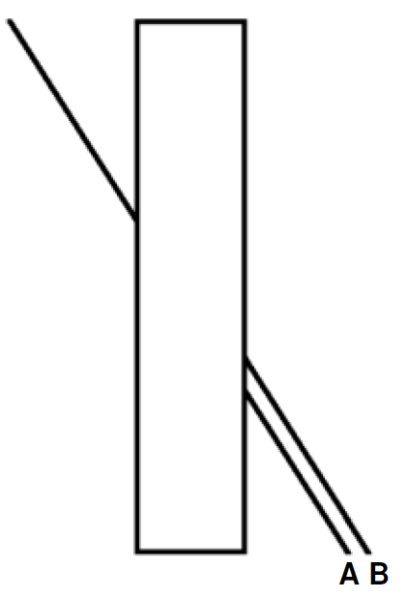

Check it with a ruler! Which one is it? _____

8. Look at the pairs of lines in the three diagrams below. Do they look straight or curved? Guess: ________

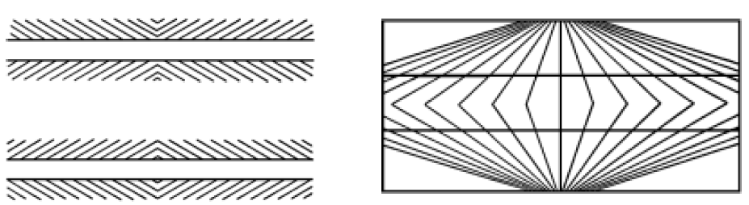

Check them with a ruler. Are they straight or curved? _____

Why do you think that they look curved? Give your best hypothesis.

9. How would you describe the “rounded” shape on the inside of this structure?

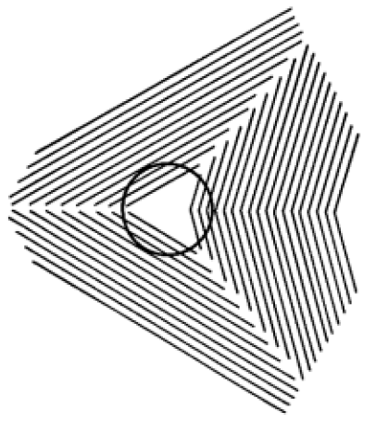
It is actually a perfect circle. How can one prove it?

Why do you think people perceive it differently?

10. Look at the box to the right. Describe what you see when you stare at it.

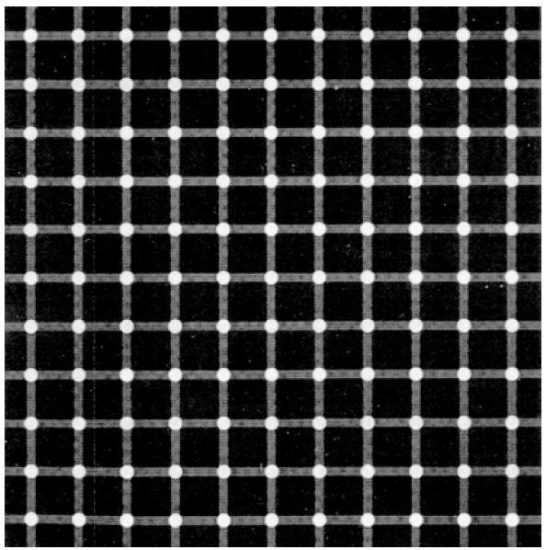

Why do you think it appears the way it does?

The illusion is called the Scintillating grid illusion, which may be a variation of the Hermann grid illusion. Dark dots seem to appear and disappear at intersections, hence the label “scintillating”. The effect may be explained by Lateral inhibition, which is the capacity of an excited neuron to reduce the activity of its neighbors. Lateral inhibition disables the spreading of action potentials from excited neurons to neighboring neurons in the lateral direction. This creates a contrast in stimulation that allows increased sensory perception.

Conclusions and Questions

1. How does this lab illustrate each step of the scientific process?

2. Most likely by the fourth or fifth illusions, you were making assumptions about the answers for each illusion. What aspect of the scientific process is most involved?

