Why is there a need for classification?
- Innate need for _____ and _____.
- _____ organisms can be added more easily.
- Elimination of the problem of _____ between scientists of the same country, different countries, language, culture, etc.
- Scientists attempt to order the natural world by _____ and _____ all living organisms.
- As technologies improve, so have our systems of classification.

- Study of classification is called – _____
- Benefits of Taxonomical Classification
- _____ and _____ name organisms.
- Prevents _____ such as “starfish” and “jellyfish” that aren't really fish.
- Uses same _____ (_____) for all names.

- Theory of Classification

- _____ – made an early attempt to classify organisms
_____ (categorized according to structure)
- Herbs – soft stems
- Shrubs – several woody stems
- Trees – single woody stem
_____ (categorized according to where they live)
- Water dwellers
- Land dwellers
- Air dwellers

_____

“_____ of Taxonomy”

Classified organisms by their str_____ ucture (_____).

Discarded common names and used Latin (universal): _____ Nomenclature

_____ -Name naming system (Genus and species)
- _____
- Genus species
- CAPITALIZE _____, but NOT species
- _____ in print
- UNDERLINE when handwriting

_____

A group of closely related _____.

The name is _____ & underlined or italicized.

_____
- Structurally _____ (identical) to each other and different from all other organisms.
- Can _____ to produce viable offspring.
- The name is _____ and underlined or _____.
- Homo sapiens or Homo sapiens

Basis of Classification

_____ _____
- Appendages – arms/wings, legs, antennae
- Organs – heart, brain, lungs
- Tissues – nervous, muscle, blood vessels

_____ similarities
- Proteins
- Carbohydrates
- Water
- DNA, RNA, etc.

- System of Classification (give the 8 categories)

- How many kingdoms?

Two kingdoms
- _____ first divided all organisms into large groups that he called kingdoms. He based his classification on TWO kingdoms: _____ & _____.

Modern Taxonomy
- Modern taxonomists consider the _____ of an organism when attempting to classify it.
- PHYLOGENY: The _____ _____ of an organism.
- To show the evolutionary relationship between different groups of organisms, scientists construct PHYLOGENETIC _____.
- A phylogenetic tree is a _____ tree that shows the evolutionary relationships thought to exist among _____ groups of organisms.

C. Modern taxonomy now takes into account other types of evidence when attempting to classify an organism.
- _____ is classification based on the STRUCTURES possessed by the organism.
- _____ Organization – Similarity in cell structures provides evidence that organisms may be _____.
- _____ Relationships
- _____ Similarities

Five Kingdoms
- _____ (cells that lack a nuclear envelope and many internal cell structures; simple, unicellular organisms; e.g. bacteria, blue-green algae)
- _____ (unicellular protozoans; e.g. amoeba, paramecia, volvox, more complex algae)
- _____ (multi-cellular organisms that do not carry on photosynthesis [HETEROTROPHIC]; not green; e.g. mushrooms, yeast)
- _____ (photosynthesis [AUTOTROPHIC]; green; differentiated organs)
- _____ (locomotion; not rigid; complex foods ingested)

E. Six Kingdoms
1. _____ live in _____ environments (mostly anaerobic), [halococcus]
2. _____ “small rod” cell wall, [cyanobacteria, streptococcus, e coli]
3. _____ “very first” “eukaryote,” plant-like or animal-like, no _____
4. _____ _____, cell _____, mostly multi-cellular
5. _____ _____, multi-cellular, mostly _____ producers
6. _____ _____, multi-cellular, consumers

THE 6-KINGDOM SYSTEM with THREE DOMAINS
- The domain BACTERIA contains the Kingdom _____.
- The domain ARCHAEA contains the Kingdom _____.
- The domain _____ contains the Kingdoms _____, _____, _____, and _____.

- Classification of Viruses

  - What is a virus?
    - An _____ particle that is ___living.
    - The word virus comes from the Latin word meaning “_____.”
    - All viruses are _____ that require a host.
      - Parasite: live in or on other living organisms, _____
      - Host: the living organism the _____.
    - Characteristics of Viruses
      - Viruses are _____.
      - Most can only be seen with an _____.
      - A virus is active only when _____.
      - When removed from a living cell, it _____ all activities, but retains its ability to _____.
      - They may be crystalized and stored indefinitely, but even after long periods of time, _____.
      - They vary widely in terms of size and structure, but they all have one thing in common: They enter living cells and use _____.
    - Structure of the Virus
      - Non-_____
      - Not made of cells and have no cell parts
      - Anatomy of a Virus
        - _____: lipid bilayer derived from host membrane when virus is formed.
        - _____: Protein coat that protects the nucleic acid.
          - The capsid is made of _____ that enable the virus to enter a host cell.
          - These capsid proteins have a particular shape that must match _____ on the surface of a _____.
          - When the virus attaches to these receptors, the cell is “tricked” into _____.
        - _____ Acid Core: containing either _____ or _____.
    - Viral Infection
      - Viruses can reproduce, but only _____.
      - They reproduce inside a cell by getting the cell to produce _____.
      - Since viruses must bind precisely to proteins on the cell surface, they are highly specific to the cells they infect.
      - Viruses of eukaryotes are usually _____ specific.
        - Plant viruses can only infect _____ cells.
        - Human viruses can only infect _____ cells.
        - Bacteriophages are viruses that infect only certain types of bacteria
        - Virus-free cells are _____.
    - Are viruses living or nonliving?
      - Living characteristics
        - They can _____, but only inside a living cell.
        - They can mutate or change.
        - They have _____. Their genome may consist of only four genes, or up to a hundred genes.
      - Nonliving characteristics
        - They are non-cellular
        - They have _____ (no food or energy requirements)
        - They can be _____ and stored indefinitely. They come to “life” only when injected inside a living cell.

- Viral Reproduction

  - Process of Viral Reproduction
    - Since viruses have no enzymes and no cell parts, they force the host cell to _____.
    - A viral infection begins when the _____ (DNA or RNA) of a virus makes its way _____.
    - Once inside, the virus _____ the cell, reprogramming the cell.
    - The viral genome takes over the host cell and makes the _____ start producing _____.
    - The host cell will begin to make copies of the _____ and producing the _____.
    - The host cell assembles the parts into viruses.
    - The reproductive cycle ends with the exit of hundreds or thousands of viruses from the infected host cell.
    - This often _____ the host cell. Each of these viral progeny has the capacity to infect neighboring cells thereby spreading the infection.

  - Two Reproductive Possibilities
    - Once a virus is inside a host cell, two different processes may occur.
    - Some viruses replicate themselves immediately, killing the host cell.
    - Other viruses replicate themselves in a way that does not destroy the host cell.

    - _____ Cycle:
      - Some viruses replicate themselves immediately, _____ the host cell. In a lytic infection, a virus enters a cell, makes copies of itself, and causes the cell to burst.
      - _____ T4 is an example of a virus that causes a lytic infection.
      - Five Steps of the Lytic Cycle
        - _____: Tail fibers are used to attach to receptor sites on the surface of the host cell
        - Entry: Phage DNA is injected. Empty capsid remains outside. Host cell DNA is destroyed.
        - Synthesis: The host cell is directed to produce viral genomes and protein _____
        - Assembly: The viral DNA or RNA is assembled inside the protein coat.
        - _____: The cell swells, bursts, and releases 100’s of new viruses.

d) A phage that reproduces only by a lytic cycle is called a _____ Virus.
West Nile, Avian Flu, HIV, Ebola, SARS, Covid 19

    - _____ Cycle: Other viruses replicate themselves in a way that does not _____ the cell.
      - In this type of viral reproduction, the host cell makes copies of the viral genetic material indefinitely.
      - The virus incorporates its DNA into the _____. The viral DNA is then _____ along with the host cell’s own DNA.
      - Lysogenic viruses do not _____. A lysogenic virus may remain _____ for a period of time.
      - _____: The viral DNA embedded into the host cell’s DNA
      - The prophage may remain part of the host _____ before becoming active.
      - Eventually, certain environmental conditions (chemical, radiation) may trigger the switchover from the _____ cycle to the _____ cycle.

- Retroviruses
  - Retroviruses have _____ as their genetic information rather than _____.
  - Process of Retrovirus infection
    - These viruses have an enzyme called _____, which transcribes their _____ template into _____.
    - The newly made DNA then enters the cell’s nucleus and integrates into the DNA of a chromosome.
    - In this way, the retrovirus may _____ for a length of time.
    - It will eventually become _____ causing the host cell to make new viruses, and causing the _____ of the host cell.
    - Retroviruses are responsible for some types of cancer.
    - The _____ virus is a retrovirus.

- Comparison of Viruses and Cells

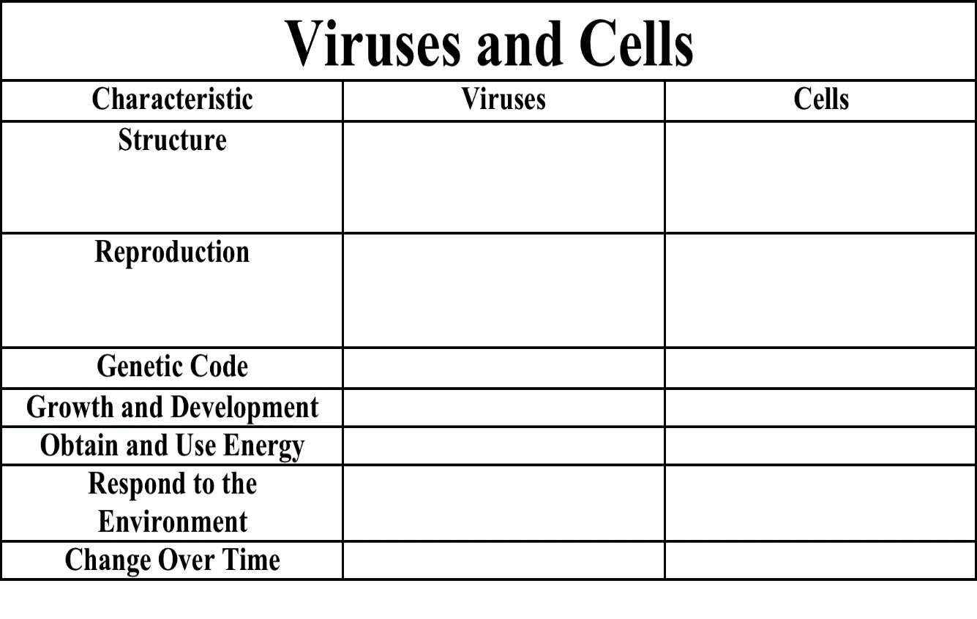

- Common Viral Diseases
  - Flu
  - AIDS
  - Hepatitis
  - Colds
  - West Nile Virus
  - Chicken Pox
  - Ebola

- Viroids
  - They are known for their extreme _____ and small _____.
  - They are much smaller than a _____.
  - They consist of _____ but they have no _____. They are tiny molecules of _____.
  - They have been identified in _____, but they are suspected of causing some diseases in animals for which no pathogen has ever been isolated.
  - The important lesson we have learned from viroids is that a _____ can be an infectious agent and cause disease.

- Prions
  - These are disease-causing particles that do _____ contain DNA or RNA.
  - They are tiny bits of _____.
  - Prions cause degenerative brain diseases such as _____.
  - How can a protein, which cannot replicate itself, be a pathogen?

- The leading hypothesis is that a prion is a _____ normally present in brain cells. When a prion enters a cell that contains the normal form of the protein, the prion converts the normal protein to the prion version.

