Acceleration & Free Fall
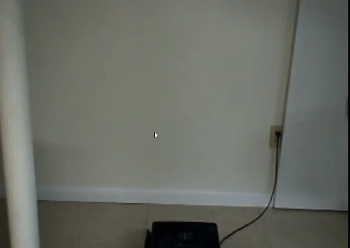

See https://www.learningctronline.com/courses for Materials and Resources.

Topics:
1. Acceleration & Free Fall

Objectives:
- Define and calculate acceleration, acceleration due to gravity, and free fall.
- Distinguish free fall from terminal velocity, incorporating air resistance.
- Describe how motion is produced.
- Explain what is meant by relative motion and factors involved.
- Distinguish between speed and velocity and know how to calculate both. Describe the types of speed and velocity.

TAKE NOTE

- Reading (Hewitt Text)

- Acceleration Activity

- Problem Sets Acceleration & Free Fall

- Lab: Speed (Lab Report due in 9 days) … calculations / data, Conclusions

- Lab: Constant Acceleration

- Lab: Free Fall

- Test: Linear Motion

- Week 6 Devotional (https://www.learningctronline.com/devotional)
Text: Chapter 2: Linear Motion 2.4 – 2.8; 5.6 – 5.7 (Hewitt)

Class Notes: Force & Motion Document

Homework:
- Problem Set Acceleration
- Problem Set Free Fall

Lab: Constant Acceleration
- Perform the lab as directed using the worksheet provided.
- Complete all calculations and data, showing work whenever appropriate.
- Conclusions should be answered in complete sentences that convey a complete thought.

- Save the documents into your LAB folder in the Physics folder on your desktop.

Lab: Free Fall
- Perform the lab as directed using the worksheet provided.
- Complete all calculations and data, showing work whenever appropriate.
- Conclusions should be answered in complete sentences that convey a complete thought.

- Save the documents into your LAB folder in the Physics folder on your desktop.

TEST: Velocity, Acceleration, Free Fall

1) the academic integrity policy

- Tests must be completed WITHOUT referring to books, notes, the internet, people, or any outside resources.
- Students MAY use the approved Periodic Tables, approved Reference Tables, or approved equation (formula) sheet (provided by the teacher) along with calculators and scratch paper.
- A guardian should be proctoring the test. Proctoring means to monitor the following:

2) Take the "in one sitting", meaning that once you start the test, you must complete it without interruption.

3) There is a 50-minute time limit on this test. Please have the proctor write the time taken at the top of your answer sheet with their signature or initials.

4) Proctors should NOT be reading the test or engaging students during the test.

5) Do NOT use RED font. Black font is best.

Supplemental Resources (Optional)
- Reaction Time Lab
- Acceleration Problems (Basic)
- Free Fall Problems & Graphs (Basic)
- Speed Acceleration Free Fall Quiz (Basic)

http://somup.com/cFXh0in1ky Motion in Two Directions ctr (0:25)
http://somup.com/cFXh3Mn1k0 Terminal Velocity ctr (0:59)

http://somup.com/c06nqdBqAI Terminal Velocity (1:27)

http://somup.com/crfhovbJTq Air Resistance (Rescuers Down Under) (1:16)

